UDK 504.045 (45)

PolEmiCa model for local air quality assessment in airports
K.Synylo, A.Krupko
(National aviation university)

Aircraft engine emissions have a direct impact on air quality in local, regional and global scales. Several studies exhibited extremely high concentrations of toxic compounds (including nitrogen oxides (NO_{x}), particulate matter (PM₁₀, PM_{2.5} and UFP), unburned hydrocarbons (UHC) and carbon monoxide (CO)) due to airport-related emissions and a significant impact on the environment (Herndon et al., 2008) and health of the people living near the airport (Peace et al., 2006).
Key variable of local air quality (LAQ and related impact considerations is the pollutant concentration (quantity of a pollutant per volume of ambient air), for which national and global regulations specify limit values.
Spatial and temporal dispersion and distribution of air pollutants is the basis of unbiased assessment of the present position and future trends of air pollution and of the development of cost-effective strategies to improve air quality and to meet regulatory requirements. Usual practice for the Former Soviet Union countries, in particular in Ukraine today, that the air pollution must be calculated, first, for the stationary sources using the OND-86 method and just these data must be taken into account in procedures of zoning around the polluters, including the airport. OND-86 calculation method is mainly used for stationary sources, with some assumptions – for ground vehicles, but not appropriate for aircraft (Zaporozhets and Synylo, 2015).
Main purpose of the PolEmiCa is to provide the dispersion (Pollution) and inventory (Emission) calculations for the aircraft engine emission during the LTO cycle of the aircraft movement inside airport area. It includes the aircraft emission from Start-up procedures, Auxiliary Power Unit (APU) and Ground Support Equipment (GSE) also.
The complex model PolEmiCa consists of the following basic components:
- engine emission model provides emission factor assessment for aircraft engines, including influence of operational and meteorological factors. Current version realizes 3 methods for emission indexes calculation as ICAO, BFFM2 and P3T3 methods;
- jet transport model evaluates basic mechanisms of contaminants transportation and dilution by the jet from the aircraft engine exhaust providing basic parameters of the jet for further dispersion analyses;
- dispersion model calculates the dispersion of the pollutants in the atmosphere due to turbulent diffusion and wind transfer.
PolEmiCa calculates the concentration filed inside airport area taking into account intensity of flights of airplanes, a loading factor of different taxiways and runways, and other operational circumstances. Basic expression for definition of maximum instantaneous value of concentration in grid point is a solution of turbulent diffusion equation according to Eulerian approach for moving point source with preliminary transport and dilution of contaminants by an exhaust gases jet. PolEmiCa provides calculation the instantaneous and averaged (hourly, annual) concentrations of air pollutants in the vicinity of the airport.

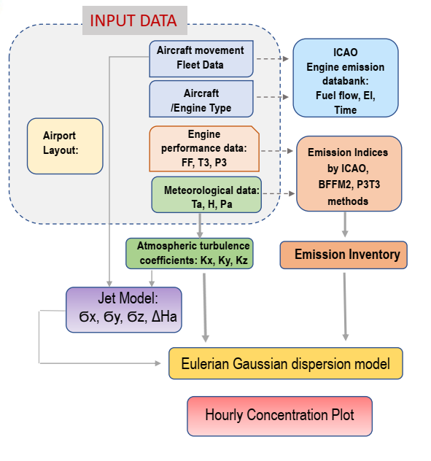
Fig.1. Structure and data flows of PolEmiCa model

So, PolEmiCa could be applied, as tool for implementation of European standards and best practices of airport air quality regulation in context of sustainable aviation.
MDG CAEP successfully completed the verification procedure of the PolEmiCa model in 2019. Currently CAEP/12-MDG-FESG/4/WP/09 [3] initiated a feasibility study to test how LAQ dispersion calculations for individual airports can be set up and carried out within MDG in order to provide a quantity that is based on near-ground concentration at and around airports caused by aircraft traffic. Complex model PolEmiCa was also involved in the LAQ feasibility study towards a concentration-based LAQ metric.

References:
- Herndon S., Jayne J., Lobo P. in: Commercial aircraft engine emissions characterization of in-use aircraft at Hartsfielde Jackson Atlanta International Airport. Environ. Sci. Technol. 42, 2008, pg.1877 – 1883.
- Peace H., Maughan J., Owen B., Raper D. Identifying the contribution of different airport related sources to local urban air quality. Environ. Modell. Softw. 21, 2006, pg.532 – 538.
- Zaporozhets O. PolEmiCA Local Air Quality Model Evaluation: Inventory/Dispersion Assessment & Analysis / O. Zaporozhets, K.Synylo // САЕРMDG9 Meeting, Cologne, 1-2 May 2015. – 41
- CAEP/12-MDG-FESG/4-WP/09 LAQ Dispersion Feasibility Study. CAEP fourth virtual meeting, 15 to 19 June 2020 (CAEP/12-MDG-FESG/4)

