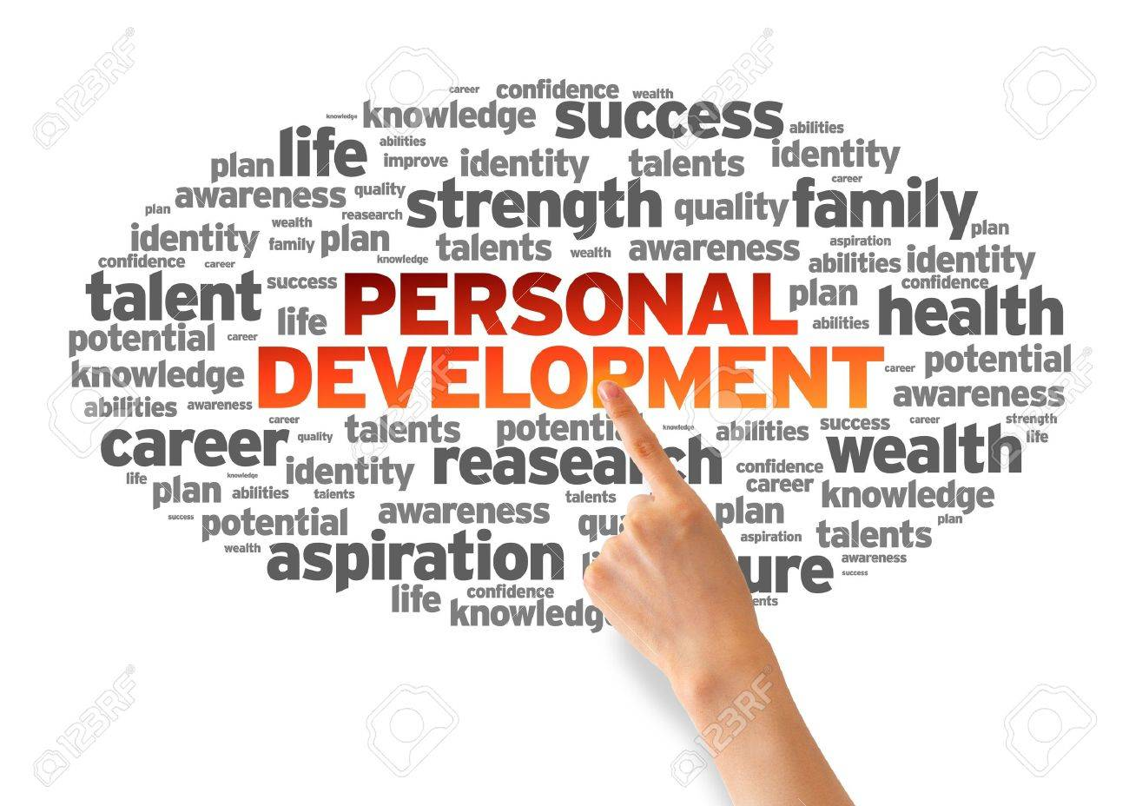
Discussion
«Life isn’t about finding yourself. Life is about creating yourself.» — George Bernard Shaw
1.1
Text 1
Vocabulary table
- Personal development
- set goals
- enhance employment skills

Personal development is a lifelong process. It is a way for people to assess their skills and qualities, consider their aims in life and set goals in order to realise and maximise their potential.
The process of improving oneself through such activities as enhancing employment skills, increasing consciousness and building wealth. The growing success of the self-help and personal development movement has assisted many business managers in obtaining more qualified and motivated personnel for their companies, and it has also encouraged more people to go into business for themselves.

A Guide to Developing a Personal Development Plan As part of the University Performance Development Review process you may wish to consider how best to plan your long term development. However, Personal Development Plans (PDPs) can be useful for individual and teams to identify and address both short and long term development goals. Personal development planning is also a systematic approach to continuously develop your skills to ensure that you have the necessary skills and knowledge when opportunities to progress arise. How do you develop a PDP? Development is a process of expanding, shaping and improving skills, knowledge and interests to improve your abilities and effectiveness.
This can involve developing skills and knowledge that will enable you to move ahead to the next stage in your career but also to expand your breadth of skills and knowledge so that you become more expert in your current post or even to develop a new skill outside work e.g. playing a sport. To address a development need effectively it is necessary to:
- Define what you want to achieve and set yourself a goal(s).
- Plan the actions you need to undertake to achieve that goal – you should write a personal development plan (PDP) to outline the actions you are going to undertake to achieve your goal.
- Evaluate your development to assess how close you are to your goal and to examine if further action needs to be taken to achieve your goal.

Why should you set goals? Here are just a few good reasons to set yourself goals:
- To establish the direction that you need to take.
- Provide you with time to reflect on your role and the areas in which you want to develop.
- Motivation is key to achieving goals. Individuals and teams find goals are motivating as they provide direction and a way of measuring success.
- Allow you to take control and be proactive rather than be reactive to events.

How should you set goals? Often goals can be very straightforward e.g. I must learn to use PowerPoint by the end of the month as I have a presentation in three weeks. However, sometimes they can be more involved and more thought needs to be taken to identify your goals.
When developing goals ask yourself:
- What do I want to achieve?
- How important is this goal to me?
- What are the factors that will help me achieve my goal?
- Who can help me achieve my goal?
- What are the factors that may stop me achieving this goal?
- What is the gap between where I am now in terms of my skills and knowledge, and where I want to be?
When thinking out your goals you can think of your situation in terms of a SWOT analysis, i.e.
SWOT analysis (or SWOT matrix) is a strategic planning technique used to help a person or organization identify strengths, weaknesses, opportunities, and threats related business competition or project planning. It is intended to specify the objectives of the business venture or project and identify the internal and external factors that are favorable and unfavorable to achieving those objectives. Users of a SWOT analysis often ask and answer questions to generate meaningful information for each category to make the tool useful and identify their competitive advantage. SWOT has been described as the tried-and-true tool of strategic analysis,^{[2]} but has also been criticized for its limitations.
Strengths and weakness are frequently internally-related, while opportunities and threats commonly focus on the external environment. The name is an acronym for the four parameters the technique examines:
- Strengths: characteristics of the business or project that give it an advantage over others.
- Weaknesses: characteristics of the business that place the business or project at a disadvantage relative to others.
- Opportunities: elements in the environment that the business or project could exploit to its advantage.
- Threats: elements in the environment that could cause trouble for the business or project.
The degree to which the internal environment of the firm matches with the external environment is expressed by the concept of strategic fit. Identification of SWOTs is important because they can inform later steps in planning to achieve the objective. First, decision-makers should consider whether the objective is attainable, given the SWOTs. If the objective is not attainable, they must select a different objective and repeat the process.

Strengths – what are you good at? In what areas do you make most contribution? What comments and feedback have you received that gives you an indication of how others see your strengths.
Weaknesses – what areas do you feel you need to develop? Have you received any feedback or comments that may suggest that there are development needs in some areas? What aspects of your work do you find relatively easy to undertake and what areas are more difficult to complete? Think out what are the areas you should develop and consider how you can reduce or manage them so that they don’t hinder your ability to achieve your goals.
Opportunities – what is your potential? Are their opportunities that may arise in the University that you could apply for if you had more skills and knowledge in your area?
Threats – is there a great deal of change happening in your area of work that may lead to a change in your role and do you feel you need to develop your skills to ensue that you are able to continue to undertake you’re role effectively.
When you have thought out your goals clearly you then need to develop an action plan to help you achieve those goals.
Goals and actions must be SMART:
SPECIFIC | The goal must state exactly what you need to achieve.
MEASURABLE | You need to know when you have succeeded. Therefore outline as precisely as possible what skills and knowledge you will have acquired have when you have achieved your goal.
ACHIEVABLE | The goal should be achievable and within your capacity and constraints. You should not set yourself goals that are impossible or unrealistic to achieve.
RELEVANT | Think to yourself, are these the right goals? Will they help you get to where you want to be?
TIME RELATED | Realistically consider how much time do you need to achieve your goal? Some goals can be achieved in the short-term, some may take a long time to achieve. Setting time related goals will be helpful in organising your time effectively and breaking down the goal to smaller elements. With long term goals milestones are extremely important to keep you motivated to achieve your longer term goal.

How should you set goals?
In order to put yourself on course to achieve your goals you need to take action. Ask yourself the following:
- What additional knowledge do you need?
- What experience do you need?
To help you develop yourself there are many different types of training you can undertake.
Listed below is a brief selection:
Attending a course | The University and the School of Lifelong Learning have a wide range of courses for staff.
Gaining a qualification | Gaining a qualification can be an excellent way to develop in-deapth knowledge of a topic. The University sometimes offers support to staff to follow qualifications that are relevant to their post.
Coaching and Mentoring | You could also find a mentor or coach to help you. A mentor tends to be a more senior or more experienced in a certain field mentoring another with less experience, where as coaching can be two members of staff in which one assists another to examine and find solution to a problem.
Shadowing and delegation | You can get more experience by undertaking a project to expand or attending meetings etc to expand your skills.
Performance Review | The review process is a good way of receiving constructive feedback and working with your line manager to identify development aims and actions to be taken to improve your knowledge, skills and confidence in your work.

Evaluating your Success
The learning process is a cyclical process in which you need to identify your development goal, initiate the action(s) that you need to reach your goal and then periodically you have to evaluate your progress. Taking time to evaluate and reflect your progress is essential to enable you to make necessary changes to your plan. When evaluating your progress you need to ask yourself:
- What have I learnt?
- What more do I need to do to achieve my goals?
- Is my progress too slow or ahead of schedule?
- Do I need any assistance to achieve my goal?
- What’s hindering my progress?
- Do I need to change my plan?
- What additional benefits am I gaining from the process?
Assignments
- Answer the questions.
- Sum up what the text says.
- Translate and learn the following adjectives.
- able
- accepting
- adaptable
- bold
- brave
- calm
- caring
- cheerful

- Divide into pairs. Choose six adjectives from the list above which you feel describe you and how others might perceive your behavior at work.
- Translate the following sentences into Ukrainian. Put questions to all of them.
- Translate the following sentences into English.
- PROJECT
Identify transferable skills necessary for career ladder.
Give a presentation to the class.

