МІНІСТЕРСТВО ОСВІТИ І НАУКИ УКРАЇНИ
Національний авіаційний університет
ФАКУЛЬТЕТ Аеронавігації, електроніки та телекомунікацій
Кафедра аеронавігаційних систем

ДОПУСТИТИ ДО ЗАХИСТУ
Завідувач кафедри
д-р техн. наук, проф.
В.Ю. Ларін
« » 2020 р.

ДИПЛОМНА РОБОТА
(ПОЯСНЮВАЛЬНА ЗАПИСКА)
випускника ОСВІТНЬОГО СТУПЕНЯ МАГІСТРА
За освітньо-професійною програмою
«обслуговування ПОВІТРЯНОГО РУХУ»

Тема: «Використання авіаційних тренажерів у підготовці фахівців з обслуговування повітряного руху (комплексна)»

Виконав: | _________ C.В. Субботін
Керівник: доцент. | М.М. Богуненко

Нормоконтролер | __________ Т.Ф Шмельова

Київ 2020

MINISTRY OF EDUCATION AND SCIENCE OF UKRAINE
NATIONAL AVIATION UNIVERSITY
FACULTY OF AIR NAVIGATION, ELECTRONICS AND TELECOMMUNICATIONS
AIR NAVIGATION SYSTEMS DEPARTMENT

PERMISSION FOR DEFENCE

Head of the Department
Doctor of Sciences (Engineering), prof
___________V.Yu. Larin
"_____" ______ 2020

MASTER’S THESIS
ON THE EDUCATIONAL PROFESSIONAL PROGRAM
"AIR TRAFFIC SERVICE"
(EXPLANOTARY NOTE)
Theme: "Usage of aviation simulator in a process of ATS officers training (complex)"

Performed by: S.V. Subbotin

Supervisor: assistant professor________________________ M.M. Bogunenko

Standard inspector ________________________ T. Shmelova

KYIV 2020

NATIONAL AVIATION UNIVERSITY
Faculty: Faculty of Air Navigation, Electronics and Telecommunications
Department: Air Navigation Systems Department____________________
Educational degree: Master _____________________________________________
The specialty: 272 “Aviation Transport”___________________________________
Educational Professional Program: Air Traffic Service

APPROVED BY
Head of the Department
V. Larin
“____”_____________2019

Master’s Thesis Assignment

Student`s name: Serhii Vitaliyovich Subbotin

- The thesis theme: “Usage of aviation simulator in a process of ATS officers training”
approved by the Rector’s order of “24” October 2019 № 2476

2. The thesis should be performed from : 14.10.2019 to 09.02.2019

3. Initial data: Training experience as student of ANS department and work experience as instructor in flight simulator center “Virtual Flight School”.

4. The content of the explanatory note (the list of problems to be considered): The lack of realism in current existing voice communication modules of ATCOs training simulator.
5. The list of mandatory graphic materials: research details, principal layouts.
Power Point should be used to provide graphic support and presentation.

6. Calendar Schedule of Performing the Master’s thesis.

Tasks | Period of works execution | execution note
Preparation of Chapter 1:  “OVERVIEW OF CURRENT REQUIREMENTS AND EXISTING FACILITIES” | 14.10.19 – 23.10.19 | Complete
Preparation of Chapter 2:  “TECHNICAL FEATURE AND STRUCTURE OF AERONAUTICAL SIMULATOR” | 2.11.19 – 30.11.19 | Complete
Preparation of Chapter 3: “ENHANCED RADIO COMMUNICATION TRAINING SYSTEM DEVELOPMENT” | 10.12.19-20.12.19 | Complete
Preparation of Chapter 4: “MAIN TECHNICAL FEATURES AND TECHNICAL REQUIREMENTS TO THE SYSTEM” | 22.12.19-31.12.19 | Complete
Preparation of principal layouts | 03.01.20 -10.01.20 | Complete
Preparation of report and graphic materials | 15.01.20 –24.01.20 | Complete

7. Date of issue: «___»____________ 2019.

Supervisor of master’s thesis ________________ M.M. Bogunenko

Excepted the task ________________ _______________

(name, surname)

ABSTRACT
Explanatory note to a graduate work “Usage of aviation simulator in a process of ATS officers training (complex)”: 93 pages, 22 figures, 16 references.
The aim of the graduate thesis is the analysis of aeronautical voice communication training simulator and development of brand new system .
Means of improvement – Analysis of work experience as simulator instructor.
The object of improvement – Simulator training of ATCOs.
The subject of improvement – Hardware means of simulator training.
Simulation training of aviation personnel is a vital and huge part of their studying. Simulation training is strongly connected with usage of phraseology and radio skills. The focus is on development of cheap and effective training system for obtaining radio usage skills.
AIR TRAFFIC CONTROL OFFICER, ATCO SIMULATOR TRAINING, ATCO TRAINING SIMULATOR, VOICE COMMUNICATION MODULE, VOICE COM MODULE INTEGRATION.

РЕФЕРАТ
Пояснювальна записка до дипломної роботи «Використання авіаційних тренажерів у підготовці фахівців з обслуговування повітряного руху».
93 сторінки, 22 рисунків, 16 використаних джерела.
Мета дипломної роботи – аналіз голосового (радіо) модуля у диспетчерських тренажерах та розробка нової легко інтегрованої навчальної системи зв’язку.
Засоби досягнення – аналіз досвіду роботи інструктором у центрі авіатренажерів.
Об’єкт дослідження – тренажерна підготовка фахівців з управління повітряним рухом.
Предмет дослідження – Матеріально-технічна база тренажерної підготовки фахівців з управління повітряним рухом
Тренажерна підготовка є невід’ємною та значною частиною навчання фахівців з управління повітряним рухом. Тренажерна підготовка дуже тісно пов’язана з використанням фразеології та наявністю навичок користування радіозв’язком. Головною ціллю є розробка дешевої та ефективною навчальної системи для тренування авіаційного персоналу з метою отримання навичок роботи з радіостанцією.
ТРЕНАЖЕРНА ПІДГОТОВКА СПЕЦІАЛІСТІВ З ОБСЛУГОВУВАННЯ ПОВІТРЯНОГО РУХУ, ДИСПЕТЧЕРСЬКИЙ СИМУЛЯТОР АВТОМАТІЗОВАНОЇ СИСТЕМИ КЕРУВАННЯ ПООВІТРЯНИМ ПРОСТОРОМ, ТРЕНАЖЕРНИЙ МОДУЛЬ УЛЬТРАКОРОТКОХВИЛЬОВОЇ РАДІОСТАНЦІЇ.

COMMENT SHEET

CONTENT
CHAPTER 1. OVERVIEW OF CURRENT EXISTING SIMULATOR FACILITIES 13
1.1. General concept of aeronautical training simulator 13
1.2. Procedural training simulator 14
1.3. Modular training simulator 15
1.4. Complex (integrated) training simulator 18
1.5. General requirements to training rooms (training centers/units) 20
1.6. The analysis of current existing simulators market 24
1.6.1 FUSION MODELING COMPLEX 24
1.6.2 Litaktak air solution 25
1.6.3 ATMIS - 3D Tower Simulator 26
1.6.4 Aerotechnica training simulator 29
1.6.5 FASTNET VOICE COMMUNICATION SIMULATOR 34
1.7 The analysis of current existing voice communication simulators 36
Conclusion to chapter 1 40
CHAPTER 2. TECHNICAL FEATURE AND STRUCTURE OF AERONAUTICAL SIMULATOR 41
2.1 The regulatory framework for the construction of aeronautical simulator-training systems 41
2.2 Typical functions of the workplace instructor of the aircraft simulator 49
2.3 Design principles for the modular architecture of aviation software 58
Conclusion to chapter 2 69
CHAPTER 3. ENHANCED RADIO COMMUNICATION TRAINING SYSTEM DEVELOPMENT 71
3.1 Incoming data for development of training radio communication system 71
3.2 Principal layout and main features of simulator 72
Conclusion to chapter 3 77
CHAPTER 4. MAIN TECHNICAL FEATURES AND TECHNICAL REQUIREMENTS TO THE SYSTEM 78
4.1 Main features of developed voice communication device 78
4.1.1 Features of telephone module 79
4.1.2 Features of microphone module 81
4.2 Main technical requirements to the additional equipment 83
4.2.1 Requirements to headset 83
4.2.2 Requirements to microphone 86
Conclusion to chapter 4 87
GENERAL CONCLUSION 88

DEFINITIONS
Air traffic. All aircraft in flight or operating on the maneuvering area of an aerodrome.
Aircraft. Any machine that can derive support in the atmosphere from the reactions of the air other than the reactions of the air against the earth’s surface.
Air traffic control service. A service provided for the purpose of:
a) preventing collisions:
1) between aircraft, and
2) on the maneuvering area between aircraft and obstructions; and
b) expediting and maintaining an orderly flow of air traffic.
Air traffic control unit. A generic term meaning variously, area control center, approach control unit or aerodrome control tower.
Air traffic service (ATS). A generic term meaning variously, flight information service, alerting service, air traffic advisory service, air traffic control service (area control service, approach control service or aerodrome control service)
Airway. A control area or portion thereof established in the form of a corridor.
Altitude. The vertical distance of a level, a point or an object considered as a point, measured from mean sea level (MSL).
Heading. The direction in which the longitudinal axis of an aircraft is pointed,
ICAO International Civil Aviation Organization
Pilot-in-command. The pilot designated by the operator, or in the case of general aviation, the owner, as being in command and charged with the safe conduct of a flight.
QNH is an aeronautical code Q code. indicating the atmospheric pressure adjusted to mean sea level
Terminal control area (TMA). A control area normally established at the confluence of ATS routes in the vicinity of one or more major aerodromes

ABBREVIATIONS
ACC Area control center
ADF Automatic direction finder
ATC Air traffic control
ATS Air traffic service
ATCO Air traffic controller officer
ATCS Air traffic control service
ATM Air traffic management
ATS Air traffic service
CP Communication panel
CTR Control zone
HF High frequency
ICAO International Civil Aviation Organization
IDE Integrated development environment
PCS Potential conflict situation
PIC Pilot in command
PTT Push to talk
SARU Search and rescue unit
TCU Traffic control unit
TG Training group
TM Training management
TWR Tower
VHF Very high frequency

INTRODUCTION
It is well known that simulator training plays a huge role in a process of aviation personnel training. Simulator training might compete in approximately 20 percent of whole time spent on education and training of ATCO student. Pilots may spend up to 40 percent of educational time on simulator training.
Here comes the vitality of proper simulator education. It allows to gain some critical for aviation personnel skills and abilities. For ATCO simulator training is much closer to real job than even pilots flight simulator. The working place of ATCO is equipped as close to real as it possible due to technical progress. Current ATCO working place is almost fully computer-based. This means that the hardware on a workplace of CTA TMA control unit looks just like a modular or complex training simulator with an only difference – voice communication module. In a software-based device these modules are always neglected the developers. Even if such module is presented in simulators software it is usually low functional.
Anyway, talking about voice communication module is almost always referred to device-based unit as radio panel in 70 percent of cases is presented in its classic layout with knobs and buttons, while only in brand new VHF/HF radio stations are presented as a part of automated air traffic control system or as a standalone touch screen.
From all above mentioned it came clear that the necessity of standalone VHF/HF radio communication simulator for student ATCOs studying is desperately high, not only for the external layout but for the correct usage of push to talk button of manual frequency switching.
The aim of this graduate thesis is to investigate the nowadays market of ATCO simulators in order to confirm the absence or incompatibility of these modules to gain real radio skills. The second aim is to develop simple, standalone, analogue and device-based radio communication simulator in order to satisfy training center needs.

The following tasks have to get accomplished:
- Analyze general process of aviation personnel simulator training
- Analyze the current market of voice communication device
- To develop a voice simulator to satisfy the requirements
- To express the systems main features and settings

CHAPTER 1. OVERVIEW OF CURRENT EXISTING SIMULATOR FACILITIES

1.1. General concept of aeronautical training simulator
The ATS system, as a particularly complex Human–machine system of increased responsibility, has the following feature: the range of possible problem situations in the system is quite extensive, and the probability of any of them being relatively low. Therefore, in the event of a critical or emergency situation, the ATCO, as a rule, either completely lacks personal management experience in it, or the knowledge, skills, and skills in this situation were obtained for a long time and were practically lost. Therefore, it’s quite difficult to talk about the readiness of a particular ATCO to solve a specific problem in the current situation without constant training.

ATCO`s simulator training includes:
- initial training of an ATS specialist;
- training for admission to independent work at a specific control center;
- pre-job training in the conditions of the spring-summer and autumn-winter periods;
- training during breaks in work;
- training for changes in the structure of airspace;
- training of specialists in advanced training courses for ATS personnel.
Keeping in mind the importance of simulator training in the process of the ATC officer’s formation, its contribution to ensuring flight safety during air traffic control, it is advisable to approach this problem in a comprehensive and systematic way. Therefore, ATC simulators can be divided into three types:
- procedural;
- modular;
- complex(integrated).

1.2. Procedural training simulator
Procedural simulators - allow student ATCO to acquire the ability to perform practical actions on individual air traffic control procedures without the participation of an instructor, realizing the knowledge gained in theoretical lessons. The similarity coefficient of procedural simulators is the lowest and they allow you to build the skills of only individual air traffic control procedures. Procedural simulators can be created on the basis of personal computers. Such simulators can be installed in educational institutions and aviation enterprises and used in initial training and advanced training. Procedural simulators can be used in the process of briefing, analysis, professional studies, theoretical knowledge tests, as well as by decision administration. They allow you to:
- test knowledge;
- simulate situational tasks;
- conduct computer business games with modeling of air traffic control processes;
- simulate the elements of air traffic dynamics to visualize air traffic control processes and develop skills to apply theoretical knowledge in air traffic control.
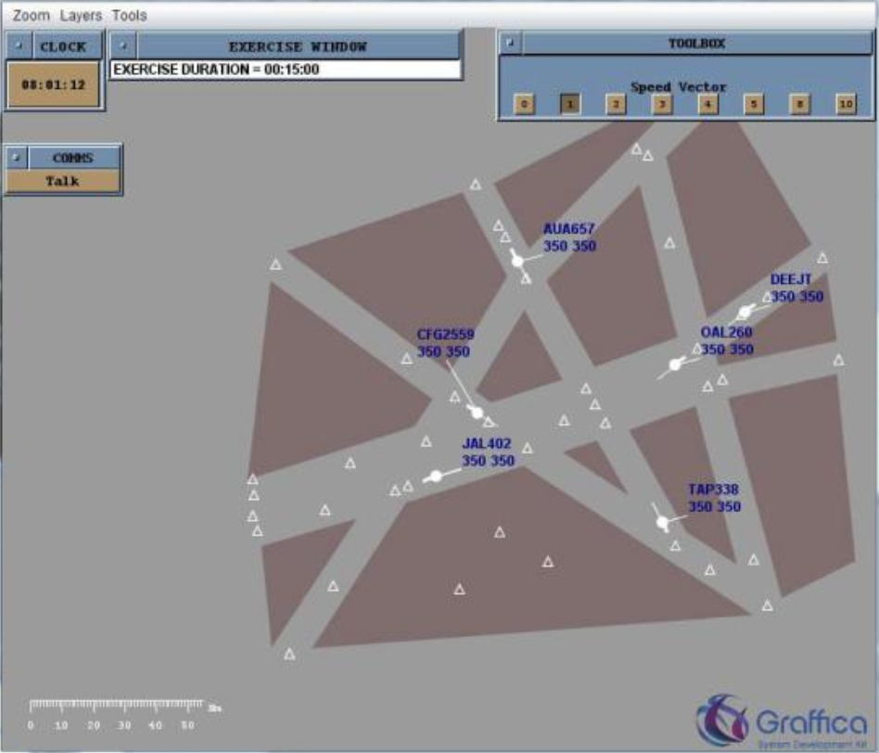
Figure 2.1. – Procedural simulator RADAR SKILLS TRAINER

For procedural simulators, exercises should be developed on the individual elements of the rules and technological procedures in air traffic control in order to consolidate the acquired knowledge. At the same time on the simulator one learner works on a specific task. This simulator can work in the mode of training and control of knowledge and skills with grading.

1.3. Modular training simulator
Modular simulators - allow you to conduct practical training at one specific control unit in the real ATC area. The simulator includes the workplace of the ATCO and the pseudo pilot (instructor). The similarity coefficient of modular trainers is higher than procedural ones. They allow you to acquire practical skills and form an core competencies of individual activities when it is necessary to make independent decisions in air traffic control. Modular simulators can be created on the basis of personal computers and installed in educational institutions and in the movement services of enterprises for conducting various types of training at one of the air traffic control centers. When using modular simulators, it is possible to simulate real air traffic control zones of various airports, simulate any air situation and conduct individual training of any degree of complexity, depending on the task. For modular simulators, exercises should be developed to develop and acquire skills in air traffic control for various complexity elements (without collision proximity or with without, if there are special conditions and special cases in flight). At the same time, the student works in conjunction with the instructor-operator who performs the functions of the aircraft pilots, ATCO of adjacent TCU and services that provide flights. One of the positive features of the modular simulator is that during the training the instructor can stop the flight plan, analyze the mistakes made and determine the correct actions in this situation or, if necessary, repeat the entire exercise from the beginning. In the process of simulator training, the instructor has the ability to creatively adequately respond to changes in the dynamics of flights of aircraft, creating non-standard situations during air traffic control. Thus, the modular type of the simulator is an indispensable tool in the process of individual training of ATS personnel with limited air traffic intensity (up to 8 aircraft in communication).
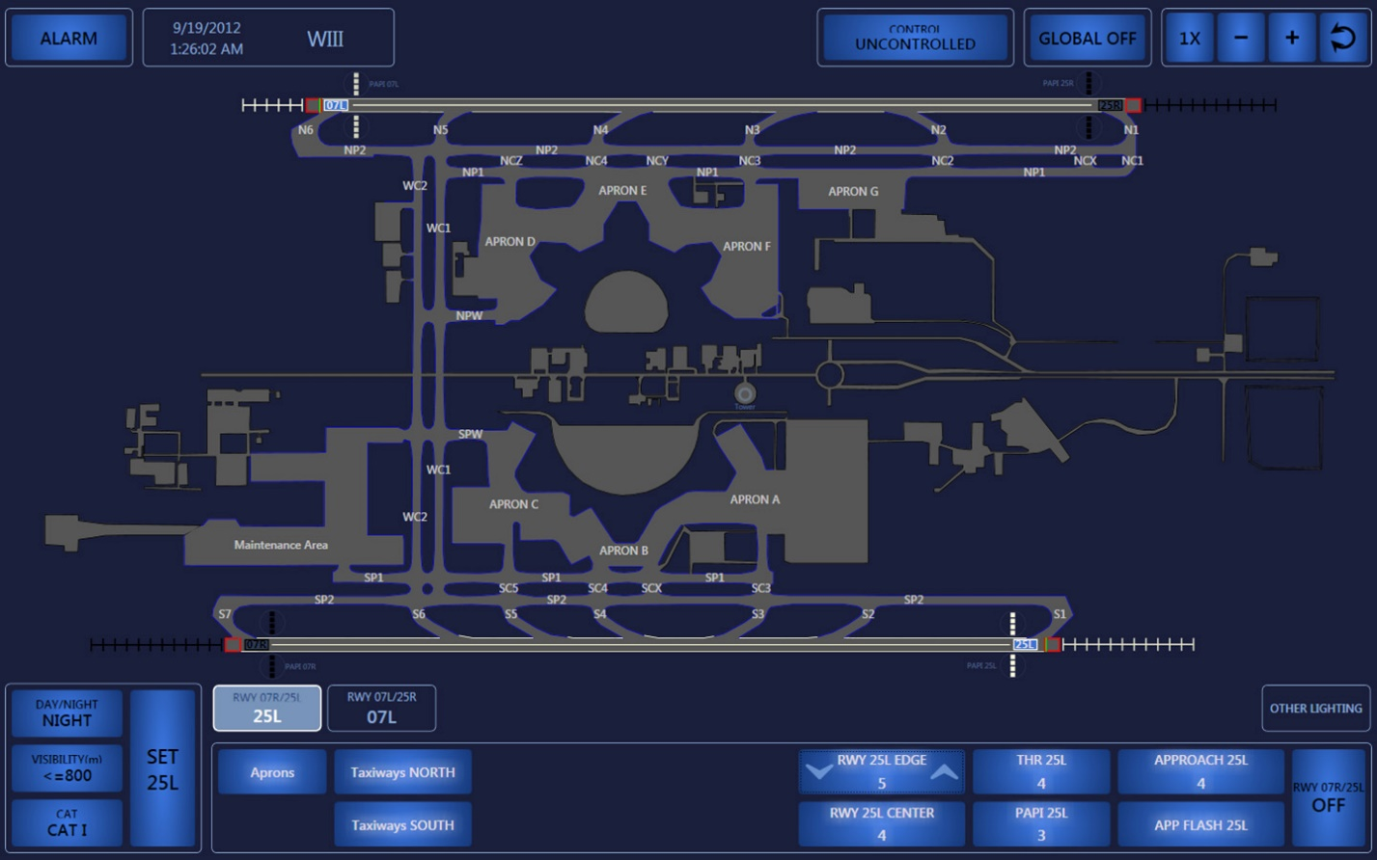
Figure 2.2 – Modular training simulator
Modular trainers can be used:
-for the acquisition of the necessary individual core competencies;
-supporting individual core competencies;
-increase individual core competencies;
-to test skills when extending the validity of the qualification mark;
-for training before the initial admission;
-when upgrading in class;
-for testing practical skills after a break in work;
-when training in connection with a change in the structure of airspace;
- to maintain the core competencies during air traffic control in special conditions and special cases in flight;
-to test practical skills after mistakes at ATC.
On modular simulators as an instructor (pseudo-pilot) should be experienced professionals who have been trained in special courses in educational institutions.
In the educational institution, training is carried out in accordance with the approved programs, and in aviation enterprises during working hours according to the schedule.
In the educational institution, training on modular simulators is carried out with the aim of:
- initial training of ATS personnel
-Increases in the classroom;
- skills testing in the presence of gross violations of the rules of the air traffic (by decision of the enterprise administration);
-certification of ATS personnel;
-checking skills when renewing a certificate;
-training by decision of the administration of the enterprise, including with admission to independent work.

The remaining types of training on modular simulators are conducted in aviation enterprises. The disadvantage of modular simulators is that they form a core competencies only for individual activities and do not simulate group activities and horizontal communications "ATCO - ATCO", "ATCO – senior ATCO", "ATCO - SARU".

1.4. Complex (integrated) training simulator
Complex simulators - allow for practical training of ATS personnel as part of a ATCO shift as close as possible to the real work of the traffic service at air traffic control and to develop skills of group activities simultaneously in the area of responsibility of all control centers. Integrated simulators have a fairly high similarity coefficient and should be installed in educational institutions, where their operation is economically significantly higher than in airline companies, since their use requires special facilities, maintenance of technical personnel, instructors and operators, and effective operational work during the year. For complex simulators, exercises of varying degrees of complexity should be developed, the same as for modular ones, but taking into account the flight plan covering the entire flight area of a specific air zone. The complex simulator provides for the joint work of pilot-operators, an operator simulating the work of ATCO of adjacent ATCU and services providing flights, instructors and trainees. A feature of the complex simulator is that it works out group activities as part of an ATC shift with the development of interaction elements provided for by the technology of work in the air traffic control process. The complex simulator is the final element of the simulator training for the ATS personnel and has the highest coefficient of similarity to the real work of the ATCO. Using a complex simulator, skills are acquired to analyze the air situation for each ATCO, not only in their air traffic control zone but also in the adjacent one, to predict its development in the general flight plan, which makes it possible to train flight managers in the organization and control of shift work.

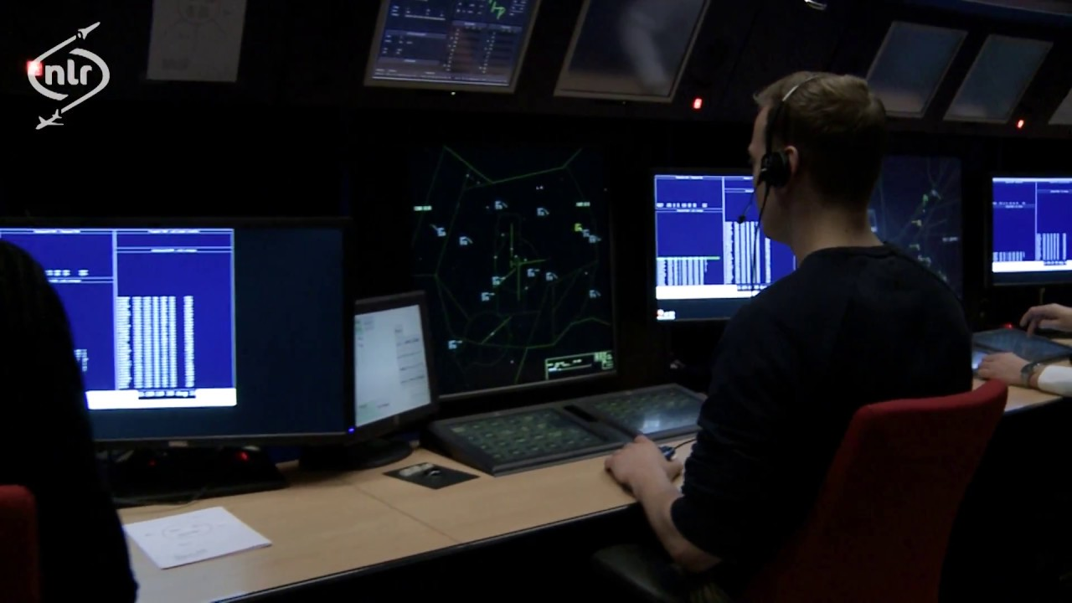
Figure 2.3 – NRL complex (integrated) training simulator

In the system of practical training of ATS personnel, the use of all types of simulators (procedural, modular and complex) is mandatory, since each type of simulator instills certain skills that can only be developed and acquired in one of the types impossible.
It is advisable for enterprises to establish procedural and modular simulators, and complex ones at training centers of educational institutions. The installation of complex simulators in an educational institution providing initial training is economically feasible.
In accordance with the requirements of the Air Code of Ukraine, training in Ukraine was carried out and is carried out in a certified training center of the Department of Internal Affairs of the State Flight Academy of Ukraine and in the training center of Kiev.

During training, the following types of simulators are used:
- digital training modular ATCO simulator "Instructor";
- digital training modular ATCO simulator "Trainer";
- analog training complex ATCO simulator "Intern";
- Digital training complex ATCO simulator AS ATC "Start".

The introduction of computer-based simulators into the ATS system will allow us to successfully improve and flexibly modify the simulator training system, taking into account the changing requirements for the work of ATS personnel.
The frequency of simulator training is determined by the timing of the destruction of the ATC skill. Studies have led to the conclusion that the destruction of individual skills in ATC
in extreme situations, depending on the level of its complexity, occurs in the range from 1.5 to 3.5 months.

1.5. General requirements to training rooms (training centers/units)
The training complex should provide the solution to the following main tasks at various levels of training for ATCOs:
-support and control by ATCOs of the required level of theoretical knowledge, knowledge of regulatory documents, technical characteristics of aircraft;
-processing by ATCOs of the skills of using information from the radar, display means and control elements located on the controllers' panels in the air traffic control process;
-treatment of air traffic control skills with air traffic controllers in accordance with established rules and standard technologies for working under normal conditions, in special cases in flight, during flights under special conditions, in extreme and emergency situations of varying degrees of difficulty, and solving conflict situations;
- development of the emergency phase of the aircraft flight and warning for the timely and targeted deployment of search and rescue operations;
-the development of skills for the interaction of ATCOs in pairs, in shifts, with ATCO of adjacent control centers and with services;
-processing the actions of ATCOs in case of failures of the used technical means, as well as when exposed to factors that limit the capabilities of these means;
- Timely identification and development of typical errors and omissions in the work of ATCO;
-selection of the optimal workplace, for each ATCO, taking into account his professionally important qualities;
- Identification of the maximum level of air traffic intensity for each ATCO and the duration of effective work at given intensity levels;
- early detection of loss of professional suitability of the ATCOs;
-prediction of the reliability of the control room the composition of shifts in critical and emergency situations;
-modeling real flows of aircraft to identify the features of the air traffic control zone, bottlenecks in air traffic control and develop recommendations for their elimination;
-identification of compatibility between ATCOs at the workplace and in the shift.
As regular goals of the creation of the training simulator are considered:
- reduction of operating costs of the airline for training and retraining of the air traffic controllers;
- providing the possibility of organizing directly at the airline self-training of the air traffic controllers;
- improving the quality of exercises for the simulator compared with the situation existing on existing simulators;
- reducing the time for developing exercises and ensuring their diversity;
- development of emotional-volitional stability among ATCO when working in extreme conditions;
- improving the efficiency of search and rescue operations due to their timely and targeted deployment;
- improving the algorithm of ATCOs work;
- identifying the features of the air traffic control zone and studying processes that occur in extreme situations;
The training simulator should provide the following types of training and control: - training, testing, simulator training and testing of the practical skills of ATCO to obtain permits for independent work at each control unit;
- advanced training of the current air traffic control personnel (upgrading in the class) for each class;
-preparation for work in the spring-summer and autumn-winter periods;
-determination (confirmation) of the level of qualification of the ATCO;
-restoration of a professional level after a break in work of one month or more (for each control zone);
- retraining of existing staff on ICAO standards;
- training and verification of the practical skills of the ATCO after he violated the rules of the air traffic control;
- simulator training and practical testing of the ATCO while extending the validity of the certificate of the ATCO of the civil aviation traffic service;
-improving simulator training and testing the practical skills of ATCO when changing in the structure of airspace;
-Training specialists for certification;
- independent training of ATCO, the development of theoretical knowledge, the study of regulatory documents;
-conducting a review of real violations, critical and emergency situations, including those that occurred in other air traffic control zones;
Training simulator should allow for the pre-training and simulator training of ATCO both in the form of organized group classes at a specific training course, and in the form of independent classes according to an individual plan.
An individual approach to training in the training center is ensured by the automated adjustment of the training program, the selection of adequate methods and the optimal set of exercises in accordance with the individual characteristics of the student, taking into account the characteristics of his area of ​​responsibility, workplace, initial level of knowledge and errors. According to the listed data, taking into account the results of the previous stages of training, an individual training program is formed. It is supposed to evaluate the speed characteristics of the ATCO to solve various professional problems, evaluate his individual throughput, etc.
Training simulator adaptation is carried out at the levels of an individual program in the learning process based on the results of the exercises performed and the exercises themselves directly in the process of their implementation.
The guarantee approach to training is ensured by objective automated control of testing and exercise processes, setting the conditions for the mandatory achievement of a certain level of knowledge, skills in the learning process, “burning out” mistakes, as well as the subsequent determination of the period of destruction of knowledge and skills with scheduling recommended retraining for each specialist. Based on the learning outcomes, individual learner models are formed (includes all stages of training and activity) and the destruction of the learner’s knowledge and skills; diagnosis and correction of dangerous trends in thinking; trends in loss of professional suitability are identified. Dynamically accumulated data are issued in the form of graphs, charts, histograms, etc. If you observe the schedule for the restoration of skills and knowledge for various critical and emergency situations and the recommendations of the training simulator associated with personality traits, reliable work of specialists in these situations is guaranteed.

1.6. The analysis of current existing simulators market
Nowadays simulation plays huge role in the process of aviation personnel training. Simulators, in the modern sense, appeared when mass personnel studying necessity arose. They are mostly used in spheres where the real life coaching may fetch serious incidents or accidents with subsequent extra cost applied. Simulator equipment usage allows reducing expenses on tuition, remains safe and efficient due to simulation conformity with real life training. According to ICAO Doc9683 “Human Factors Training Manual” about 80% of aviation incidents accidents are caused by human factor. Flight simulators are to be used by pilots. Airspace control simulators are to be used by the air traffic controllers. Anyway, both of the training processes involve phraseology and procedural practice. [7, 9]
VHF radio is commonly used in ordinary pilot - air traffic controller interaction activity. Here comes that any procedural or flight simulator should be equipped with semi-duplex VHF radio simulation module which allows precisely imitate real VHF radio usage condition. For instance beginner users don’t feel themselves comfortable using PTT(Push To Talk) button which may lead to shortened or cut phrases during radio contact.

1.6.1 FUSION MODELING COMPLEX
The limitations imposed by the simulators used to train cadets-air traffic controllers necessitated the creation of a fundamentally new simulator that would combine the positive qualities of procedural, modular and complex simulators while reducing negative sides of these simulators. To accomplish this task, a modeling complex for the operation of an air traffic controller was created and continues to be developed.
To build MK FUSION, the layout of the procedural simulator was selected with the possibility of combining air traffic controllers into workstation complexes. Such a simulator construction scheme provides the following advantages:

- mobility - operational (from several minutes to one workplace) placement of the simulator in any classroom equipped with personal computers of the appropriate configuration;
- cost - at least an order of magnitude lower than existing training facilities. The cost of maintenance and maintenance is also significantly lower compared to existing simulators;
- Realism - the creation of any training situations, including contingency and emergency;
- adaptability - the ability to simulate any sectors of air traffic control and the interfaces of most automated air traffic control systems used in Ukraine (for example, Aerotechnica and INDRA);
- individuality - MK FUSION is ideal for implementing an individual approach to the training of cadets - air traffic controllers both in groups and individually, including independently.
The disadvantages of MK FUSION include the following:
- lack of a complete list of workplaces of air traffic controllers (for example, the place of a Tower ATCO (TOWER) and a procedural control ATCO);
- insufficient elaboration of the procedures for interaction between control centers and services;
- poor reliability of the workplace - the lack of remotes of the workplaces of air traffic controllers.

1.6.2 Litaktak air solution
The Air Traffic Control Tower (ATC) tower simulator is designed to increase the “actual” training factor and, as a result, increase the level of training of air traffic controllers. Computer graphics are widely used to simulate a “real” environment.
The ATC tower simulator can be used both in standalone configuration and for comprehensive training in combination with the Area Control Center (ACC) simulator.
The ATC tower simulator includes:
- Instrumentation workstations of the airfield control tower controller (TWR);
- The terminal of the pilot working places.
The air traffic control tower simulator is designed to train controllers on a simplified, normal and complex surface of the environment and simulates air and ground movement in the terminal area. The technology used allows us to evaluate the optimal conditions for loading the airport (runway, parking, taxiways) to increase the throughput of the airport. Training can be carried out in simplified and difficult climatic conditions day or night, winter or summer.
The ATC tower simulator simulates some additional equipment in the terminal area, such as ground-based radar (SMR), fire alarms, video cameras, binoculars, runway light control, etc.
The situation at the airport can also be assessed from the perspective of a pilot.
The ATC tower simulator includes a visualization system that implements a sector or circular (360 °) view. The performance of the visualization system is determined by the computer equipment used.
The Simulator Constructor tool allows you to perform corrections to specified three-dimensional objects, aircraft coloring schemes, and introduce additional components on the runway and on racks.
From the position of the instructor, exercises can be generated both offline and in complex mode. Exercises can be recorded and played. All positions are equipped with a voice communication system.

1.6.3 ATMIS - 3D Tower Simulator
The SOFT 3D Tower Simulator provides realistic training for Tower air traffic controllers in non-working environments. 3D Tower Simulator is a full-blown air traffic control tower simulator providing an interactive, very realistic learning environment for controllers.
It realistically copies operations that provide training in an absolutely safe environment. In addition to the initial training, 3D Tower Simulator provides retraining to increase ATCOs awareness of the repeated exposure of rarely encountered airport operations and conditions. Before leaving for a change of destination, certified transmitting controllers can prepare and actually learn the operations they will encounter in their new assignment, thereby significantly reducing the training time required upon arrival.
3D Tower Simulator can be used in non-training applications. It assists in site surveys for proposed new construction at or near the aerodrome, and also assists in the planning of new runways or changes in local arrival or departure procedures in an accurate and safe simulated environment.
The simulator will be controlled by local air traffic control personnel, as it is designed for minimal support. This is a standalone simulator that the instructor can turn on, choose a training scenario and conduct training.
The simulator has nothing to do with operating systems. This is an autonomous simulation system, which requires only power outlets from the ATC center.
The main features of ATMIS - 3D Tower Simulator:
- copies any tower environment and will display information about the simulated landscape from the window in real time;
- the landscape includes the location of the airport, weather and seasonal environmental changes in the full daily cycle, radar information data and voice communication systems;
- the visual system will allow the student to detect, recognize and identify aircraft and vehicles at distances sufficient to meet training requirements;
- provides a visual display with a field of view of 30 degrees vertically and 360 degrees horizontally;
- includes a library of civilian and military aircraft (fixed wing, rotating wing), all 3D models of aircraft have moving parts, such as doors, gears, steering wheels and ailerons;
- the vehicle library contains, but is not limited to, the following ground vehicles: pickup truck, tracking car, airfield fire engines (ambulance, fire truck, pickup truck), snow blower, sedans, step wagon, mowers, luggage carts, tankers, tugs, vans and tow trucks;
- Provides a visual representation and programmable levels of weather events specific to the geographic location of each control tower. Representation of variable ceilings at all heights and the ability to display a clear, scattered, broken and cloudy sky conditions are also included;
- provides programmable levels of visibility ranging from pure to zero. The following and any possible combinations are available: fog, haze, rain, snow, drizzle, sand storms, etc.
- Weather Information and Weather Forecast ATMIS is a weather display that displays scenario-specific weather conditions and provides a 30-minute weather update, wind / altimeter / visibility in METAR encoding;
- dynamic simulation in real time, allowing: change of flight path, missed approaches, runway changes, 270-degree turn, touch and movement, exit to runways and changes in composition;
- ground control using dynamically controlled aircraft and vehicles;
- exercise management tools, simulated pause for instructing students, recording and playing exercises to improve the visual representations of students, including voice communication and real-time actions;
- Exercise preparation tools designed to load various exercises with different aerodrome layouts and aerodrome conditions.[16]

1.6.4 Aerotechnica training simulator
The control room simulator is designed for training, professional development, certification assessment of air traffic controllers, as well as for conducting research on air traffic management issues.
The ATCO simulator provides support for all the procedures and functions of the workplaces of ATCO at the air traffic control system of the terminal control area (ACC), the aerodrome control center (ATM), the airfield control tower (TOWER), and the airfield command ATC center of the armed forces.
ATCO simulator consists of training modules (TM), each of which provides training, conducting exercises, documenting and analyzing them in a minimal configuration.
TM includes:
- workplace of the instructor pilot (WP-PI);
- workplace of the planning manager (WP-P);
- Workplace of the Executive Manager (WP-E).
At each workplace (WP), communication panels (CP) are installed to conduct radio communications between ATCO and pilots.
For complex training from the workplace of the head of the simulator (WP-5V), TM can be combined into training groups (TG), into a single ATCO simulator.
In ATCOs Sim, it is possible to simulate air traffic in a user-specified ATC area. The structure of the airspace modeled in a diesel fuel contains a description of the static characteristics:
- management sectors;
- airfields;
- types and types of aircraft;
- holding areas;
- ATC points;
- tracks;
- Safety Nets parameters;
- flight restriction zones, etc.
It is possible to simulate:
- radar sources that consisting of:
primary radar (PSR);
secondary radars (SSR), including with mode S;
automatic direction finders (ADF);
- weather data;
- air traffic;
- air-ground communications.
Simulator is characterized by an average time between failures of at least 5000 hours. The service life of the system is at least 10 years.
The FDP server application runs on WP-PI and provides the creation and support of planning and exercise routines:
- creating the configuration of the area of ​​responsibility of the ATC center;
- creation of a database of technical means of providing air traffic control;
- creation of a database of aircraft types (Aircraft);
- creating a configuration of jobs simulator;
- creating a configuration of adjacent air traffic control systems for interaction;
- creating a database of system parameters and constants;
- creating an exercise database;
- conducting exercises in the structure of the created database;
- preparation of baseline data for air traffic modeling;
- enter the configuration (segregation) of the ATCO simulator;
- preparation of weather data used in modeling the movement of aircraft;
- creation of a database of flight performance characteristics of aircraft types;
- creation of a database of routes of the ATC area;
- storage and updating of the database of exercises;
- formation of a preliminary (daily) flight plan and transfer of the initial data for the exercise to the track generator;
- additional editing of routes and motion parameters of simulated aircraft before starting an exercise;
- entering system parameters and setting the training mode;
- imitation of the actions of the ADP ATCO - car departure / car landing;
- processing of planned information during the exercise (functions of the ATC server).
The exercise generator runs on WP-PI and provides after starting the exercise:
- modeling of reference aircraft trajectories based on the initial FDP data;
- modeling of weather conditions and events based on FDP data;
- correction of aircraft trajectories based on pilot commands.
The exercise generator runs on WP-PI and provides after starting the exercise:
- modeling of reference aircraft trajectories based on the initial FDP data;
- modeling of weather conditions and events based on FDP data;
- correction of aircraft trajectories based on pilot commands.
Server hardware Voice Rec. can be installed on a separate device and provides:
- communications configuration management;
- providing voice exchange of controllers and pilots;
- documentation of voice exchange.
Documentation:
- interface of controllers and pilots;
- events;
- LAN data exchange;
- reproduction of documented data and voice exchange.
Implemented as a WP-SV application.
Features
WP-SV:
- creation of the configuration of TM and TG, communication facilities;
- saving the configuration and databases of all TM and TG (exercises, sectorization and cartographic information);
- application (input) of the selected configuration;
- time synchronization of all equipment Simulator.
WP-PI:
Exercise Preparation:
- creation of aircraft flight plans;
- description of mega-event plans;
- description of events on the aircraft, at the airport;
- preservation of prepared exercises;
- editing existing exercises.
Exercise:
- setting exercise parameters;
- enter the time of day and start the exercise;
- aircraft flight control at the command of the ATCO (deviation from the plan);
- voice exchange of the pilot with the ATCO;
- voice interaction with the ATCO for adjacent units.
WP-E, WP-P:
- presentation of data on air traffic (tracks / rafts) against the background of cartographic information;
- display of SFPL flight plans, sector planning;
- automatic and manual coordination of aircraft control transfer;
- management of traffic planning on the route, during departure, during aircraft landing;
- alarm procedures Safety Nets and MONA, MTCD;
- equipment and process management;
- display of weather data, aeronautical and reference information;
- CPDLC support.
Voice communication system
All workplaces are equipped with communication panels that provide:
- radio communications of ATCO with pilots and display on the monitors of a bearing on the aircraft;
- radio communications of pilots;
- negotiations of ATCO with adjacent air traffic control unit;
- negotiations of pilots;
- documentation of all negotiations.
Administration
Setting up at any pilot workplace as an instructor:
- a description of the areas of responsibility of the FIR and the control sectors of ATCO;
- input of cartographic information;
- adjustment of system parameters of air traffic control processes.
The tactical and technical parameters of the ATCO simulator are determined by the requirements of the customer.
The aerodrome control tower simulator (TWR visualization equipment) may be included in the control room simulator.
Flight control tower simulator
The simulator of the airfield control tower is made using computer graphics technology in order to increase the “reality” factor, and, as a result, the level of training of controllers.
The TWR simulator can provide training for ATCO both offline and as part of a diesel engine.
The TWR simulator includes:
- instrumental RM of TWR ATCO;
- RM airfield pilots.
The simulator is designed to train ATCO in simplified, normal, and complex ground-air traffic conditions in the area of ​​the airfield. The simulator construction technology makes it possible to evaluate the optimal loading conditions for the airfield (runway and parking, taxiing routes) in order to increase its throughput.

Training can be carried out in various climatic conditions in the daytime and at night, in the winter and in the summer.
The simulator can simulate additional traffic control tools in the area of ​​the aerodrome: airfield survey locator, fire situation sensors, video cameras, binoculars, runway fire control, etc.
It is possible to assess the situation at the airport from the position of an aircraft pilot.
The simulator consists of a visualization system that allows you to provide a sector or circular (360 °) view. Equipment determines the resolution and performance of the visualization system.
The simulator’s designer allows you to make corrections to the embedded 30-objects of the airfield, to paint the types of aircraft, to add individual components on the runway and parking.
The instructor ensures the creation of the exercise both in stand-alone mode and for the complex training regime (as part of Simulator). The possibility of documenting and reproducing the course of an exercise is laid.
Workplaces are equipped with a voice communication system.

1.6.5 FASTNET VOICE COMMUNICATION SIMULATOR
2RC9210F is a tactical radio network simulator with the ability to introduce intentional interference. The basic structure of the simulator consists of four stands: one for the Instructor and three for the Students.
Instructor Stand:
- RRC9210 transceiver (optional);
- PC computer (monitor, keyboard, mouse);
- headset with microphone;
- GPS signal booster;
- specialized USB / RS232 converter;
- AC / DC adapter;
- chassis frame;
- transmission cables and network;
- multiport switch 10/100 Mb;
- software for the Instructor's stand;
- transport bag;
Student Stand:
- RRC9210 transceiver (optional);
- PC computer (monitor, keyboard, mouse);
- headset with microphone;
- AC / DC adapter;
- chassis frame;
- transmission cables and network;
- Software for Student's stand;
- transport bag.
Benefits
- training conducted in the audience with interaction with this walkie-talkie;
- constant supervision of the instructor over the student’s actions and the possibility of independent communication with all operators (supervision of the instructor over all “students” at the training ground is impossible due to the large distances);
- multi-stage education of operators - from basic maintenance of a radio station to more complex actions;
- the possibility of repetition of exercises;
- automatic distribution of tasks to the operator for comprehensive training of the operating modes of the radio station.
Opportunities:
- control simulators from the instructor's computer via LAN;
- preparation of radio data for work in a radio network, remote programming and deactivation of a radio station;
- imitation of a radio network consisting of 8 radio stations;
- receiving location signals from the GPS system.

1.7 The analysis of current existing voice communication simulators
In nowadays, fast-growing world of aeronautical simulators, the least position belongs to aeronautical voice communication simulators. While voice communication simulator training is very popular in maritime, naval or military spheres, the positions of voice communication simulators in civil aviation ATCOs and pilots training is much less. Depending on presence of voice communication module current aeronautical simulator are divided on:
- Simulator with integrated voice communication module;
- Simulator with external voice communication module (without voice communication module);
More than half of complex training simulators are equipped with voice communication module but these modules are usually computer based or virtual based. This means that voice communication module is fully digitalized. With all its pros it has also a lot of cons.
The pros (advantages) of digital or computer-based voice communication module are:
- Low price (only software shall be purchased);
- Flexibility. A large pool of settings and emulation modes;
- Size. As it is a software-based, there is no necessity in extra hardware;
- Large distance between stations.
Cons (disadvantages) of digital or computer-based voice communication module are:
- Realism. As all software-based simulators fully digital it is hard to emulate all features of a real VHF/HF aeronautical radio.
- Ergonomics. Using software-based simulator module means that you don’t have additional equipment such as intact headphones mike and push to talk button, thus students shall use regular headphones with mike. In such case as a PTT button is usually used spacebar keyboard button which absolutely different from real radio usage.
Unlike software-based training voice communication modules, device-based training communication modules are closer to real usage. The main and vital difference is that such modules gives a real feeling of radio station operation. From their name it is understood that this kind of voice communication simulators are performed in a layout of standalone device that is much close to the layout of real VHF/HF radio communication unit. Anyway, such devices also have their advantages and disadvantages.
Pros of device-based communication training module:
- High ergonomics. Device-based station looks and controls just like a real station module, has an idem adjustments and feels like a real one. This helps to gain touch and control abilities;
- Just like real usage. The sensitivity of push to talk button, mike to mouth operation and channels adjustment. So many factors can affect on coaching of student ATCO specialist;
- Real hearing. Analogue voice sounds just like in real station where voice(sound) is transmitted. Unlike it, digital sound is always different in a native characteristic.
Cons of device-based communication training module:
- Extra space needed;
- Low adjustments;
- Line in sight distance between stations.
From all above mentioned, it is understood that there is a necessity in such VHF training modules for aviation studying market. These modules are used by the universities, training centers etc. Sometimes such modules are integrated into complex or procedural simulators e.g. Full flight simulator. Otherwise these modules can be independent from simulator itself and be installed for any simulator needed e.g. maritime, subway, aeronautical, submarine simulator etc. Although they could be used as standalone radio training solution for police, fire fighters, medical brigade, search and rescue troops etc. But such standalone or independent systems are always computer-based. It means that you can’t use same machine for radio and e.g. for air traffic control simulator simultaneously. [10]
Here comes true that such systems are only presented on a market as a software program to be installed on computer machine furthermore even if they are presented as standalone device-based unit, they are always appearing to be a part of a complex simulator.
The highest number of solutions presented is for maritime simulation market and often goes as a part of navigation or SATCOM simulator etc. Computer based (software) and standalone device-based simulators shares market 50 by 50 with an only common disadvantage of their complexity, maritime targeting and high cost. [11]
Software based simulator is a great solution in case when there is a necessity to practice only in communication, without control simulation training. Such software can be divided by professional (radio sim) and amateur (TeamSpeak, RaidCall). Unlike professional software, amateur software doesn’t support semi-duplex communication. Semi-duplex radio communication means that you have to push PTT button to speak (transmit) and release to hear (receive). If both students will push the PTT button simultaneously neither of them will hear anything. In case of using duplex radio simulator as teamspeak or raidcall, both students will here each other in mentioned above situation which doesn’t correspond to real radio usage. That’s why radiotelephony training with PTT semi duplex radio simulator is so important.
It is obvious that necessity of a standalone semi-duplex device-based module presents on a market of simulation training.
Although, there is no doubts that a pair or more of regular small radios like “Voyager Air Soft” can compete in these segments but there are some pros and cons of their usage:
- Independence of any other device
- Comparatively low price
- Easy to purchase
- Easy to repair.
- “Perfect Simulator” – real device that works on principles used in aeronautical maritime and other spheres.
Disadvantages:
- Lack of free channels – only about 8 channels are allowed for public usage, as these devices are very popular in nowadays town, where universities are always situated it is hard to find free “clean” channel.
- Impossibility to control noise – noise is a frequent condition in radiotelephony so that it is very necessary to imitate noise for training, that is impossible using real powerful devices in a small area
- Inability to record the training process- sometimes it is very necessary to record training process because during the training it is often hard for instructor to correct mistakes, so it is very suitable for instructor to listen the recording afterword’s and make a short debriefing correcting mistakes.

Conclusion to chapter 1
The performed research showed that the market of aeronautical simulators has a lot of interesting solutions for simulator training of air traffic control officers and almost half of them are equipped with integrated voice communication module but the other half (almost all software-based) do not have an integrated voice communication module or the realism of these module is not that close. A huge role should be given to external push to talk button and mike. A large amount of device-based VHF/HF voice communication radio simulator are built for the maritime purpose. Thus comes the conclusion that the necessity of standalone device-based VHF/HF voice communication simulator solution is pretty height in order to satisfy the necessity of external voice communication simulators for ATCO simulators which are not equipped with integrated one.

CHAPTER 2. TECHNICAL FEATURE AND STRUCTURE OF AERONAUTICAL SIMULATOR
The International Civil Aviation Organization (ICAO) has researched a list of features for the assessment of Doc 9625 simulators. The purpose of this guide is to provide civil aviation departments with methods for the qualification assessment of a flight simulator through initial and subsequent predictions of the simulator. The Flight Simulator Design and Performance Data Requirements document, released by the International Air Transport Association in 2009, is associated with Doc 9625 which shows the requirements to information background of simulator structure. Although, the Flight Simulator Estimation Handbook, a technical assessment guide, was released that same year that described the scheme of tests required for proper certification. Similar documents were also performed in Ukraine. Then building the simulator, the creators faced with the task of checking the simulator's compliance with the real device. As a rule,more than 70% of the solutions creation time is spent on development math model of an object. It is really hard to emulate the all operator’s actions performed on a natural environment of the simulator. The way out of this situation may be the automatic supply of input signals to the simulator, taken from the records of the real system. Please note, after estimation of simulators certificate level according to FAA or JAA requirements, making changes to structural elements, software, etc., including updating the simulator components, can lead to changes in the characteristics of the entire system, and the simulator itself may not be corresponding to the previously assigned level. Unfortunately, the necessary list of requirements and relevant regulatory documents for training and training systems in this area is difficult to access.

2.1 The regulatory framework for the construction of aeronautical simulator-training systems
Training systems are developed by organizations around the world. The leaders in terms of the number of staff training tools created are CAE (25%), Thales (15%), FSI (15%), L-3 Link (11%) (the percentage of the total number of developed tools is indicated). The share of Russian manufacturers is estimated at 2%. For civil aviation, the ratio of the number of operated aircraft to the number of simulators used is as follows: USA - 14.1, Canada - 38.6, EU - 16.9, Russia - 77.0 [17]. Thus, the task of creating simulators for training personnel that meet modern standards in Russia is relevant [18, 19].

The International Civil Aviation Organization (ICAO) developed criteria for the evaluation and qualification of simulators [20]. In 2009, the third edition of the Guidelines for the Qualification Evaluation of Aerobatic Trainers ICAO Doc 9625 was released, which is advisory in nature. This manual establishes the requirements for the characteristics and documentation necessary for the qualification of aircraft flight simulators used for training and periodic inspections of flight crew members. The purpose of this guide is to provide the State Civil Aviation Authority with methods for qualifying the flight simulator through initial and subsequent periodic simulator evaluations. The described methods allow civil aviation departments of other states to recognize the qualification assessment given by the state that conducted the initial and periodic assessments of the flight simulator. The International Civil Aviation Organization, a specialized agency of the United Nations, was created as a result of the signing of the Convention on International Civil Aviation in Chicago on December 7, 1944. ICAO is a standing body that implements the principles laid down in the Convention. ICAO sets standards in the areas of safety, security, efficiency and regularity, as well as environmental protection from the effects of aviation [21]
The European Joint Aviation Administration has also developed JAR-FSTD A: Aeronautical flight simulation training devices 2008, compiled by combining JAR-STD 1A, Aeronautical Flight Simulators, JAR-STD 2A, Flight Training Devices, JAR-STD 3A, JAR-STD 4A . JAR-FSTD A describes four categories of full flight simulators level A – D simulator systems, where Level D simulators belong to the highest qualification category. In addition, flight training devices and flight & navigation procedures trainer training systems are classified into three levels, as well as basic instrument training device.

Similar documents were also developed in Russia:
- Standard for the qualification assessment of aircraft flight simulators “Standards of validity of aircraft flight simulators for training air personnel in air transport”;
- Requirements for the source data package for the design of the flight simulator in accordance with IATA Flight Simulator Design and Performance Data Requirements 7th edition;
- Methods for assessing the compliance of aircraft flight simulators with the requirements of NGAT.
If national standards are approved, the question arises about the procedure for training specialists on simulators that were built before the adoption of the standard. There is one solution: to train specialists only on those tasks that can be solved on such a simulator in accordance with the requirements of ICAO [7].
In addition, the following documents were also issued in Russia:
- Order of the Ministry of Transport of the Russian Federation dated July 31, 2009 No. 128 (as amended on November 22, 2010) “On approval of the Federal Aviation Rules“ Preparation and execution of flights in the civil aviation of the Russian Federation ”;
- Order of the Ministry of Transport of the Russian Federation of September 12, 2008 No. 147 “On Approval of the Federal Aviation Rules“ Requirements for Aircraft Crew Members, Aircraft Maintenance Specialists and Civil Aviation Flight Support Officers (Flight Dispatchers) ”;
- Order of the Ministry of Transport of the Russian Federation of September 12, 2008 No. 147 “On Approval of the Federal Aviation Rules“ Requirements for Aircraft Crew Members, Aircraft Maintenance Specialists and Civil Aviation Flight Support Officers (Flight Dispatchers) ”;
- Order of the Ministry of Transport of the Russian Federation dated July 31, 2009 No. 128 (as amended on November 22, 2010) “On approval of the Federal Aviation Rules“ Preparation and execution of flights in the civil aviation of the Russian Federation ”;
- Order of the Federal Antimonopoly Service of the Russian Federation dated January 29, 1999 No. 23 “On the Enactment of the Federal Aviation Rules“ Certification of Aviation Training Centers ”;
- “The standards of validity of flight simulators for the training of aviation personnel in air transport”, approved by the FAS Russia on 05/15/98 with Supplement No. 1 of 07/18/2000;
- FAP "Certification of Aviation Training Centers", approved by the FAS of Russia No. 23 of January 29, 1999.
On May 18, 2010, on the territory of TsAGI in the city of Zhukovsky, the first meeting of the "Flight Simulators" section of the Scientific and Technical Council of the Ministry of Industry and Trade of the Russian Federation was held, the main tasks of which are the development of aircraft simulator building in Russia, as well as the formation of an examination and certification system for flight simulators and other technical training aids.

After building the simulator, the developers are faced with the task of checking the simulator's compliance with the real device. Up to 80% of the development time of the simulator, providing adequate modeling, is spent on testing the mathematical model of the object. Often, the causes of identified errors are difficult to determine due to the large number of interacting systems. For verification, it is necessary to compare the data obtained during testing of a real system with the data generated by the simulator. For comparison, it is quite difficult to reproduce on the simulator all operator actions performed on a real system. The way out of this situation may be the automatic supply of input signals to the simulator, taken from the records of the real system. In real systems, additional emergency automation systems can be provided, which, for example, alert the operator of the possibility of a dangerous situation. The simulation of such systems also needs to be checked for the possibility of false alarms and, most importantly, to check for mandatory triggering of alerts when the system goes into unwanted or emergency modes of operation.
The model verification process can be conditionally divided into two stages:

- checking the parameters of the modeling systems for compliance with the measured parameters on real systems (static tests);
- verification of the output parameters of the modeling systems depending on the input signals (dynamic tests).

At the stage of dynamic tests, for a given set of parameters, the value of one parameter changes and the behavior of the system is investigated. In the testing process, it is necessary to conduct several measurements for each parameter in conjunction with a changing input set. A situation arises in which conducting a large number of tests increases the amount of information studied and the complexity of its processing, on the other hand, with an insufficient number of tests, it is possible not to reveal incorrect model behavior. Therefore, special attention should be paid to the collection of information during verification: write down the version numbers of all software, the entire array of input parameters, and possibly the details of the person who conducted the tests. Dynamic tests also include expert assessment of instructor operators when performing certain tasks on the simulator [23].

Delays in the operator-simulator circuit occur for a number of reasons. First, it takes some time (0.3–0.5 s) for the operator to receive information from the simulator, comprehend it and perform some actions. It is assumed that the time of this delay when working on the simulator and on the real system should be the same (without taking into account the psychophysical component when controlling the real system) and is not taken into account when evaluating the parameters of the simulator. The second reason for the delay is the process of transmitting and converting control actions, in which the input signals are converted into signals available for processing in the system. The next reason is the process of obtaining and processing input signals in the modeling subsystem. And the last one is the process of obtaining and processing information in the visualization subsystem. In the general case, the delay is the time between the operator entering information and the system response, expressed in a change in the information-control field, and it is important to know the maximum value of this parameter. For example, if the delay is 20 ms, its increase at some point in time above the permissible value will reduce the update frequency and, therefore, may lead to an increase in the calculation error. To determine the magnitude and source of the delays, it is necessary to use diagnostic software and hardware. It should be borne in mind that in modern distributed training systems, a delay of 1-2 update cycles is inevitable. For example, in civil aviation simulators, acceptable delays are:
- according to ICAO 9625 A: 100 ms for simulators of levels V and VII, 200 ms for simulators of levels I, II, III, IV and VI;
- according to JAR-FSTD A: 150 ms for AT levels C and D, 300 ms for AT levels A and B.

The procedure for estimating the delay time itself may distort the results. It should be borne in mind that the output of information on the screen, as well as recording on a permanent storage device, consumes resources from the subsystem of data display and storage. It is advisable to store data in RAM until the end of the information collection cycle, and only at the end of the recording can output or save.

Based on ICAO Doc 9625 Manual of Criteria for the Qualification of Flight Simulation Training Devices (2009), the generalized requirements for the visualization subsystem of the simulator systems of civil aircraft are formed.
To simulate visual cues, you need the following:

- full compliance - reproduction (repetition) of a real visual environment in perspective, creation of conditions for accommodation of eyes to infinity;
- compliance in the main - modeling of the real visual environment in the future;
- general signs - general signs of a real visual environment in the future, sufficient to perform a simple instrument flight, instrumental approach.

Environmental modeling (airfields and the earth's surface):
- full compliance - reproduction (repetition) of the real environment with the highest possible accuracy for any given location;
- compliance in the main - modeling of the real environment;
- common features - simple modeling of the main features of the real environment.

In Russia, the Regulation on the Federal Air Transport Agency (FAVT) does not define the concept of qualification of flight simulators, therefore, work on the approval of new simulators for the training of civilian aviation personnel in the country includes the following:

- examination of evidence based on the results of preliminary (factory) tests of simulators;
- flight assessment of the characteristics of simulators by subjective criteria;
- assessment of the possibility of implementing flight training programs on simulators taking into account the educational and methodological capabilities of simulators;
- execution of an act (conclusion) on the possibility and conditions for issuing permits by the Flight Operations Administration of the Federal Aviation Administration for the use of a simulator according to approved programs [25].

When choosing a simulator developer, the following parameters should be considered.

Limitations, namely the presence in the products of the developer

- export restrictions;
- technologies that do not allow their use by other suppliers of simulators;
- protected intellectual property with restrictions on use.

Dates:

- the deadline for the development of the first copy of FSTD from the date of receipt of the initial data and purchased component parts by aircraft to RFT (the simulator is ready for training);
- the period of warranty after-sales support FSTD;
- delivery time for spare parts from the date of request;
- the developer’s willingness to change the schedule during delays in the provision of raw data and / or purchased component parts.

The delivery of the first simulator in a configuration with relevant on-board equipment (especially avionics) for an aircraft that has just passed the development stage, in some cases, occurs with a significant delay. For operational training of personnel, it is allowed to supply a simulator of a lower level, for example, without a mobility system and a collimation system. To accelerate the development of such a simulator, it is advisable to use the cockpit of one of the test benches (strength, technological, bird resistance, etc.) that have completed the test program, or it is possible to finalize the engineering simulator.
Data and software requirements are described in the following Aeronautical Radio, Incorporated reports:

ARINC 440 - Guidance on the provision and maintenance of equipment-related data;
ARINC 441 - Guidance on the provision of binary software for educational and training purposes;
ARINC 442 - Guidance on the provision of models based on a control card / source program for educational and training purposes;
ARINC 610 - A design guide for hardware and software designed for use in flight simulators.
When developing mathematical models for the simulator, the use of specialized software systems can complicate the procedure of maintaining the model during operation, since the specialized software complex is the intellectual property of the developing company. With the appropriate agreement of the developers to successfully solve this problem, it is possible to create mathematical models using widely used programming languages, for example C ++. The manufacturer of the simulator can use the mathematical model in executable codes (Soft Package) [27].

2.2 Typical functions of the workplace instructor of the aircraft simulator
The development of aviation simulators that simulate the operation of the aircraft and the environment for the training of piloting flight crews, most often referred to as flight simulators in the Russian Federation, is carried out all over the world. Studies of the technical components of simulators show that the simulator complex can be divided into several parts, one of which is software hardware complex of the instructor’s workplace. Therefore, as a rule, in the aerospace industry, each simulator developer faces the task of creating software instructor’s workplace.

This software allows an instructor teaching piloting an aircraft to set flight training parameters, to monitor and control the simulator subsystems. Very often for each developer training software is unique, but, nevertheless, the general and main functional tracked by all manufacturers of flight simulators.
The article discusses typical software features

instructor's workplace, as well as the logic of interaction of this software with simulator subsystems.
All modern flight simulators include instructor workstation software.
This work is devoted to the technology of building a component of aircraft simulators, namely
RMI, it also discusses in detail the approaches to its construction. Manufacturers of flight simulators often have to individually design this component for their computing platform. However, identifying typical RMI functions can provide the ability to quickly prototype software, which will greatly simplify and reduce the time required to develop this type of software.

The functionality of this software is aimed at setting parametric information on-board equipment and controlling the simulator during pilot training. The purpose of the study covered in the article is to find the typical and basic functions of software
RMI used in pilot training. The subject of study was recommendations of aviation standards used in the development of simulators, literature
in this subject area, as well as consultations with practicing training by pilot-instructors.

The main users of this software are instructor pilots. They should develop pilot training programs, flight training methods, and be able to put into practice the methodology for performing maneuvers and flight procedures, according to which they intend to conduct flight training.
In accordance with the guidelines for the training of pilots, the holder of the pilot-instructor qualification must have knowledge of the human capabilities applicable to flight training, as well as the dangers associated with simulating aircraft system failures, to be able to control independent flights of cadet pilots, conduct flight training necessary for issuing certificates of a private pilot, commercial pilot, multi-crew pilot and for entering a qualification mark on the right to fly on instruments and the qualification mark of the instructor pilot.
The main tool in training the pilot simulator during the flight session for the instructor pilot is the RMI software, by means of which he can set the training parameters and the disturbing effect on the subsystems, control the simulator operation. In civil aviation, in full-flight simulators, RMI is located in the simulator cabin, military aviation simulators outside the simulator, which does not affect the typical set of software functions.
RMI software is an application program using a graphical user interface, with a system module for initializing and inputting / outputting data from the simulator subsystems.

The general principles of building RMI software are complexity, which is implemented by creating a system that is flexibly customizable for work with a different combination of software and hardware, and modularity, which is implemented by sequentially dividing the structure of the entire program into program modules, which should provide an extension functionality.
In order to provide the instructor with the opportunity to train pilots in aeronautics using previously developed techniques, this software has control elements for the graphical user interface, by clicking on which the instructor can set a disturbing effect on the simulator subsystems, change the numerical values ​​of the simulator subsystem parameters, and also display elements of the necessary parameters to It was possible to follow the correct pilot training.
The structure of the RMI program can be divided into the following components:

- a software module of general functionality, including processing control elements of the graphical user interface of the application;
- an interface software module for the exchange of information of the RMI application with the subsystem’s simulator.

In turn, the software module of the general functional includes the following components:

- software module graphical user interface;
- general application settings module, interacting with elements of the graphical user interface of the application;
- a model of interaction with the interface level of the application for changing and indicating parameter information through a graphical user interface.

At the interface level, the RMI software module interacts with mathematical models that simulate the operation of on-board systems of the aircraft.

Since the key factor in the creation of RMI software is its functionality, more often than not, for the development of this type of program, they choose the FDD Agile methodology (Feature driven development Agile), based on the modification of a flexible (Agile) methodology, an approach to software development driven by functionality, which includes There are five main activities:
- development of a common model;
- compiling a list of necessary system functions;
- planning work on each function;
- design functions;
- implementation of the function.
The functionality of the RMI software is similar to that of the entire flight simulator as a complex of computational systems with mathematical models, since it affects the management of all simulator subsystems during pilot training.
Mathematical models of the aircraft, simulating the operation of subsystems, are the main components for any simulator.
According to the recommendations of the ARINC 610 standard, revision C of the Design Guide for Aviation Equipment and Software for the Use of Educational Devices (Guidance for design of aircraft equipment and software for use in training devices), non-standard procedures for the aircraft (functions) in the simulator can be divided into three main categories.
Initial conditions, reposition, freezing parameters, which, as a rule, is reflected in the graphical user interface of the program. RMI software interacts with mathematical models of the aircraft and allows you to set flight training parameters and initial conditions, such as the geographic location of the aircraft, altitude, speed, fuel filling of the aircraft, weather conditions and parameters of external influences, such as temperature, pressure and wind.
An earlier version of the ARINC 610 standard for the design and integration of aeronautical and electronic equipment in simulators mentions IATA recommendations for the use of seventeen basic simulator functions, which are reflected in the RMI software.
The functions of the RMI software, as well as the functions of the simulator, can be divided into the following categories:
- simulation control,
- script training settings,
- optimization,
-installation of maintenance
-specific functions for military use.

The management and interaction functions of the RMI software are grouped in a graphical user interface, taking into account the above categories.
During the training session, the so-called freezing of the state of the aircraft may be necessary in order to suspend training, give the crew additional instructions or discuss his behavior. These functions may require complete freezing of the simulation process or stopping of some selected airplane parameters. During the freezing of the flight, the aircraft’s movement stops, while the aircraft systems (mathematical models simulating the operation of the aircraft systems) continue to function normally and the information exchange is preserved. To do this, in the functions of the RMI, there are buttons for the graphical user interface: freezing flight, location freezing, altitude freezing, fuel freezing.
Typical examples of how the instructor uses the freeze function during pilot training are the following situations.
- If the crew flies out of the range or makes a mistake in the piloting process, the instructor pauses the simulation in order to discuss this situation with him.
- When moving to the next training task, simulation freezing may allow learners to establish an altered aircraft configuration without performing a flight with an extended maneuver. For example, freezing the position of an airplane during an approach gives time to reduce the landing speed and select the correct flap position.
- At the end of the flight, it may be necessary to freeze the simulation before transferring the simulator to another pilot in order to continue flying in the conditions that have just been established.
- During the maneuver, the instructor can freeze the simulation in order to explain the function of the system or a state that is transient and disappears at the end of the maneuver.

During the operation of the simulator, frozen parameters (variables involved in the information exchange) remain constants, and the information exchange is stored with a given cyclogram. During the training session of the flight crew, a relocation may be necessary.
the position of the aircraft (reposition) or external influences corresponding to the training task. Using this function of the RMI software leads to a change in the geographical location of the aircraft, altitude, course, speed.
This function of changing the location of an airplane relates to setting the conditions for the maximum take-off weight of the aircraft and visibility conditions of category III or landing conditions when approaching with a crosswind. Change of parameters can be expressed in step change

to a new value or by turning as a continuous dynamic change from the initial value to the final one. For example, an instructor can rotate a plane. The number of variable parameters in accordance with the pilot reference includes latitude, longitude, course, altitude and airspeed; fuel remaining, resources and payload; external influences such as temperature, pressure and wind conditions.
During the flight session (pilot training session), it may be necessary to preserve a specific simulation setup and later make it available for re-calling during the training session. The instructor can use the frame recall function to save the parameters of the aircraft at any time without interrupting training. The function of recalling the frame can be useful if the instructor wants to be able to return to a specific point in the student learning scenario. This can also be used to set up the initial set state. Frames can also be used to maintain the state of specific aircraft systems. The flight plan frame of an aircraft navigation system is the most common example.

For each specific aircraft model, a set of subsystem failures is fixed. The main typical functionality of the program includes the ability to simulate, set failures of sub-systems of the aviation simulator during a training session.
The main purpose of aerobatic training equipment is to safely teach abnormal and urgent procedures. The instructor should be able to establish and remove failures during the simulation of the flight simulator flight equipment in such a way that all emergency and emergency cases in the training programs can be properly absorbed, but without the time-consuming reconfiguration at the end of each training scenario.

Failure can be defined as the only physical element of an aircraft that has failed. The effect of failure will extend through the entire simulation in the same way as on an airplane, with physical influence, indication of the cockpit systems, warning messages and alarms.

In all these cases, the software should provide for the possibility of using other modeling functions, such as freezing or moving, and resetting the cockpit indicators and aircraft systems to the state of no failures at the end of the training scenario.

The training for piloting military aircraft and the training for piloting civilian aircraft have much in common, but piloting military aircraft requires the development of additional functions that are often required for training tactical operations.
Frequently encountered additional functions of the RMI software are the functions of meteorological report messages (ATIS - Automatic Terminal Information Service, an automatic information transfer service in the aerodrome area), and tracking of the flight path using navigation charts.

Thus, in order to provide flexibility of tuning for any level of the simulator and its computing network, to increase the functionality, as well as the possibility of using simulators that require real-time computations, the structure of the RMI software should be characterized by modularity, which means the logical separation of the program components into sub grams.
To provide the instructor with the opportunity to train pilots in aeronautics using previously developed techniques, parameters are set by pressing the buttons of the graphical user interface of the RMI program, thus setting the disturbing effect on the simulator subsystem.
The objects of automation are mathematical models of the subsystems of the aircraft, simulators of real instruments on-board electronic equipment and the external environment for visualizing the cockpit space.

Flight simulation is implemented by mathematical models of aircraft aerodynamics, aero-elasticity, automatic control system, power plant, avionics, atmosphere and others.
The mathematical models used to simulate modern aircraft consist of a massive set of nonlinear differential equations with a large amount of data (tabular representation, presented in the program code as n-dimensional arrays), aerodynamic functions, sometimes depending on 4-5 variables , arbitrary discrete and continuous functions, as well as many restrictions imposed on the state of various aircraft systems.
From the obtained forces and moments created by these systems, the computing complex creates and solves the equations of motion using an adequate integration algorithm. This allows you to simulate the full range of static and dynamic operating conditions of aircraft, including landing and take-off (landing / take -off), ground handling and emergency situations, such as engine failure, loss of speed, failure of subsystems.
If the simulator level requires the use of real-time flight simulation systems, the computer must perform all calculations in a mathematical model (s), including data exchange (input / output) during a clock cycle, like on a real plane, to achieve the highest accuracy .
During the call by the instructor and performing all of the functions mentioned above, the information exchange of the RMI software system module from the simulator subsystems is saved. During the studies conducted during the flying sessions by the instructor pilots, it was found that the existing software solutions of the RMI of civil subjects, as a rule, have a user interface on English language. For new developments of this type of software, a desire was also expressed to use English in a graphical user interface. This requirement is due to the fact that all messages to pilots in the cockpit, warnings about equipment failures are issued in the international language - English.

Also, in consultations with instructor pilots, it was revealed that the most frequently used functions in pilot training are flight freezing,
control the power supply on board, create a snapshot - instantly save the parameters of the simulator's parameters for analyzing pilot behavior after training.
When learning to fly, instructors tend to
use the following algorithm.
1. Setting the initial location of the sa-molet (reposition).
2. Setting the weight of the aircraft.
3. Installation of weather conditions.
4. Installation of additional parameters (inertial system setting, etc.).
5. Performing equipment failures, if the exercise requires it.
Based on the foregoing, let us single out a set of RMI software functions typical for flight simulators, sufficient for designing a program with basic functions for further modification and adding individual parameters for a specific airplane model:
- setting up the state of the system and external conditions for building a learning scenario;
- freezing;
- instant change of location (re-position) of the aircraft;
- simulation of aircraft subsystem failures;
- optimization of the implementation of educational tasks and service functions of the program.

2.3 Design principles for the modular architecture of aviation software
Software design is an integral part of any project, the fundamental foundation of future development.
The software implementation of the interaction algorithms of software modules and their information exchange at the hardware level ensure the correct functioning of the developed system.

In a group of developers, it is necessary to correctly distribute and coordinate efforts to create software, while a clear definition of the structure (architecture) of the program being developed is of great importance.
Often when initially designing the structure of a software product at the stage of development or maintenance, a problem arises of regression of the program code, when further development and maintenance are impossible.
The objectives of the study of software architecture design methods were to identify, optimize and unify the proposed solutions for software development for use in the aviation industry.
As a result of studying the experience of using the modular software structure by Rockwell Automation, studying foreign scientific sources describing the possibility of using a modular architecture in software development, as well as analyzing the software technologies used in practice in the aviation industry, it was found that the main aspect of high-quality software design for The application in this area is modularity. This approach provides flexibility and scalability of the developed product, ease of maintenance, and resource saving.
Design Methods for the Flight Simulator Software Architecture.
Consider the methods of designing software architecture using the example of a full-flight simulator. Using a modular software architecture in simulators involves simulating each physical system in a separate software unit. With a modular construction architecture, program blocks can be created independently of each other and combined into a system to obtain the necessary results.

The solution to the problem of the correct interaction of software modules is the use of data transfer algorithms from module to module. This task includes both the implementation of logical connections between program blocks, and the exchange of system information with interacting subsystems, while in the software architecture it is necessary to single out the program module (s) of the interface exchange.

When designing the architecture of the entire aircraft flight simulator system, its components (program blocks) can be conditionally distributed according to the levels of interaction. As a rule, five levels of distribution of program blocks are distinguished in software architecture.

The paper presents the architecture of the flight simulator software in the form of program blocks or modules hierarchically distributed by levels. It also defines software architecture as the structure of an airplane modeling software package. At the highest level are software blocks designed for transformation and presentation of the result of all generated (received) at lower levels of information in an interactive form. This level also contains routines that describe the graphical user interface. This is a user-oriented structure and contains information about the routines that must be executed, job management. The level is intended for the presentation, preparation and rearrangement of all internal information into an interactive presentation for the user, as well as for human-machine interaction.
The next, second, level includes the initial conditions of the calculations and the actual modeling process. In addition, two additional parts are included at the beginning and at the end, respectively, where the data is read or stored and where it is convenient to carry out data conversion and translation of information.

When simulating a flight, as well as using methods of software implementation in real time, a cycle with a countdown is used. The third level contains calculations of the state vector of the time derivative and the output vector of the complete system in increments. At this level, information is exchanged: the full result of the input signals, calculated from different sources, is transmitted to lower program levels.

At the fourth, software level, the program modules contain the actual mathematical model of the aircraft, while the program modules of the first three levels are independent of its type and model. The fourth level software modules have access to the database and arrays contained at the fifth level.

The last, fifth, level contains a database, the arrays of information necessary for calculations at higher levels, a separate set of subprograms (program modules) for interpolating data in tables, configuration information, and the arrival of new data.

An example of the application of the described architecture is the implementation of aerodynamic models of the simulator aircraft Boeing 747 and Fokker F28.

An airplane can be thought of as a relatively small structure moving through the atmosphere under the influence of external forces and moments. The mathematical formulation of these relationships between an airplane and external aerodynamic forces and moments is usually described in the aerodynamic model as a software module. Since the motion of particles of coherent systems can be expressed in a generalized way, mathematical models of various types of aircraft, in the first place, differ in the corresponding aerodynamic models. Initially, the data for the construction of the aerodynamic model Fokker F28 were presented in the form of graphs. Such a representation requires transformations into a form convenient for programming; in this case, separate sets of tabular data representations are stored. Intermediate points can be found by numerical interpolation.
The mathematical model was also linearized from a set of reference states using the numerical linearization procedure. In addition, by introducing cross-references to the original graphic representation for a wide range of initial conditions, the representation of linear systems, further simplification of the aerodynamic model by eliminating minor negative effects is allowed. Since aerodynamic models are contained in separate software modules, they can easily be copied to target applications, especially for target applications with a similar modular structure. Updates to the aerodynamic model can also be implemented by updating separately stored coefficients or replacing a separate module.
An example of a modular approach to building software in the development of flight simulators is the block diagram of the flight simulator module of the Tu-204 flight simulator, shown in Figure 1, where the following notation is adopted: CNS-85 - computer navigation system, CSFC-85 - computer system flight control, CSFC-85 - traction control computer system, EDS-85 - electronic display system, IR - true heading, RTS - runway touch sign.

In this example, the simulator simulates the movement of an aircraft in space by solving a closed system of nonlinear differential equations in the corresponding program blocks, where the input parameters are the control actions of the crew, and the output parameters are the calculated flight parameters.

To ensure the similarity between real and simulated aircraft flights, continuous calculation of flight parameters in real time is carried out. The crew from the relevant modules is provided with visual, acoustic, acceleration information, including the readings of the flight-navigation complex instruments, positions and efforts on the controls (formed in accordance with the parameters obtained in the flight dynamics simulator). The system of equations of motion is decomposed (longitudinal and lateral motion, movement on the ground, aerodynamic coefficient module). The integration step is set from the conditions of stability and power of the computer.
The paper gives an example of a flight simulator software scheme, where program blocks are distributed across five levels.

Let us consider the purpose of software blocks on the example of simulation of an Airbus A300-600 series aircraft. GouldSEL 32/87 computer is a server that runs visual scenes for the simulator. All program modules in the simulator system are distributed according to the levels of interaction and presentation of information.

We describe the software blocks of the first level of the simulator software architecture.

START Main software block of the downloadable software module MAIN.LM. Used to declare an array and pass data to the main routine.
MAIN The control program (software module) for non-linear flight simulation in real time.
INCO. The main program block of the INCO.LM downloadable software module. Used to allocate memory for the exchange of information between the MAIN.LM and INCO.LM modules, as well as between INCO.LM and AERO.LM. In the initialization phase, the initial conditions are calculated using the FINCO module, during the simulation, the FAIRC integration module is executed.
MODL. It contains the laws of motion control of the simulator's mobility system.
Vidl. Contains control laws that generate inputs (CGI-Computer Generated Imagery) for the flight simulator visual system.
INSTR. Software tool interface for launching flight instruments inside the flight simulator.
Let's call the program blocks of the second level.
FSIDS. A subprogram that provides a set of input parameters for the MAIN main program module and defines the descriptions of aircraft variables.
FINER. A subroutine that calculates the inertia parameters in the equations of motion.
FSTAT. A subprogram that calculates air density at a given flight altitude using a standard atmosphere model.

FINCO. A subprogram that calculates the initial conditions and uses non-linear equations of motion of the aircraft. This program unit is primarily used for actual simulation.

INPUT Z-CARD. Communication interface between Gould SEL32 / 87 and flight simulation systems. The Z-CARD software unit converts 32-bit signals to the correct output signal.

FAIRC. A subprogram that calculates the aircraft state vector and uses one of three integration methods: the Adams method (the finite-difference multi-step method for the numerical integration of differential functions), the Heun method, and the Runge – Kutta method.

OUTPUT Z-CARD. A subprogram that converts the input from the flight control system to the flight simulator system (after converting the analog signals to digital) into 32-bit signals for Gould 32/87.

We list the software modules of the third, fourth and fifth levels.
AERO. The main procedure of this program module. Aero.LM is used to allocate memory for the exchange of information between the routines INCO.LM and AERO.LM.
FENG4. A subprogram that calculates dimensionless forces and moments obtained from the operation of aircraft engines. The number indicates the type of aircraft.
LAGM4. A subprogram that calculates forces and moments during air taxi, takeoff and landing modes.
FDERI. It calculates the time increment of aircraft derivatives using the aerodynamics model (FAIR4), engine model (FENG4), and chassis model (LAGM4).

FCOMY. A subroutine that calculates airspeed V, angle of attack a, glide angle b, incline angle g, climb (loss) rate of height C and height H from the state vector x (t) and outputting the output vector y (t).
FAIR4. A subprogram that calculates the aerodynamic forces and moments acting on an airplane.
FDBRD. A subroutine that reads a matrix or vector from the database that contains, for example, the lift coefficient (Cl) as a nonlinear function of the angle of attack (a), the position (position) of the flaps, and the Mach number (M).
FTABINT. A subroutine representing linear interpolation.

Thus, from the examples considered, it can be concluded that when designing the software architecture of flight simulators, the modular method is used, where each logical unit interacts with another by means of a program description of the data exchange interface, actions with input and output information and can be expressed in several program modules. All software modules are located at the levels of interaction in accordance with the logical structure.
Description of aircraft software architecture.
Consider the design methods for software architecture for the sun.
Traditionally, aircraft maintenance is perceived as hardware based. Software is often considered as part of the hardware, which during maintenance does not require additional staff and effort.
Historically, the initial use of software to control and operate the aircraft's onboard equipment was not required.

The need for the use of electronics in aviation arose during the Second World War. The development of airborne radar stations (RLS) using a magnetron and related technologies was proceeding at a rapid pace.
In the late 1950s and early 1960s. transistors have replaced thermionic valves for many applications. In military combat aviation, the improved cost-effectiveness of transistors led to the development in the 1960–1970s. digital aircraft systems. They were used for navigation and attack systems.
The development of electronic lamps made it possible to create digital computers, but at the expense of a huge amount of hardware. During World War II, British cryptography specialists created a machine called Colossus, which used a lot of electronic tubes with a thermal cathode (vacuum tubes) to perform logical operations and calculations. The car was huge and practically not applicable for flights.
With the development of the aviation industry, the number of software modules developed for aircraft control systems and the correct functioning of the flight increases exponentially.
Such aircraft as the Boeing 737 and Airbus320 contained approximately 30 program blocks, which were rarely modified. With the development of the Boeing 777 in the mid-1990s. their number has increased by more than 120 modules.
The production of aircraft such as the Boeing 787 has increased the number of software to 500 modules, which, in turn, are loaded into 800–900 pieces of hardware.
Today, the management of aircraft software is quite a challenge. If the software is incorrectly compiled or loaded into the hardware, the aircraft cannot fly. Therefore, at present, software management and its configuration (configuration) are, rather, not an option, but a necessity. The technology of a bootable system includes both software and hardware in the form of so-called loadable replacement units (LRUs), which are independently configured (configured) at the aircraft side level. Software modules can be loaded into hardware in several ways: using both a permanently installed downloader program on board an aircraft and additional equipment off-board.
Most modern aircraft, such as the Boeing 737, 747, 767, 777, have on board the so-called loadable software parts.

Airborne on-board systems using modular software download technology allow aircraft maintenance personnel to reconfigure loaded systems without replacing the hardware. Changing the system functionality through a new (updated) software unit makes it possible to reduce the number of replaced hardware parts, increase the unification of hardware parts, and reduce the maintenance time.
Downloadable software intended for use in on-board equipment of civilian aircraft is usually divided into several categories in accordance with the functions performed: the operating system of easily replaceable hardware blocks, the settings of the existing software, the database, variable information of airlines.
The operating system of the replaced hardware unit of the aircraft operates with the data contained in the configuration files - configuration files to determine the function of a particular hardware unit. An operating system is usually the largest and most complex software module both in terms of the amount of information contained in it and the time it was downloaded to the hardware.
Operating system settings file. This software module is a specialized database that defines the configuration (settings) and the function of the hardware unit, allowing or disabling certain optional functions contained in the operating system.
Information about the settings can be transmitted via discrete communication channels to many replaceable hardware units. Configuration files typically require less than a minute to download.
The database is a collection of data classified for ease of use and search in the operating system of the replaced hardware unit.
Examples of databases used in hardware blocks with the ability to download modular software can be databases:
- Flight control computer navigation;
- A brief reference book of take-off speeds of flight control computers;
- address reporting system of aviation communications;
- display systems for the general display.

Navigation database - a database containing data on navigation and flight route, which are used by flight control computers to perform navigation tasks. As a rule, navigation databases are updated every 28 days and become available for download a week before they are updated.
Variable airline information is also a small data file that provides information to the operating system of replaceable hardware units. The operator downloading the software on board the aircraft generates (generates) an airline information data file for the specification of such functions as generating reports or providing services for various passenger zones.
For example, on some aircraft, the operating system refers to a file of modifiable airline information when it is necessary to generate a report, record or format data.
A mutable airline information file is a data file, not a program or executable. Nevertheless, this file for some systems contains logical blocks, which are high-level program code. The degree of change / modification of the file of changed airline information is controlled by a certified operating system of replaceable hardware units, which does not allow the operator to make changes that affect flight safety, even if the changes were correct.
It should be noted that higher requirements are set for the development of aircraft software, described in standards such as DO178, ARP 4754A. This is aimed at ensuring flight safety, reliability and quality of software products. For aviation simulator software, these standards are not applicable or partially applicable (depending on the simulator level).
Despite the difference in the requirements for the development of software for civilian aircraft and the flight simulator, the technology of building a software architecture is common. Modularity is inherent in both aircraft software and simulator software. When developing the flight simulator software, not so high requirements are made for fault tolerance and ensuring information exchange as in the design and development of aircraft software.

Summarizing the approach to building a modular architecture on aviation topics, we can conclude that for the correct design of the architecture, a matrix of the necessary software modules should be formed, distributing them according to the levels of interaction depending on the complexity of the system being developed, the application and the type (types) of information exchange.
The logical graphical user interface should be at the highest level. Nevertheless, as shown by studies of the construction of the software architecture of aviation simulators, control program modules are connected with a graphical user interface and are on the same level. Of course, the graphical user interface is a separate software module or a set of software modules. The interaction of the control program modules with the program blocks of the lower levels, as well as the graphical display of the operations taking place in the system, as well as the reaction of the system - feedback on user actions are closely related, therefore these program modules are on the same level.
The table, which is a graphical representation of the design of a modular software architecture at the level of information exchange, presents as an example the two most common types of information exchange in aviation applications - ARINC 429 and MIL-STD 1553. Therefore, for the correct functioning of this system, two software modules must be developed exchange logically consistent with selected standards.

Conclusion to chapter 2
A modular flight simulator differs from conventional modern ATs with a “monolithic” structure in that its functions are divided between several clearly defined modules that are connected to each other in a unified manner. These modules must provide and receive the information necessary for the simulator to work. Each module can be implemented in different versions, but the interfaces between the modules must be standard.

When switching to a modular concept by Western companies, first of all, the factor of “marketability” of the module is taken into account, a property of modules, according to which they can be created and sold independently of each other. In this sense, such modules as a cabin, a mobility system, a visualization system, and an instructor’s console already possess marketability. “Commodity” modules are bought by the parent company manufacturing the simulators, and are combined on it into a finished product (simulator). Obviously, the parent company orders and receives “commodity” modules for creating a simulator for a specific type of aircraft.

Since, without exception, all modules have a standard interface, the parent company has the opportunity to choose and select the module (from the offered products of one functional purpose) that has the best cost-benefit ratio. So, one of the advantages of modularity is the independence of its creation, production, i.e. "marketability". The advantages of modularity also include the flexibility of the module, i.e. the module can be reorganized to meet various requirements, for example, the introduction of additional requirements for the implementation of autonomous training, simulating additional failures.

CHAPTER 3. ENHANCED RADIO COMMUNICATION TRAINING SYSTEM DEVELOPMENT

3.1 Incoming data for development of training radio communication system
The idea of creation of voice communication training simulator device came from usage of default training simulator in National Aviation University during studying on air traffic controller officer. The commonly simulator was based on two platforms:
- Radar skills (by Eurocontrol);
- Control (development of leading teachers of department of air navigation systems).
The first one was used as a standalone training simulator for earning of heading skills. The main idea of Radar Skills training simulator is to achieve the ability of understanding the angular direction of aircrafts heading relatively to the true or magnetic north and the ability to control the aircraft with its flying direction by using courses or more precise headings. Headings are usually given via relation to magnetic north, but sometimes (with the agreement of flight crew) can be provided in the relation with true north.
Radar skills training simulator is a procedural aeronautical training software-based unit. The other main advantage of training unit id that the simulator also allows to provide aircraft with the current flight level.
Height or altitude, depending on current vertical position of aircraft and the counting system is an actual distance between aircraft and the counting level.
The distance between aircraft and the current ground level is called aircraft height while the vertical distance between aircraft and mean sea level is called altitude. Every level in radio transmission is called by its own short radio code. The level is always coded in order of the pressure on the reference level.
Pressure is used to set the altitude or height showing device – the altimeter. The main feature of altimeter is that it is a pressure gauge. It measures the difference of current level and the reference one to get the pressure difference then to convert it in distance difference.
It is well known that the pressure changes with the climb or descend. Actually, the pressure decreases with a climb and arises with descend. Thus, the higher the point is, the lower the pressure is. Using the reference data and the barometrical step the reference height can be calculated.
The standard barometrical step is equal 1 hectopascal per eleven meters height. Using this equation, the reference height may be calculated. According to above mentioned data, the height is the distance between ground level and the current vertical position of aircraft. While the current vertical position of aircraft in relation to mean sea level is called altitude.
The Radar skills simulator allows to control aircraft`s vertical position in altitude or height.
The other training software is “Control training software”. It is has more functional ability. For instance, the process of takeoff or landing is emulated. Also, the process of taxiing and parking is simulated too. This simulator allows to transmit speed.
Speed is also one of the most important aircraft`s parameter. For example, the radius of turn depends on aircraft speed. This parameter is also very suitable with the collision situation detections. The speed is measured in two different measures:
- Kilometers per hour;
- Nautical hours per hour. Other words knots.
Knots are more commonly used with reference system which is equal 1.85 kilometers per hour.
Anyway, both these systems are not equipped with voice training simulator module. Thus, to provide voice communication and phraseology training is performed using standalone speaking software. Several years ago, the top voice communication software was skype, teamspeak and raidcall while nowadays the top voice communication software is discord. Almost all voice communication software allows to emulate push to talk button. Here arises the necessity of standalone voice communication training device in the process of air traffic controller simulator training.
After analysis of current existing systems, the list of requirements looks like:
- Standalone device without engaging computer machine due to usage of this device simultaneously with ATCO`s simulator.
- Low price
- PTT emulation (semi-duplex mode)
- Recording module
- Noise emulation/noise gate
- No restrictions in subscribers quantity
- Sufficient channels quantity
- Easy channels shifting

3.2 Principal layout and main features of simulator
To meet these requirements, it was decided to create analogue device which consist of two general modules: audio module and commutation module.
Audio module itself consists of two parts: microphone part and telephone part. They both are grounded in same line and the signal passes from microphone module output to general channel line (bus) and then to telephone module and another subscribers. Principal layout of network is shown on a fig 1.
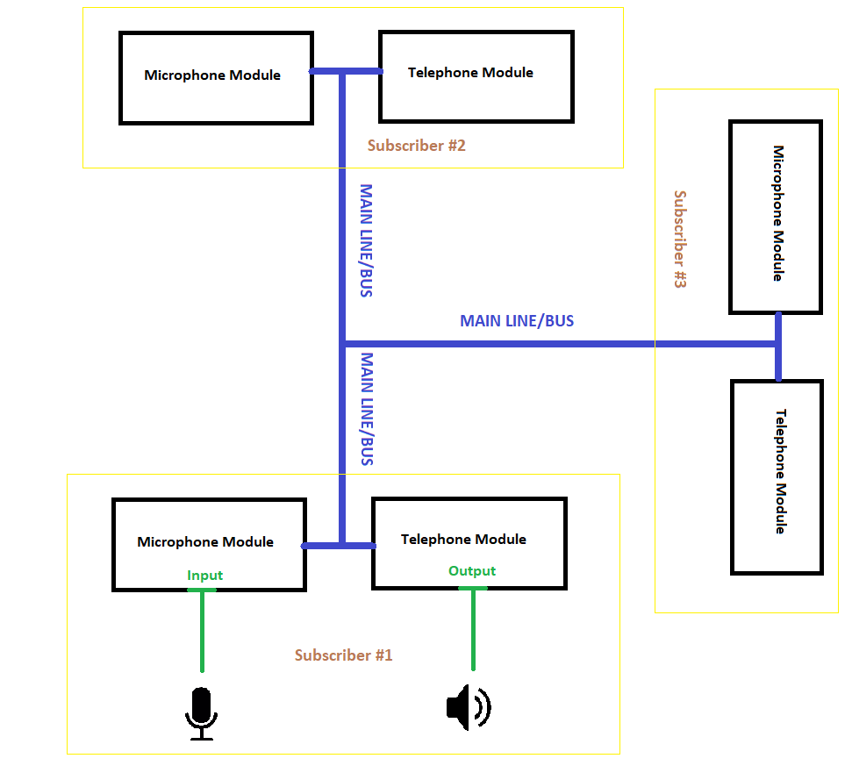
Figure 3.1 – Principal layout of network

The very important thing in such multi-channel device is channel shifter, other words commutator. Its main purpose is to shift (change) channels. As in aeronautical VHF radio a lot of frequency channels are used with step 8.33 kHz (earlier 25kHz) simulation device should emulate frequency switching. In a current device 8 channels, in our Analogue case buses, are planned. In our case commutator should shift buses to emulate different frequency channels. The principal scheme with commutator looks like.

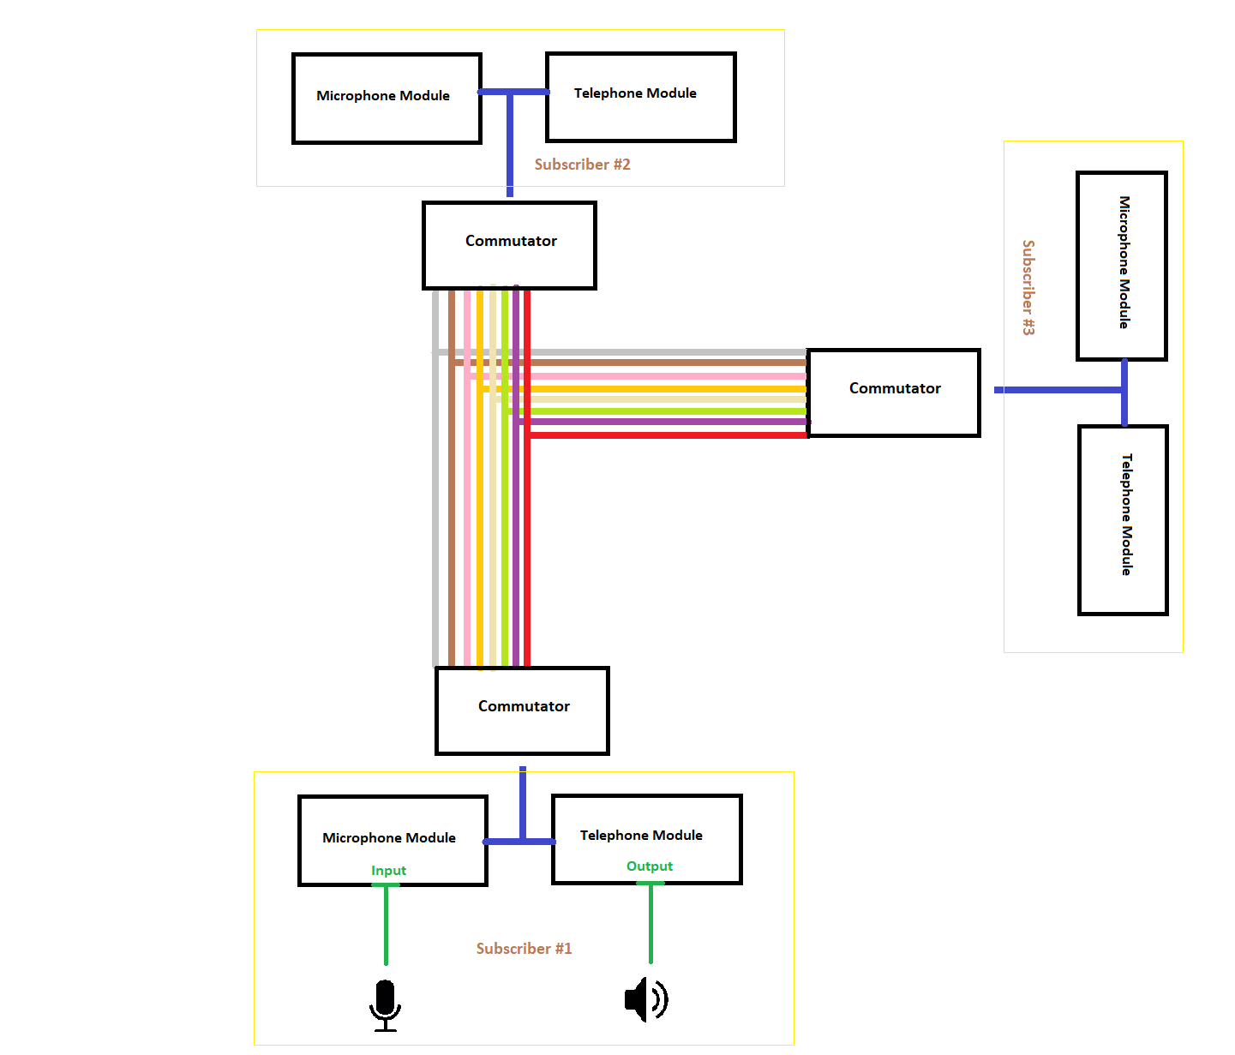
Figure 3.2 – Principal layout of network with commutator and buses

Each bus on a picture is marked with different color (tone). A subscriber device is connected with commutator which is connected to all 8 buses. It shifts main bus from subscriber to one of eight network buses. Each bus emulates frequency channel.
As mentioned above, subscriber consists of 4 main parts and 4 axillary parts. Main parts are: Microphone module, Telephone module, PTT module and commutator. Axillary parts are: PTT switch, headphones, mike and commutator control panel. Microphone Module has 2 amplifiers which amplifies signal from microphone and send it to main bus. Telephone module receives the signal from main bus then amplifies it with two amplifiers and sends it to the headphones. PTT button stands between Telephone Module, Microphone module and headphones, microphone. Its relay has two contact groups which are activated by pushing PTT button. On stage 1 (button released/listen mode) Microphone is disconnected from microphone module while headphones are connected to telephone module. On stage 2 (button pressed/transmission mode) microphone is connected to microphone module while headphones are disconnected from telephone module. Commutator uses 8 relay controlled by Microcontroller to connect main bus of subscriber to one of 8 network buses. Microcontroller uses data from commutator panel to enable the relay which corresponds to frequency selected on panel. Otherwise classic commutator switch can be used, in this case the total device cost 1.5 times less.

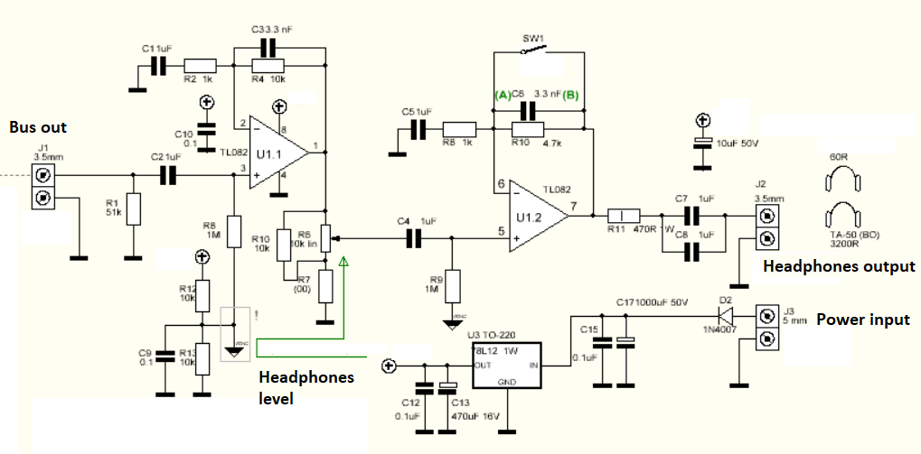

Figure 3.3 – Principal layout of Telephone module

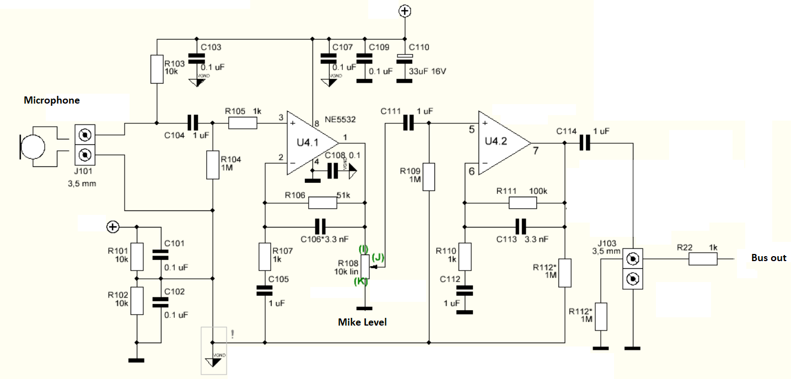
Figure 3.4 – Principal layout of Microphone module

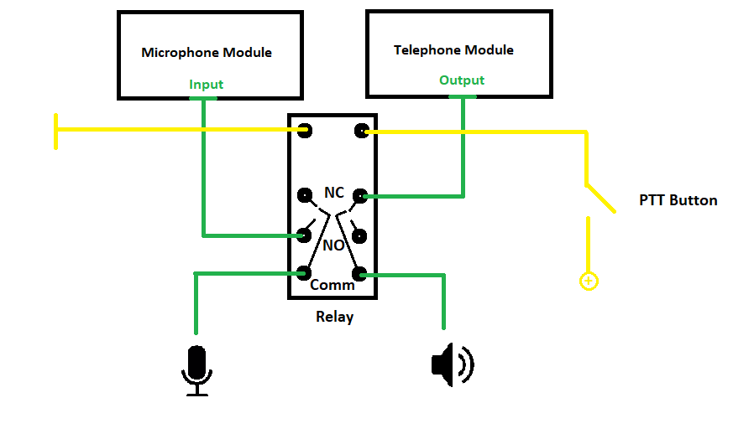
Figure 3.5 – Principal layout of PTT module

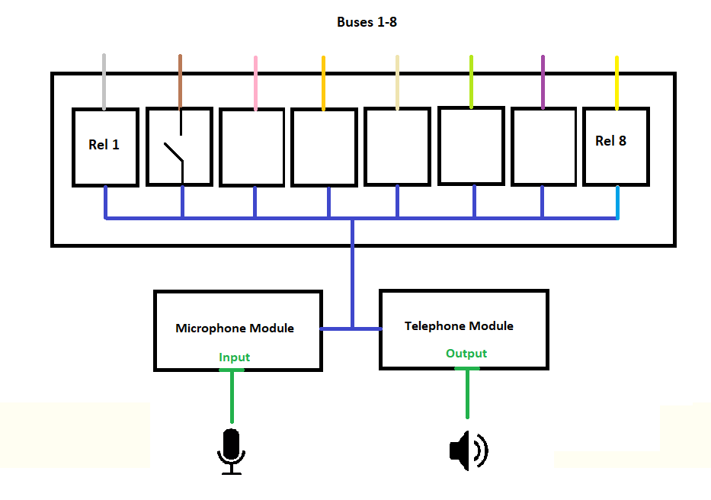
Figure 3.6 – Principal layout of Commutator

Auxiliary devices.
1) Commutator control panel might be presented as Relay-Microcontroller module or as a classical commutation switch. Relay-microcontroller module is developed on a basis of Arduino Pro micro with own IDE. It was chosen for its reliability and ease of programming due to own IDE. It consists of microcontroller, relay module, 8-segment indicator and n-coder.
First of all, a frequency and corresponding relay are programmed into Arduino microcontroller. The current frequency (channel) is indicated on 8 segment indicator. User can change standby frequency with n-coder and shift active and standby frequency with n-coder button. When the certain active frequency selected, microcontroller switches the relay which connects main bus of subscriber to corresponded to this frequency network bus.
2) PTT button is an outsource button on a wire, which stand for switching PTT listen/transmit modes. Can be equipped with extra microphone and speaker.
3) Recording device. As already mentioned above, record ability is a vital thing for simulator. It is presented as an 8 channel soundcard with appropriate software such as Cubase. The soundcard is connected to all 8 network buses and is not a standalone device and controlled from computer.
4) Network bus. It was chosen to use shielded twisted pair due to its perfect transmission ability.

Conclusion to chapter 3
After performing a research process, it came obvious that a new type of training device is needed on market of aviation or transportation knowledge. It should be a standalone device-based unit with PTT button, semi-duplex communication, channel setting and recording. Analogue type of device was chosen due to its similarity to real VHF radio. The device was invented and developed. Principal schemes and layouts were drawn. Then, a concept model was assembled and tested. The developed device fully meets all requirements inclusively low cost and ease repair.
The result of testing on a practical lesson resulted in such conclusions:
- The accuracy of PTT button usage arose.
- Due to record ability, debriefing came more accurate and productive.
- Students became more convenient with frequency setting
- Total performance of Master simulator arose due to usage of standalone device instead of additional software.
- Simulator training became more interesting and thus, productive.
To sum up the device was developed accordingly to the requirements of aviation studying market. The student testing results showed that simulator training became more interesting, practical and productive due to brand-new features of device.

CHAPTER 4. MAIN TECHNICAL FEATURES AND TECHNICAL REQUIREMENTS TO THE SYSTEM

4.1 Main features of developed voice communication device

As it shown in previous chapter, voice communication simulator module consists of three main electronic parts:
- Telephone module;
- Microphone module;
- Commutator module.
Each of them has own technical features and requirements.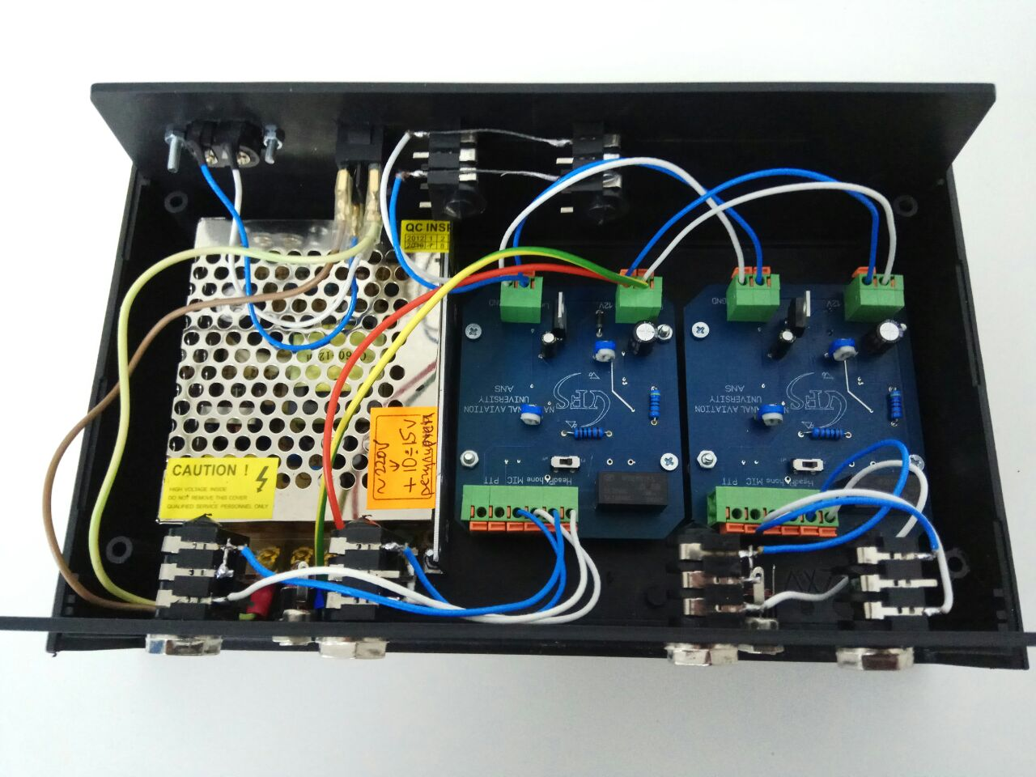
Figure 4.1 – Assembled voice communication module without commutator

4.1.1 Features of telephone module
Both telephone and microphone module are equipped with analogue sound amplifier. Telephone module has TL082, its main features are mentioned below:
- wide common-mode (up to vcc+) and differential voltage range;
- low input bias and offset current;
- output short-circuit protection;
- high input impedance j–fet input stage;
- internal frequency compensation;
- latch up free operation;
- high slew rate : 16v/µs (typ).[12]
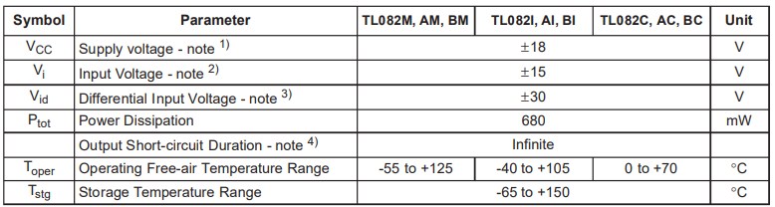
The TL082 JFET-input operational amplifier family із designed to offer a wider selection than any previously developed operational amplifier family. Each of these JFET-input operational amplifiers incorporates well-matched, high-voltage JFET and bipolar transistors in a monolithic integrated circuit. The devices feature high slew rates, low input bias and offset currents; and low offset voltage temperature coefficient. Offset adjustment and external compensation options are available within the TL082 family. [12]
Figure 4.2 – TL082 acceptable value rates
Notes:
1. All voltage values, except differential voltage, are with respect to the zero reference level (ground) of the supply voltages where the zero reference level is the midpoint between VCC+ and VCC- . ±18 V Vi Input Voltage - note 2);
2. The magnitude of the input voltage must never exceed the magnitude of the supply voltage or 15 volts, whichever is less. ±15 V Vid Differential Input Voltage - note 3);
3. Differential voltages are the non-inverting input terminal with respect to the inverting input terminal. ±30 V Ptot Power Dissipation 680 mW Output Short-circuit Duration - note 4);
4. The output may be shorted to ground or to either supply. Temperature and/or supply voltages must be limited to ensure that the dissipation rating is not exceeded. [13]
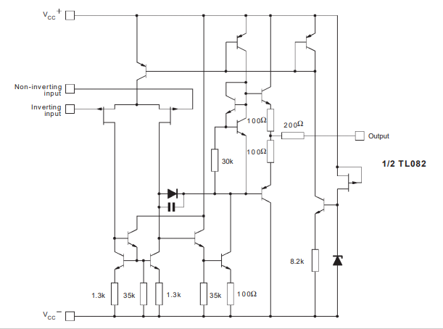
Figure 4.3 – TL082 schematic diagram

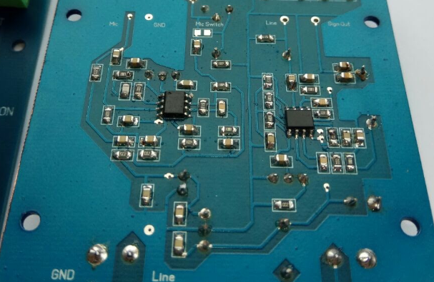

Figure 4.4 – Both amplifiers are soldered to PCB. TL082 is on the right

4.1.2 Features of microphone module

While telephone module is equipped with TL082 amplifier, the microphone module is equipped with NE5532 amplifier. The difference is that microphone module amplifier is less powerful than telephone, because it links directly to the bus and has to send a regular signal to the line(bus) while telephone amplifier has to send strong signal to headset.
The NE5532 is an internally compensated dual low noise OP-AMP. The high small signal and power bandwidth provides superior performance in high quality AMP, all control circuits, and telephone applications.[14]
- Internal Frequency Compensation;
- Slew Rate: 8V/µs ;
- Input Noise Voltage: 8nV Hz ⁄ (fo = 30Hz);
- Full Power Bandwidth: 140KHz . [15]

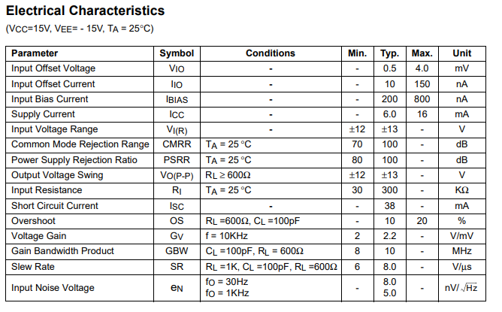
Figure 4.5 – NE5532 features data
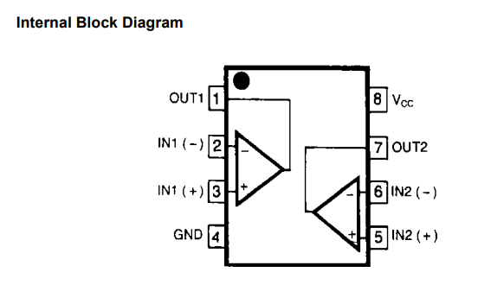
Figure 4.6 – NE5532 block scheme

Main technical requirements to the additional equipment
The developed voice communication module is a standalone device but it has an additional equipment. These equipment are a headset, microphone and a push to talk button. There are some specific requirements to these equipment due to some technical peculiarities of system.

4.2.1 Requirements to headset

By the type of acoustic design headphones are distinguish on:
- opened type;
- closed type.
With the open type of headphones, the bowls have holes and do not interfere with the sound output from the opposite side of the speaker. Due to this, the sound pressure on the ears is reduced and a greater natural sounding is noted. The nature of the sound is very similar to on-ear headphones (incomplete).
Half-open (half-closed). The bowls have small holes. A certain compromise between the open and closed type, allows you to achieve a little more sound insulation and less fatigue of the ears, while maintaining the ease and naturalness of sound. But in essence these are the same open headphones.
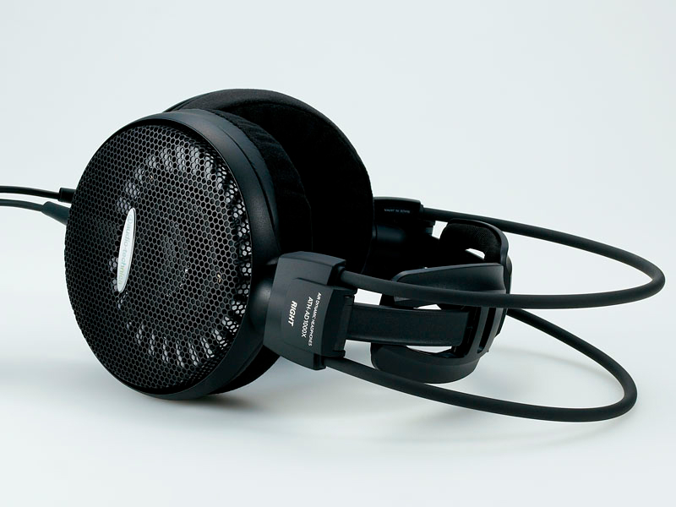
Figure 4.7 – Opened type headset

When the type of headphones is closed, the bowls have no holes and, therefore, return all the sound to your ears. Such a design can achieve a good degree of sound insulation, as well as work out the sound depth in a quality manner. In this case, the cup materials and their design features play an important role. Sometimes the manufacturer provides the opportunity to choose removable bowls from different types of wood, each of which colors the sound in its own way, thus helping to choose the paint to your liking.

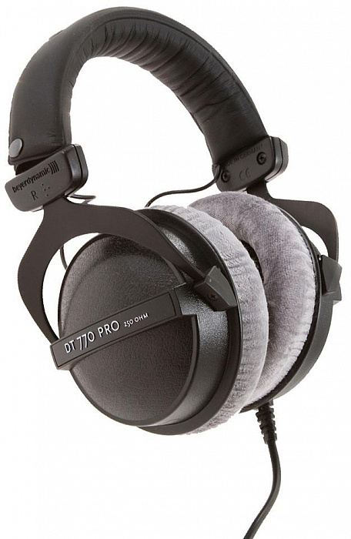
Figure 4.7 – Closed type headset

By the type of input connector headsets are divided into:

- Mini Jack 3.5mm is the most popular connector. Most headphones use this particular jack. This connector plugs into computers, phones, tablets, laptops, players, TVs.
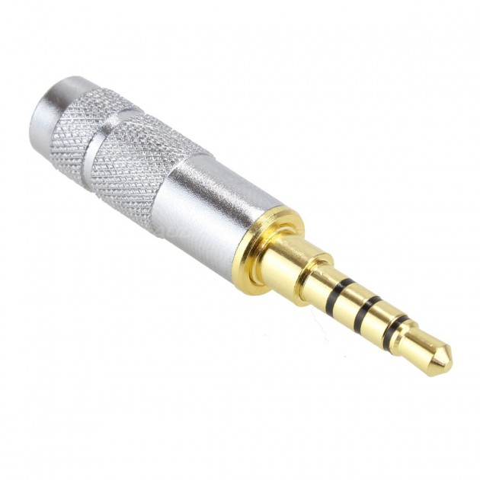
Figure 4.8 – Closed type headset

- Jack 6.3mm - a professional connector, used in studios for consoles, in musical power tools. Often comes with a 3.5mm jack adapter.
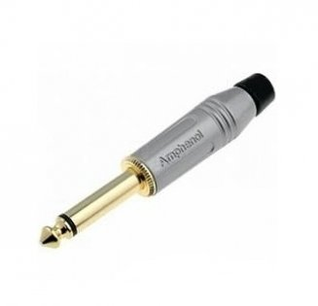
Figure 4.9 – Closed type headset

- USB is a very popular connector used in computers and laptops. Headphones with this plug are usually designed for gaming and have customizable multimedia buttons.
The requirements to the headset are not so tight. The solutions was designed in order to minimize the problem of finding the corresponded type of headset. The system will work correctly with almost any type of commonly used headsets. While the only requirement is that jack 6.3 plug is obligated to its reliability and endurance, there are some recommendations. Anyway, 3.5 to 6.3 jack adapters may be easily find in audio stores. The recommendations are to use closed type headset, in order direct all available sound into student`s ear and the resistance should be 30-60 Ohm.

4.2.2 Requirements to microphone
Microphone is also very important component for voice communication simulator. The quality of microphone is directly connected with clearness of radio communication types of commonly used microphones are:
Dynamic microphone - in design, it is similar to the dynamics of a conventional speaker. The only main difference is that instead of applying voltage to the speaker coil to create sound, we simply remove the voltage from this coil, which is created by external sound. However, the dynamic microphone is slightly different in design from the speaker. It has a different aperture design, its coil contains a larger number of turns and is wound with a much thinner wire.
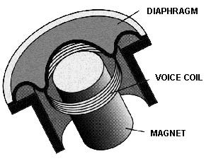
Figure 4.10 – Dynamic microphone structure

Condenser microphone - is a condenser, one of the plates of which consists of an elastic material. With sound vibrations, it changes the capacitance of this capacitor. If the capacitor is charged, then a change in capacitance leads to a change in voltage, which is a useful signal from the microphone. For the operation of such equipment between the plates, a so-called polarizing voltage (phantom power of 48 V) must be applied.
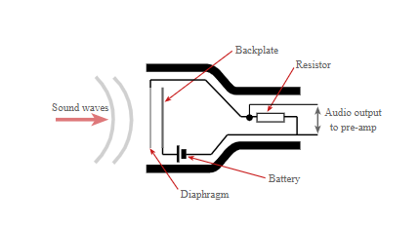
Figure 4.11 – Condenser microphone structure
The requirements to the microphone are also not so tight. The system will work correctly with almost any type of commonly used microphones. In this case, requirements are still jack 6.3 plug and usage of dynamic microphone because, system itself cant provide 48 volts phantom power supply.

Conclusion to chapter 4
From all above mentioned comes the features and requirements to additional equipment of voice communication simulator system:

- Power supply: 220 volts alternating current;
- Microphone dynamic microphone with resistance: 1.5-2.5 kOhm;
- Headphones resistance: 30-60 Ohm;
- Channels: 8 (depends on commutator capability);
- Subscribers on a channel: unlimited;
- Max bus length: up to 500 meters (depending on conductor).

GENERAL CONCLUSION
In this work we analyzed the modern approach to the process of aviation personnel simulator training, its impact on ATCO student`s education to understand the core of interaction between human and machine in this process. Then we made a research of nowadays air traffic control officers training simulators market with a focus on existence of integrated voice communication module. The result of research described in conclusion to chapter 2 became the initial data for developing of new voice communication simulator module. On the next stage the voice communication simulator module was developed and assembled with the respect to result of previous stages. In the end was developed a set of features and requirements to created voice communication simulation system.
To sum up, all details from all 4 chapters strictly indicates that the new developed voice communication simulator system is unique in its essence of a standalone device-based communication module and can greatly change the process of student ATCOs studying process to more realistic and interesting, starting with realistic layout with a push to talk button realistic algorithm until the natural radio communication sound.

REFERENCES
- Макаров Р. Н. Теоретические основы профессиональной авиационной педагогики /[Макаров Р. Н., Герасименко Л. В., Нидзий Н. А, Стрелец И. В.]. – М.: МАПЧАК, 2000. – 325 с.
- Казачкин Б. И. Авиационные тренажеры как связующее звено между наземной и летной подготовкой / Б. И. Казачкин. – Монино , 1999. – 160 с.
- Желтухин В. В. Автоматизированные обучающие системы в сфере управления профессиональной подготовкой летного состава. Роль предтренажерной подготовки. // Межвузовский сборник научных трудов. СПб., Академия гражданской авиации, 1999. Т. IV. – С. 192–200.
- Doc 9868 Procedures For Air Navigation
- Annex 1 to the Convention on International Civil Aviation Organization (ICAO) “Personnel licensing”
- Doc 10056 “Manual on Air Traffic Controller (ATCO) Competency-based Training and Assessment”
- EUROCONTROL – SESAR Concept of Operations Step 1. Edition: 01.00.00. Date: 09.05.2012.
- EUROCONTROL - The Network Manager tasks and the ASM improvement initiative. AFUAS Workshop. Date: 24th June 2015
- Типові вимоги до автоматизованих систем керування повітряним рухом (наказ Украероруху від 15.03. 2011 року № 87)
- Bogunenko M.M. Implementation of the pilot common project into Ukrainian airspace/ Bogunenko M., Luppo О., Alekseev О., Kolesnyk T.// Системи обробки інформації Харків, - 3 (149) 2017 – P. 121-126,
- Argunov G.F. Принципы построения и использования интеллектуальных тренажёров управления воздушным движением / Г.Ф. Аргунов, В. П. Харченко, О. С.Ерёменко // Тренажерні комплекси та системи: зб. наук. пр. – К.: Інститут проблем моделювання в енергетиці ім. Г. Є. Пухова, 2005. – Том 2. – С. 107-112.
- TL082 Datasheet (PDF) - Texas Instruments
- TL082 Datasheet (PDF) - STMicroelectronics
- NE5532 Datasheet (PDF) - Texas Instruments
- NE5532D Datasheet (PDF) - NXP Semiconductors
- SimSoft official web site url: http://www.simsoft-atc.com/atmis-3d-tower-simulator.php
- Литвиненко А.А. Анализ состояния российского рынка авиационных технических средств обучения // Авиатренажеры, учебные центры и авиаперсонал-2012: IV Междунар. конф. М.: Динамика, 2012.
- Решетников В.Н. Космические телекоммуникации (начала). Тверь: НИИ «Центрпрограммсистем», 2009. 128 с.
- Решетников В.Н. Космические телекоммуникации. Системы спутниковой связи и навигации. СПб: Ленинградское изд-во, 2010. 132 с.
- Бюшгенс А.Г. Современные тренажерные технологии в России // Аэрокосмический курьер. 2010. № 5.
- International Civil Aviation Organization. Doc 9625-AN/938 Manual of Criteria for the Qualification of Flight Simulation Training Devices, Montreal, Canada: International Civil Aviation Organization, 2009.
- Шибаев В.М. Современные нормы годности авиационных тренажеров – залог безопасности полетов // Авиатренажеры, учебные центры и авиаперсонал-2012: IV Междунар. конф. М.: Динамика, 2012.
- Шибаев В.М. Документ ICAO 9625 H – новый подход к формированию требований к характеристикам авиационного тренажера с учетом задач подготовки летного состава // Тренажерные технологии – резерв повышения безопасности полетов: круглый стол. М.: Крокус Экспо, 2011.
- Allerton D. Principles of flight simulation. Chichester UK, Wiley, 2009.
- Шибаев В.М., Аполлонов Д.В., Еркин И.Н. Методика определения запаздывания ответной реакции систем авиационного тренажера. Жуковский: ЦЭСАТ ЦАГИ, 2011. 12 с.
- 10. Кольцов С.Е. Результаты работ по допуску в эксплуатацию новых тренажеров для подготовки авиаперсонала гражданской авиации // Авиатренажеры, учебные центры и авиаперсонал-2012: IV Междунар. конф. М.: Динамика, 2012.
- 11. Карлин В.С. Опыт создания авиационных тренажеров в компании «Гражданские самолеты Сухого» // Авиатренажеры, учебные центры и авиаперсонал-2012: IV Междунар. конф. М.: Динамика, 2012.
- Litvinenko A.A. A Russian market research in the field of avia aircraft technical. IV Mezhdunar. konf. “Aviatrenazhery, uchebnye tsentry i aviapersonal-2012” [4th int. conf. “Flight simulators, training centers and a flight crew”]. Moscow, Dinamika Publ., 2012 (in Russ.).
- Reshetnikov V.N. Kosmicheskie telekommunikatsii (nachala) [Space telecommunications (basics)]. Tver, Centrprogrammsistem Publ., 2009, 128 p.
- Reshetnikov V.N. Kosmicheskie telekommunikatsii. Sistemy sputnikovoy svyazi i navigatsii [Space telecommunications. Satellite communications and navigation system]. St. Petersburg, Leningradskoe izd. Publ., 2010, 132 p.
- Byushgens A.G. Modern training technologies in Russia. Aerospace courier. 2010, no. 5 (in Russ.).
- Doc 9625-AN/938, Manual of Criteria for the Qualification of Flight Simulation Training Devices. Montreal, Canada, Intern. Civil Aviation Organization Publ., 2009.
- Shibaev V.M. Modern worthiness standards for aerosimulators is flights safety provision. IV Mezhdunar. konf. “Aviatrenazhery, uchebnye tsentry i aviapersonal-2012” [4th int. conf. “Flight simulators, training centers and a flight crew”]. Moscow, Dinamika Publ., 2012 (in Russ.).
- Shibaev V.M. ICAO 9625 H is a new approach to form requirements to the feachers of flight simulators considering instructional tasks for flight crew. Krugly stol “Trenazhernye tekhnologii – rezerv povysheniya bezopasnosti poletov” [A panel discussion “Simulators technologies is a way to increase flights safety”]. Moscow, MVC “Krokus Ekspo”, 2011.
- Allerton D. Principles of flight simulation. Chichester, UK, Wiley, 2009, 471 p.
- Shibaev V.M., Apollonov D.V., Erkin I.N. Metodika opredeleniya zapazdyvaniya otvetnoy reaktsii sistem aviatsionnogo trenazhera [A method for indicating delayed response of flight simulator systems]. Zhukovskiy, TsAGI Publ., 2011.
- Koltsov S.E. The results of authorization for operation of new simulators to train a civil flight crew. IV Mezhdunar. konf. “Aviatrenazhery, uchebnye tsentry i aviapersonal-2012” [4th Int. conf. “Flight simulators, training centers and a flight crew”]. Moscow, Dinamika Publ., 2012 (in Russ.).
- Karlin V.S. An experience in developing flight simulators in the company “Sukhoi Civil Aircraft”. IV Mezhdunar. konf. “Aviatrenazhery, uchebnye tsentry i aviapersonal-2012” [4th Int. Conf. “Flight simulators, training centers and a flight crew”]. Moscow, Dinamika Publ., 2012 (in Russ.).

