ministry of education AND SCIENCE of ukraine
National Aviation University

E.A. Sapeliuk , A.I. Bogdanovich, A.V. Popov

Diagnostic and Control Systems of Technical State of Aircraft

Recommended by Academic Council of Aerospace Institute National Aviation University for students of the Field of Study: 27 “Transport”
Specialty: 272 “Aviation Transport”
Specialization: 01 “Aircraft and Aero-Engines Maintenance and Repair”

Laboratory Works Method Guide

Kyiv - 2018

UDC 681.518.5:629.7 (076.5)
D 53

All rights reserved. No part of this book may be reproduced
in any form without the prior written permission of the publisher

Autors: E.A. Sapeliuk - Ph.D., assistant of prof. – lab.work №2,3
A.I. Bogdanovich - Ph.D., assistant of prof. – lab.work №5,6
A.V. Popov - Ph.D., assistant of prof. – lab.work №1,4 (together
with E. A. Sapeliuk.

Reviewers: Ju.M. Podrezov. Dr.Sci, prof. (Frantsevich Institute for problems of
materials science of NASU);
K.E. Grikevich. Ph.D. Senior Researcher (Frantsevich Institute for problems of materials science of NASU);
M.V.Kindrachuk. Corr.member of NASU, prof. Dr. Sci (Eng.), (NAU).

Затверджено методично-редакційною радою національного авіаційного університету (протокол № __ від «___»____________2018 р.).

Матеріал методичних рекомендацій відповідає навчальній програмі дисципліни «Діагностика та системи контролю технічного стану повітряних суден».
Для студентів технічних спеціальностей, що навчаються англійською мовою.
D 53
Diagnostic and Control Systems of Technical State of Aircraft: Method Guide / E. A. Sapeliuk, A. I. Bogdanovich, A. V. Popov. – K.: NAU, 2018. – 45 p.

The theoretical stuff responds the educational program of Diagnostic and Control Systems of Technical State of Aircraft, is accompanied by some of examples.
A manual intended for the students of technical specializations, which are training in English.

UDC 681.518.5:629.7 (076.5)
D 53

© Sapeliuk E.A., Bogdanovich A. I.
Popov A.V., 2018
© НАУ, 2018

CONTENS

1. GENERAL METHODICAL recomMendationS….………..…………………………… …4
2. Laboratory work №1………………..…………………….....5
3. Laboratory work №2.……………………………………......5
4. Laboratory work №3…. ………………………………..…13
5. Laboratory work №4…………………………………….....15
6. Laboratory work №5…………………………………….....23
7. Laboratory work №6………..…………….………………..28
8. Laboratory work №7………..…………….………………..34
9. Laboratory work №8………..…………….………………..38
10. Laboratory work №9………..…………….………………43
11. REFERENCES ……………………………..……..…………...44

GENERAL METHODICAL recomMendationS

The task of laboratory works consists in fastening by students of theoretical knowledge which they receive during studying of this discipline. In addition to it students should get practical skills of processing of the statistical data and creation of mathematical models of functioning of engines and aircrafts systems. Successful fulfilment of task depends of on self-sufficient activity of students in the course of theoretical preparation to laboratory works.
Before students will execute the work, they must get acquainted with the description of the work, by means and methods, which are used in the course of studies, as well as listen to the briefing about safe methods of labor. Engineers and technicians which operates and uses the equipment, should check up diagnostic devices, computers and the tool. These operations are carried out in the beginning and in the end of laboratory works. In process of fulfilment works, the check is foresee of the students knowledge by the teacher and estimation of degree they of preparation for use of equipment.
Graphic workings out (the images in form of the graph or scheme as well as diagrams) are envisaged for each of individual work. These elaborations should be fulfilled on millimetre sheets of paper according to ESKD requirements.
Intermediate and auxiliary calculations, which are envisaged in each of laboratory works, must be executed separately, but their results must be included into reports. The outlines, drawings and illustrations are executed in pencil or by black paste. Each drawing must have accompanying text. The Text takes seats under drawing. All results of calculation and the intermediate data must have dimensionality.
After completion of the work the students must switch off the equipment and checking - measuring device. The student must clean the work place and present the report to the teacher. The Reports must contain the name of the work; purpose its execution, problems to solve, and consecution of performing the works. In Report follows to include main parameters, which were measured in process of execute works, mathematical expressions for calculation of diagnosing factors, the algorithms of processing statistical dates and other information.

Laboratory work № 1

Primary laboratory work
On the first laboratory work instructor need introduce and meet with all students of the group. For this instructor need carry out of roll call the all students.
For instructor need tell plan of work along of discipline name “Diagnostics and Control Systems of Technical State of Aircraft”: number of lectures and laboratory works, number of models and value of rating.
Students need come to laboratory work preparatory: the student need have report of laboratory work, know essence of laboratory work, work order, know result of laboratory work.
After ending of laboratory work student need form report: fill up of tables and write conclusion.
Student need answer on questions of the instructor.
Far student need get estimation or bolls along laboratory work. Hen this balls sum up and compose of torrential estimation model. Balls sum up for two models and compose of torrential estimation discipline.

Laboratory work № 2

Calculation and analysis of diagnostic signs of faulty gas turbine engine (GTE)
This work is carried out on example of vibration parameters for different types of aviation engines.
Change of vibration parameters in process of engine operation is a sign of its malfunction
The work purpose:
- research of parameters behaviour that are calculated for GTE in the presence of rotors disbalance;
- forecasting of change of the engine condition;
- acquisition of practical skills of the analysis of technical condition of the engines on vibration parameters.
Brief theoretical information.
Vibration reflects condition of details, units and also character of working processes in the engine. Vibration is caused by unbalance of the engine rotors and by pulsate on of burning of a mix of air and fuel in the combustion chamber. Absence of balance of rotors is interpreted by thermal deformations of machine elements. Besides disbalance can arise because of easing of communications of details and wear process of unit. Disbalance change leads to change of vibration parameters.
Check and analysis of dynamics of parameters vibration allows to estimate a condition of elements of gas and air tracts also of engine rotors. Vibration level is supervised in flight and on the earth. For this purpose on engines gauges of vibration are established and in a crew cabin there are special indexes. The vibration parameters values are written down on the indicators. On modern engines following vibration parameters are measured:
– Amplitude of vibration - L (mm);

– Speed of vibration – V (mm/sek); $V=\frac{\text{dL}}{\text{dt}}$.
– Vibration acceleration – W (mm/sek²); $W=\frac{\text{dv}}{\text{dt}}$.
– Factor of vibrating overload – К_{g}; $K_{g}=\frac{W}{g}$.
where W – vibration acceleration of the engine; g – acceleration of free falling
Amplitude of vibration, speed of vibration and vibration acceleration are measured on turbojet engines. Factor of vibrating overload is measured on turboprop engines. Different measuring complexes are fixed on each type of the engine these complexes include:
- a sensors – give the mechanical signal X(t);
- an amplifiers signal;
- a frequency filters – miss the informative signals and do not miss the frequencies, which are not checked;
- an integrators – integrate the signals;
- an indicating instruments.
The principle of the equipment action of vibrations checking is founded on transformation of the mechanical fluctuations X(t) of the engine body in electric signal.
The Sensors are fixed on framework of the engine in zone of the bearing.
Signals are converted from sensor according to equation:
W² (f, ∆f) = $\frac{1}{T}\int_{0}^{T}{X^{2}}(t,f,$∆f)dt (2.1)
where W² (f, ∆f) – estimation of average value of vibration signal (The square-law); ∆f – сhange of vibration frequency; T – period of fluctuations.
Functional expression (1) is actualized according to the diagrammed
(fig. 2.1).
Sensor
Filter
[ ]²

Fig.2.1. A scheme of complex of the measuring equipment

Filters are established with narrow pass-band on single -shaft engines. The set of measuring equipment of vibration, which has been established on engine AI-24, excretes frequency of fluctuations of rotor that is equal 205±1,5 Гц. This results from the fact that the engine has constant frequency of rotation of a rotor, is equal 12300 revol/min (205±1,5 Гц)
The general spectrum of GTE vibration is very difficultly analyzed. This spectrum includes fluctuations of various parts of the engine (of the rotor, bearings, blades of the compressor and turbines). Therefore the principle of synchronous detecting is used for allocation of a useful signal from the general spectrum of the engine vibration .

Amplitude is calculated on following formula for selected frequency
Â = $\frac{1}{T}\left[\sqrt{(\int_{0}^{T}{X(t)\text{cos}ω_{0}\text{tdt})^{2}+(\int_{0}^{T}{X(t)\text{sin}ω_{0}\text{tdt})^{2}}}}\right]$ (2.2)
where Â – estimation of the value of fluctuations amplitude; T - period of fluctuations; X(t)cos$ω_{0}t$, X(t)sin$ω_{0}t$ - harmonic fluctuations

The scheme of such analyzer is shown on fig. 2.2

ID
F₁
SD
A
SN
GSS
X(t)
Fig.2.2. The analyzer scheme of rotor harmonics

Signal Х(t) from the vibration sensor goes to the inlet device (ID) of the analyzer. This signal includes a considerable quantity of the components, that are noise. This noise needs to be removed. Therefore the signal from the inlet device goes оn the preliminary filter of low frequencies (F₁). Low frequencies of fluctuations are removed by this filter. These frequencies do not give the necessary information about technical condition of the engine. Further the signal goes on the synchronous detector (SD). On this detector the signal goes from the sensor (SN) of the engine turns too. Such signal goes through the generator of supporting signals (GSS). The generator of supporting signals will transform frequency of rotor rotation to frequency of component which is measured. This process is carried out under the formula (2.3).
f₀ =К_{i} f_{T}(t) (2.3)
where f₀ - frequency which corresponds rotation of the rotor on the required regime of work engine; K_{i} - coefficient of transformations. This coefficient is designated in a range 0.01.... 99.999 with step
$Δ$K_{i} = 0.001; f_{T}(t) - frequency of tachometer signal.
The detector allocates amplitude (A) of vibration from the general signal. Amplitude is calculated on the equation (2). In practice the especial method is used for vibration analysis. The method analyses dynamics of vibration parameter. These parameters are measured by airplane instruments. The method essence consists in estimation of tendencies of vibration level and speed changes of vibration parameter. Process is stationary for of vibration change of the serviceable engine. Infringement of stationary process testifies to defect occurrence.

Work order
1. To familiarize with theoretical bases of the control of vibration level GTE.
2. To familiarize with methods of diagnosing ГТД on dynamics of vibration parameters.
Note. The teacher gives variants of the initial data for students .
3. The student should enter these values for the variant in the protocol (The table 2.1).
4. To construct the diagram of vibrations velocity change (or the factor of overloading) depending on engine operating time. The example is shown on fig. 2.3 of such diagram.
5. To execute smoothing of the diagram which has been constructed.
Practically, values of parameter are scattered in the course of diagram construction. In this case to define the tendency in behaviour of parameter is very difficult. For analysis and forecasting of change of parameter it is necessary to execute of the diagram smoothing. Smoothing we will carry out by method of sliding average. For this purpose we will divide the diagram into intervals $(Ι,\text{ΙΙ},\text{ΙΙΙ},ΙV,V)$. In each interval should be four values of parameters. Values of parameter from an interval ($Ι$) to write down in a column 2 of the tables 2.2. The table 2.2 carry in protocol.

Table 2.1

Initial values of vibration parameters
1 | 2 | 3 | 4 | 5 | 6 | 7 | 8
Engine operating time t(h) | 100 | 200 | 30 300 | 400 | 500 | 600 | 700
V(mm/cek) or K_{g}
Engine operating time t(h) | 800 | 900 | 1000 | 1100 | 1200 | 1300 | 1400
V(mm/cek) or K_{g}
Engine operating time t(h) | 1500 | 1600 | 1700 | 1800 | 1900 | 2000 | 2100
V(mm/cek)or K_{g}
Engine operating time t(h) | 2200 | 2300 | 2400 | 2500 | 2600 | 2700 | 2800
V(mm/cek) or K_{g}

[П]
П_{max}
П_{min}
ΔП
Δt
t⋅10 [hours]
1
2
3
4
5
6
7
I
II
III
IV
V
0

Fig. 2.3. Example of change of some parameter "П"
at presence and of defect development
Table 2.2.
The dates for smoothing of the functional dependencies
№  of interval | Values of parameter  (V or Kg ) |  | Values of the engine operating time (t)
№  of interval | Actual  values in  interval | Average  value in  interval | Actual  values in  interval | Average  value in interval
1 | 2 | 3 | 4 | 5
Ι
Ι Ι
Calculate average value of parameter in the interval ($Ι$)and to write down in column 3 of the tables 2.2. Calculation to carry out under the formula:
$V_{\text{ср}}=\frac{1}{m}\sum_{i=1}^{m}{\text{Vi}}$ (2.4)
where m - quantity of parameter values in interval (m = 4)
Next in column 2 of the tables 2.2 to write down values of parameter for an interval (Ι Ι ). There will be 4 parameter values. But last numeral of the first interval will be the first numeral of the second interval i.e. this numeral passes to the next interval (the numeral slides).
6. Then execute the actions according to article (5) for of all intervals. All data to write in table 2.2, columns 2 and 3. We have got one coordinate (on V or Kg) for point of the lines, which will smooth the graph. But necessary to find the second coordinate (on lines t). For this we will consider the Engine operating time (t) in each interval. Four denotations of the Engine operating time must be in each interval. All denotations of the Engine operating time from interval (Ι) write in column 3 tables 2.2.
7. Calculate the average value of Engine operating time (t_{ср} ) in the interval ($Ι$) and to write down in column 4 of the tables 2.2. Calculation to carry out under the formula:
$t_{\text{ср}}\frac{1}{n}\sum_{g=1}^{n}{t_{g}}$ (2.5)
where n - quantity of Engine operating time values in interval (n = 4)
Then write down in column 4 of the tables 2.2 values of engine operating time for an interval (Ι Ι ). There will be 4 Engine operating time values. But last numeral of the Engine operating time of first interval will be the first numeral of the second interval. That is to say this numeral go over in the following interval (the numeral glissades).
8. Farther to execute the actions according to of article (7) for all intervals. All data to write in table 2.2, columns 4 and 5. We have got the second coordinate (on axis t) for points of the lines, which will smooth the graph. All points to insert on graph in accordance with coordinates that have been gotten. Through these points to conduct the line, which smoothes the graph.
9 To appreciate character of line that has been gotten (the Dependency linear or curvilinear).
10 To Prolong the line of smoothing till intersection with at most possible importance of the parameter [P] (Look fig. 2.3).
11 To Define time in current which parameter will reach at most possible importance of value [P] (Do the forecast). This problem necessary to solve with use the equation of lines, which smoothes the graph (fig. 2.3).
If line was got curvilinear then go to point 12. Equation will such for linear dependency :
П_{пр} = П_{нч} + f$Δ$t (2.6)
where П_{пр} - at most possible importance value of vibration parameter
(For velocity of vibrations – 50 mm/sec., for Kg - 5.5); П_{нч} - value importance of vibration parameter in the last interval i.e. on area of the forecasting (the table 2.2, column 3); f – velocity of change of vibrations parameter; t – forecasted time possible of the engine service.
The velocity (f ) is defined all through lines of the smoothing. This velocity is considered as constant. Then:
$f=\frac{П_{к}−П_{н}}{t_{k}−t_{n}}$ (2.7)
where П_{к}- П_{н} ⁼ $Δ$П - change of values of vibrations parameter in period of observation. (П_{к} - from table 2.2, column 3 for the last interval, П_{н} - from table 2.2, column 3 for the first interval); t_{k} - t_{n} = $Δ$t - operation time of the engine in process of the observation (t_{k} – from table 2, column 5 for last interval, t_{n} – from table 2, column 5 for first interval)
Then forecasted time ($Δ$t) is determined from (4) and (5):
$Δt=\frac{П_{\text{пр}}−П_{\text{нч}}}{f}$ (2.8)
The operation time of the engine under which its usage will be impossible:
Т_{нар} = 2650 + $Δ$t (2.9)
12. Calculate the for curvilinear dependency (See fig. 2.4).

[Kg]

K_{gтек}

Kg_{min}
t₁ t₂ t₃ t
Fig. 2.4. Example of parameter Kg change at presence and of defect development.
The line has been smoothed within the range of the engine operation time from t₁ till t₂. Equation has a following type for curvilinear dependency (the example is considered for factor Kg).
K_{g} = at² + K_{gmin} (2.10)
12.1. Necessary to define the velocity (a) of change Kg, which forms the parabola.
12.2. We shall consider snippet of the parabola at time interval from t₁ till t₂. We will record equation of the parabola for this interval.
K_{g тек} = a(t₂ – t₁)² + K_{g min} (2.11)
12.3. We shall define (a ) from equation (2.11).
$а=\frac{K_{\text{gтек}}−K_{g\text{min}}}{(t_{2}−t_{1})^{2}}$ (2.12)
12.4. We shall consider that curve is changed with this velocity on forecasted sector of time (t₂ – t₃)
12.5. For forecasted of the sector we will compose equation of the parabola. But we shall enter indication:
(t₃ - t₂)² = ∆t²
Then
[Kg]= а∆t² + K_{gтек} (2.13)

12.6. We define (∆t ) from equation (2.10)
$Δt=\sqrt{\frac{[K_{g}]−K_{\text{gтек}}}{a}}$ (2.14)
The operation time of the engine under which its usage will be impossible
Т_{нар} = 2650 + $Δ$t (2.15)
The record should include:
1. The name and aim of the work.
2. Version of the task.
3. Initial data for your own version (table 2.1).
4. Graph of vibration parameter change (see fig.2.3 or 2.4)
5. Table 2.2 with results of calculation average values of parameter and average values of the engine operation time.
6. Results of calculation velocities of change parameters, forecasted time of the engine functioning and operation time of the engine before refusal (Formulas 2.9, 2.10, 2.11 or 2.12, 2.13, 2.14).
7. Conclusions.
Question for self – preparation
1. Why appears the vibration of the engine?
2. What parameters of vibration is characterized ?
3. Why factor of overloading is measured for TPE?
4. What the complex includes of the measurement of vibrations?
5. Why electric filters are used in system of the measurement engine vibrations?
Literature [2]
Laboratory work № 3

Research of metals concentration in oil of the GTE by means of device
«БАРС-3»
The work purpose:
- to study principle of functioning the analyzer «БАРС-3»;
- to acquire practical skills in study of condition GTE with use of analyzer «БАРС-3».
Brief theoretical information
For analysis of the technical condition GTE, from engines the test of oil is merged in volume 60-100 ml. The test is send in laboratory of the diagnostics of the aircraft technology. Such laboratories are available in all large airlines of Ukraine.
The label by technician the date of test selection and engine number are registered. The engine operating time is registered in addition after its calculation in dispatcher office.
Oil from the test is subjected by preliminary preparation in laboratory. Preliminary preparation consists in interfusion of oil in small bottles for the purpose of sacrament of uniform distribution of products of wear process of details the engine in the selected test. Process of agitation is very laborious also long. Therefore oft in airlines various methods and means are used for obtain of necessary result. These are mechanical or electric mixers, electromagnetic vibrators, centrifuges and other equipment. But the advanced method is ultrasonic. This method allows to create uniform distributions in oil of products of wear process of various dispersion. After preliminary preparation, the oil is cleaned by special filter («Владипор»). Such filters are made from of special material that is provided high level of a filtration and clearing of working body. After oil is passed through the special filter («Владипор»). On the filter there are products of wear process of the engine. Such filters are called filters – commutators. The filters – commutators are prepared from selected tests with the help of special equipment (the fig. 3.1).
3 33333
1
7
6
2 22
4
5
Fig. 3.1 Installation for preparing of filters - commutates
1 - body of the device; 2 - filter «Владипор»; 3 - measured glass;
4 - nut; 5 - metal gridiron; 6 - vacuum cylinder; 7 – receiver

For this purpose, 20 ml of oil is selected from tests and is poured in measured glass 3, which is installed on body 1 of the devise. The filter paper of type «Владипор»provides fineness of filtering 1 micron. For speedup of filtering process and for formation of the imprint, the device is equipped by vacuum station and receiver (7).
After all oil will get through filter, on which remains the imprint, the filter take out of installation. This imprint contains different metals in the form of wear process products of engine details. Further the filter – reflector is located in sensor of device «БАРС-3». In the sensor X-rays influence on wear products. Structurally the analyzer «БАРС-3» consists of two blocks: sensor and board of management. The sensor, as the main block of the analyzer, is intended for fastening of x-ray tube, spectral head, the high-voltage device and other details (See fig. 3.2) .
Spectrometer head (3) has four of metering channels, which consist of stream X-rays, imprint, the first filter - reflector, the second filter - reflector and counter of Geiger. Spectrometer head is removable and connected with body of the sensor by means of lower nut (8). The spectrometer head is intended for sacrament of direct influence of quanta of X-rays on imprint. In head there is division of fluctuations to long and short waves. These fluctuations arise in the course of excitation of metal atoms on imprint by X-rays. Each atom of metal which is postponed on a imprint, radiates energy quanta. A spectral head will send this energy on special filters (11) and detector (10).
Three removable spectrometer heads enter to kit of the analyzer, each of which analyses four chemical elements:
- the first head - an iron, copper, zinc, plumbum;
- the second head - titanium, chromium, nickel, molybdenum;
- the third head - calcium, manganese, cobalt, uranus.
Fig. 3.2. The Sensor
4
7
6
5
8
3
2
10 1
111111111
9
1
122
1- small table; 2- tube x-ray; 3- spectrometers head; 4- body;
5 - high-voltage device; 6 - upper nut; 7 - lid; 8- lower nut;
9 - radiator; 10 - the detector; 11 – the first filter; 12- imprint

The sensor has been installed on special table with sliding pocket. Imprint is installed in pocket for the further analysis of the metals. The locket is calculated on loading one filters – commutators. The board of management is intended for show of result measurements on numerical panel, delivery of electric current to analyzer and registration of signal, which enter from filter-radiator. Full scheme of analyzer is shown on fig. 3.3.

1
2
9
8
6
7
5
4
3
A
B
10
11
Fig. 3.3. The block diagram of analyzer
1 - x-ray tube; 2 - high-voltage devices; 3 - devices of control; 4 - devices of amplifiers-former; 5 - amplifier; 6 - filter-radiator; 7 - proportion counter; 8 - the first filter; 9 - samples; 10 - accounting devices; 11 – indicator

The analyzer includes the gauge (А) and control panel (В). The control panel consists of electric network and several functional nodes. The main units are:
- The device that forms signal amplifiers;
- computing mechanism;
- control unit;
- transducers devices;
- stabilisation device.
The functional units are connected to scheme of the board by means of switcher. For this there is a toggle switch "Network- battery". On lateral panel of the board of management, there is a socket "accum" for joining to the source of the direct current. Also there is a socket "Signal" for checking signal, which enter from of spectrometric head.
On front panel of the board digital indicator panel is located. Also there are tumblers: "Channels", "Starting", "Unset", " Indication ", "Exposition". A small lamp for indication of the voltage presence. The Principle of the analyzer functioning is founded on influence of x-ray rays on atoms of the element, which is analyzed. In process of influence upon atom of the element occurs absorption of x-ray (of photons) by this element. The element is agitated and its electrons pass to other orbit. But electrons cannot be in this orbit long. They pass to old orbit. In this cases T quantum of energy is secernеd with a wave from some long which is characteristic for this element (For example for iron). These are new photons, kinetic energy W which is defined by law Einstein
W = h$ν$  W₁, (3.1)
where h$ν$ -X-reys photon’s energy of X-rays; W₁  energy of electron bonds into atom of metal.
These photons should pass through filters (8) and (6) which are allocated the analyzer gauge (See fig.3.3). Materials of filters is selected so that not to pass photons from the big long wave. But photons from small long wave should pass between atoms of a material of filters. The Flow, which remained, is reflected from filter-radiator (6), gets on proportional counter (7), where quantum is changed of energy in electric signal. The Signal is increased by the amplifier and it is given on counting device by means of which occurs the speed measurement of the count and amount of the impulses.

Work order

The note: Work is carried out by means of impulse simulators for engine «AИ – 24».
1. Study the principle scheme of the analyzer and its work.
2. Study the work of device for of fabrication of the filter – commutator.
3. To study safety precautions regulations at work with the X-ray equipment.
4. To prepare samples of filters - commutators (filter «Владипор») on the special equipment
5. On the electronic block to establish exposition 16 second. Exposition time to write down in column 2 tables 3.1.
6.On the electronic panel to switch on the channel №1 (check-up of iron )
7. Switch on X-ray tube without of the filter - commutator (to press the button "Start-up"). Calculation of quantity of impulses will begin.
8. To write down quantity of impulses in colon 3 of the table 3.1 (This is background quantity of impulses for iron – I_{f,} exposition 16 second).
9. On the electronic block to establish exposition 64 second. Exposition time to write down in column 2 table 3.1.
10. Switch on X-ray tube without of the filter - commutator (to press the button "Start-up"). Calculation of quantity of impulses will begin.
Table 3.1.
The Results of researches of metals concentration in oil of engine «AИ – 24»
Metal | Exposi  - tion  t(сек.) | The measured quantity of impulses  (I_{i изм} x 1000) |  |  |  | Real quantity of impulses  (I_{f} x 1000) |  |  | Average value of real impulses quantity
Metal | Exposi  - tion  t(сек.) | Back-  ground I_{fo} | I₁ | I₂ | I₃ | I₁ | I₂ | I₃ | Average value of real impulses quantity
1 | 2 | 3 | 4 | 5 | 6 | 7 | 8 | 9 | 10
Fe
Cu

11 To write down quantity of impulses in colon 3 of the table 3.1 (This is background quantity of impulses for iron – I_{f} exposition 64 second).
12.On the electronic panel switch on the channel 2 (check-up of copper )
13. To execute points 7,8,9,10,11.(Only for copper)
14. To obtain the initial data from the teacher for execute of laboratory work. These are simulators of quantity of the impulses measured at the analysis of iron and copper concentration in oil of engine «AИ – 24». Measurements are carried out thrice (I₁, I₂, I₃). These data to write down in table 1, columns 4,5,6.
15. To calculate real quantity of impulses which reflect concentration metals in oil. Calculation to carry out under the formula:
I_{f} = I_{изм} - I_{fo} (3.2)
where I_{f} - real quantity of impulses; I_{изм} - The measured quantity of impulses; I_{fo} - background quantity of impulses
Calculations to execute for iron and copper, for of all expositions and background values. Results to write down in columns 7,8,9 table 3.1.
16. To calculate average value of quantity of real impulses. Calculation to carry out under the formula (3.2) for all metals and expositions. Result to write down in table (3.1), column (10)
$I_{ф}=\frac{1}{3}\sum_{i=1}^{3}{I_{\text{fi}}}$ (3.3)
17. To construct graphic dependences for iron and copper
I_{f} = F(n; t) (3.4)
where I_{f} - actual quantity of impulses, n - quantity of measurements; t - exposition time.
18. To compose the record of laboratory work. The record should include:
- the name and the work purpose;
- the basic scheme of the analyzer and the short description of its work;
- working table 3.1;
- the graphics are constructed on expression (3.3);
- conclusions.

Question for self – preparation

1. Tasks of analyzer «БАРС-3».
2. What physical phenomena’s are used in process of the functioning analyzer?
3. What elements are monitored by replaceable heads of the analyzer?
4. What for the background quantity of impulses is measured?
5. What such filter - commutatоr?
Literature [6]

Laboratory work № 4

Preparation and analysis of exemplary suspensions for creation of calibration diagrams
The Purpose of the work:
- to investigate technology of the preparation exemplary suspension;
- to receive practical skills of analysis exemplary suspensions and construction of calibrate graphs;

Brief theoretical information
In the course of aviation techniques diagnosing many problems arise. It is connected with that planes, engines and their equipment very complicated. For estimation of technical condition of the aircrafts it is necessary to have methods and means of diagnostics. On modern aircrafts there are onboard monitoring systems. These systems measure and analyze parameters of technical devices. Information about technical condition of units is transmited to crews and comes in engineering centres of the airlines. However very often it is not enough such of the systems for qualitative of estimation of technical condition of the aviation equipment. In knots of aviation techniques processes arise, which are not checked by such systems. Especially many of such processes arise in aviation engines. Process of wear out of the engine details is very dangerous. Oil systems are used for decrease of this phenomenon intensity. Oil of these systems lowers friction factor, takes out products of deterioration from a zone of contact and also cools details. However wear process is continued and its products remain in oil of the engine. Presence of such products is defined with the help the diagnostic equipment МФС-5 (the small photometer spectral) or БАРС-3 (without diffraction analyzer x-ray spectral).But this diagnostic equipment defines quantity of metals in oil by measurement of size of an electric current (МФС-5 or quantities of impulses (БАРС-3). The size of an electric current which is measured by the ampere meter, will be to increase, if the quantity increases in engine oil certain metal. The increase of metals quantity in oil also will lead to increase of quantity of impulses on the panel of registrar БАРС-3. On the filter – commutator, atoms of metals are excited under influence of heat temperature (МФС-5). In the x-ray spectrum analyse Atoms are excited under the influence of X-rays. Filters - switchboards are created by by way to pump of the engine oil through special filter («Владипор»). Products wear processes remain on the filter. The excited atom of an element radiates by quanta of energy with a wave, that is long which is characteristic for certain metal or another element of Mendeleyeve table. These quanta are fixed, measured and represented to the researcher In the form of an electric current or quantity of impulses. Presence of several metals can be analyzed and fixed by any of these analyzers.
In technical diagnostics the concentration (K) of metals in oil it is accepted to measure in grammas of metal on tone of oil (г/t). But the parameters have been measured on МФС-5 and БАРС-3, such information have not. There is problem in estimation of condition and possibility operation of the engine till achievement by these parameters of limiting values.
Diagnostic equipment of the type МФС-5 and БАРС-3 provides the qualitative analysis of the products of wear out of the engine details. But there is a problem: to find a way of recalculation quantities of impulses or size electric current in units of measure of concentration of metals in oil (g/t).For this purpose it is necessary to create exemplary solutions (suspensions), in which concentration of metal (for example - iron) will be known in advance.
In general for recalculation of indicators of the diagnostic equipment it is necessary to create beforehand built caliber graph.
For this purpose these solutions are analyzed on the specified equipment and to receive point of future caliber diagram
K = f (n): (4.1)
where K - concentration of metal in oil; n - quantity of impulses or electric current size;
The such graphs will display the dependency of the quantitative factors of the installations МФС-5 (in milliampere ) and БАРС-3 (in amount of pulses) from actual of element concentration, which is measured in grams on ton of the oil (g/t), in exemplary suspension.
Concentration of metal is created very big in exemplary suspension.
For resiliency of other points of the diagram it is necessary to create Worker suspensions. In these suspensions concentration of metal will be less than in the exemplary. The Worker suspensions are made from initial exemplary suspension by way top up of the half by clean oil . But practically working suspensions are made individually with various concentrations of metals. Salts or oxides of metals are used for creation of any suspensions. For engines D-30KU norm limits of copper contents 5 g/t and of iron 4g/t are installed. Oil MK-8 (GUEST 6457-53) and oxides corresponding to chemical element are used for preparation exemplary, work suspensions. The value of element concentrations in exemplary, work suspension must cover all possible range of change of concentrations of this element in oil of engines. The big requirements are spread to oxide of chemical elements. These requirements are collected in table 4.1.
Table 4.1
Requirements which are spread on oxides of metals, for manufacturing of exemplary suspensions
Chemical  formula of oxide | Name of oxide | Standard | Analysing metal | Clean  of oxide | Mass part of metal
Fe₂O₃ | Iron thee oxide | 070062 | Fe | Very clean | 0,6994
Cu0 | Cuprum oxide | 120626 | Cu | Clean for analyzing | 0,7988

It is necessary mass of each oxides, which are used for preparation of exemplary, work suspension, with given concentration of the chemical element, is defined under the formula:
Q = qM_{n}10⁻³/S (4.2)
where q - the appointed concentration of the chemical element, [g/t];
Mn - mass of oil that is used for preparation of exemplary, work suspension [g]; S - mass segment of metal in oxide.
The mass fraction (S) of chemical element in oxide is defined through the relation of weight atom of the given element to total of elements atom weights which form oxide.
The appointed concentration must be on 50-100 % greater, than at most admissible diapason of chemical elements concentration in oil of GTE, conditions of which are diagnosed.
Mass of the oil for of exemplary, work suspension depends on of analysis amount (N) and is defined on formula:
M_{n}=MaN+120, (4.3)
where Ma - mass of oil which needs for execution of one measurement (20г.); N - quantity of measurements of concentration of chemical element for оne point on the diagram (3-5 measurements); 120 - the reserve and unused remainder of oil.
Work order
1. Get acquainted with means of engines wear check.
2. Get the task from the teacher for work performance. The task is given in form of the table (A) of initial data.
The note: in work each student will generate eight samples of suspensions with various concentration of iron.
3. To prepare the table 4.2 for of the student protocol.
Table 4.2
Results of quantity calculations of iron oxides in samples of working suspensions
Suspensionparameters | Numbers of samples
1 | 2 | 3 | 4 | 5 | 6 | 7 | 8 | 9
q[g/t]
N
M_{n}[g]
Q[g]

4. From the table (A) values of appointed concentration of iron q [g/t] to write down in table 4.2, columns 2-9.
5. From the table (A) quantity of measurements of each sample (n) to write down in table 4.2, columns 2-9. For each variant there will be one numeral .
6. To calculate quantity of oil M_{n}[г], which necessary for each sample of suspension. Calculation to carry out under the formula 4.2.
7. Results of calculations to write down in table 4.2, columns 2-9.
8. To calculate quantity of oxides Q [g] which are necessary to use for suspensions with the appointed concentration of iron q [г/т]. Calculation to carry out under the formula 4.1.
9. Results of calculations Q[g] to write down in table 4.2, columns 2-9.
10. According to table 4.2 to construct graphic dependence Q = f (q) for eight suspensions.
11. To prepare the report of work performance
12. In protocol is necessary to present:
- number, the name and work variant;
- the work purpose;
- the list of means of estimation of wear process of engines;
- a construction order of calibre diagram;
- the requirements shown to oxides of metals;
- results of calculations of necessary quantity of oxides for preparation of working suspensions (Table 4.2);
- conclusions.
Questions for self-examination
1. What such exemplary suspensions?
2. How prepare the main and work samples?
3. What are oxides of metal are used for preparing main sample?
4. To write formulas for calculation of the necessary mass oxide for preparation work sample.
Literature [6]

Laboratory work № 5

Research of concentration of iron in oil of engines by means
of the device ПОЖ-М
The aim of the work:
- To study principle of work of the device ПОЖ-М;
- To investigate possibility of estimation of condition GTE by the analysis of oil by means of ПОЖ-М;
- To receive practical skills of diagnosing GTE by differentially- magnetic method.
Brief theoretical information
The principle of action of the device of an estimation of iron in oil (ПОЖ-М) is based on differential - magnetic method of definition of concentration and dispersion of iron particles in oil of engines. A sensitive element of the device is the constant magnet. Therefore only concentration of iron is estimated by this device. This device does not define other chemical elements of Mendeleyev,s table.
However it is necessary to consider that engine details are made practically from iron. Сonsequently, the basic indicator of wear process of details is iron presence in engine oil.
The device ПОЖ-М is portable, easy on weight, can work from accumulators. Initially the device has intended for estimation of technical condition of helicopter Mi-8 engines. The helicopter often and long time is maintained in dusty conditions of deserts, far from basing place. It leads to intensive abrasive influence of sand on detail GTE parts and to their fast deterioration. Therefore there is a necessity regularly to keep trace concentration of iron in engine oil. This problem dares successfully by means of ПОЖ-М. Technical characteristics and its features allow to use the device for other types of engines.
Practically all GTE have knots which are exposed to intensive deterioration. To them appertain:
- forward, average and back support of engines;
- boxes of drives of units of engines;
- boxes of drives of units of planes (helicopters);
- TPE planetary reduction gear;
- support of power shafts of units of aircrafts and engines;
- additional gear wheels of drives of units of systems of aircrafts.
The differentially-magnetic method uses three technological processes:
- draining of oil from the engine (it is oil test) and preliminary preparation of test for analysis;
- preparation of filter - accumulator of metal particles which are in oil;
- analysis of quantity and dispersion of iron particles on the filter-accumulator.
Oil is perfused in a small bottle in volume of 100-120 ml. It is oil test. This operation is carried out not later than 10-15 minutes after the engine stop. The label is pasted on a small bottle. Number of the engines and time of selection of test are written on a label. Test is directed to the engineering centre of air company. The second technological process is carried out in the engineering centre. The filter -accumulator is created in laboratory of centre. For this purpose the device of estimation of fuel contamination (ПОЗ-Т) is used. The device ПОЗ-Т is the small piston pump with manual drive. In the pump the paper filter "Blue tape" is put. The pump head part is submerged in jar with oil. Oil is pumped over through the filter by means of the pump piston. In a head part of the pump there are three channels with different diameters. Therefore on filtering paper three prints remains (See fig. 5.1)

3 2 1
Fig. 5.1. The filter - accumulator
On the first print (the big diameter) there will be big particles of iron or of other metal. On the second print there will be average particles of iron or of other metal. On the third print there will be small particles of iron or of other metal. For modern engines the maximum concentration (К) of iron in oil should not exceed 5 г/т. But decisions are accepted about possibility of the engine operation according to presence of big (К₁) and an average (К₂) of iron concentration in oil too. In this case the segments are considered of (К₁) and (К₂) and (К₃) in total quantity of scobs on the filter - accumulator. Thus К₃ - concentration of iron scobs on the third print of the filter - accumulator. The segments (S_{i}) are defined each of scobs kind under the formula:
$S_{i}=\frac{K_{i}}{\sum_{i=1}^{3}{K_{i}}}\text{100}[\text{\%}]$ (5.1)
Let
$$S_{o}=\sum_{i=1}^{3}{K_{i}}$$
where K_{i} - concentration of iron scobs on i - th print; S_{o} - total concentration of iron scobs on all prints of the filter - accumulator.

The requirements to iron concentration of in engine oil are the following:
a) if S_{o} 5g/t - the engine is dislodged from operation;
b) if S₁ 30% -engine is dislodged from operation;
c) if 80% S₂ 50% - engine is taken under special control.
The prints analysis is carried out at the third technological stage. The device of ПОЖ-М is used for this purpose. The framework of device is done from an aluminium alloy. This feature allows to exclude influence of magnetic fields on instrument indications. Influence on instrument indications should render only the iron which has been selected from oil of the engine. It is one of major principles of work of the device. In the device the sensitive details are disposed. Therefore of device body well has been pressurized and does not allow dust to get inside. The little table of the device is executed from of copper foil. The filter with iron scobs should stand on this little table. The material of little table will not influence on results of measurements of concentration of iron in engine oil. The scheme of instrument and its work is shown on fig. 5.2.
The device “ПОЖ-М” works so:
1. The filter – accumulato (10) lays down by operator on little table (16). The biggest print should is disposed in centre of the little table. In this case the magnet (9) is attracted to little table. The yoke (2) is turned against an hour hand. The blind (4) is gathered up also blocks light from a lamp (5) to ФЭУ (3).
2. After that it is necessary to include the switch (15) and the device has been prepared for work.
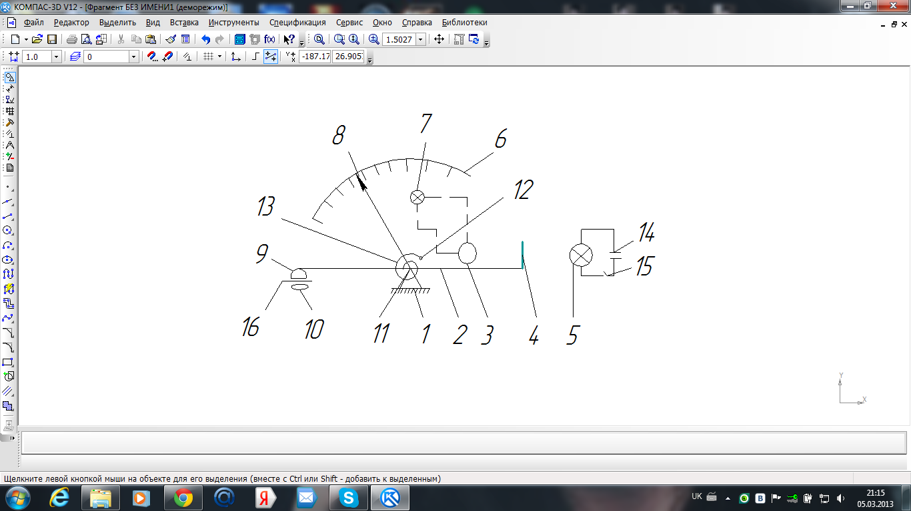
Fig. 5.2. The scheme of the instrument "ПОЖ-М": 1-support; 2- yoke; 3-FEU (electron photomultiplier); 4 – blind; 5 - electrolamp; 6 - scale; 7 - signal lamp; 8 - arrow; 9 - constant magnet; 10 - filter -accumulato; 11 - hinge axis; 12 – knob; 13 - spring; 14 - battery; 15 - tumbler switch; 16 - little table.

3. The operator starts to twist a knob (12). The spring (13) is twisted and an arrow (8), that is connected with a spring, slides along a scale (6). The spring aspires to pick off magnet from little table 5.1. Divisions into a device scale are marked in metal grammes on tone of oil (г/т). In what that the moment the spring will tear off magnet from little table.Yoke (2) will turn clockwise. The blind (4) will fall downwards and light from a lamp (5) will go on ФЭУ (3). The electron photomultiplier will include an alarm (7).
4. The operator stops to twist кремальеру. The arrow is stoped.
5. The operator reads out indications on scale.
6. Further points 1- 5 are carried out by the operator, but average and then small prints should are disposed in centre of the little table.
Order of work fulfilment.
- To study design and work of «ПOЗ-Т»;
- To Study the scheme ПOЖ-М and its work;
- To Receive the task from the teacher;
- The Given tasks (К₁, К₂, К₃) to enter into table 5.1.

- To calculate the sum of sizes К_{i}. Result to write down in table 5.1.
- To calculate segment (S) sizes of concentration of each kind of scobs on prints under the formula (1). Results to write down in the table 5.1.
Table 5.1
Results of calculations of interrelation of iron concentration on prints
Characteristic  of the print | Interrelation (K) of iron concentration on the print (i) |  |  | The sum  of sizes  К_{i}
Print number (i) | 1 | 2 | 3 | The sum  of sizes  К_{i}
Size of  Concentration on print  K (g/t) | К₁= | К₂ = | К₃=
Segment of size  concentration on print S (%) |  |  |  | 100

7. To do conclusions which are based on requirements а),в),с).
8. To prepare the report of laboratory work in which to include:
- the name and the work purpose;
- essence of differentially - magnetic method of diagnosing GTE;
- an order of creation of filter - accumulator;
- the scheme and work of the device “ПОЖ-М”;
- requirements to sizes of concentration of iron in engine oil;
- the formula (1) for calculation of concentration segment of iron in oil on each print;
- Table 5.1 with results of calculations;
- Conclusions
Questions for self-examination

1. In what essence of differentially - magnetic method of estimation of condition GTE ?
2. Denominate name of the basic parts "ПОЖ-М".
3. Describe work as “ПОЖ-М”

4. What for device "ПОЗ-Т" is necessary?
5. In what circumstance the engine is dislodged with operation?
Literature [3]

Laboratory work № 6
Research of technical condition of engine «AИ -25» on parameters of working process
The work purpose:
- To master principles of parametrical diagnostics of turbo jet engines;
- To study methods of reduction of parametres ГТД to standard atmospheric conditions;
- To investigate influence of external air temperature on diagnostic parameters of the engine;
- To receive practical skills of engine starting and diagnosing ГТД on parameters of working process.

Brief theoretical information
Technical diagnostics has many methods and means for estimation and research of technical conditions of aviation engines. Among them the special place is occupied the parametrical diagnostics. Engines are adapted in greater degree for diagnosing at the parameters of working process. Parametrical diagnostics provides for analysis of parameters of the engine on various behaviours of its work. Parametrical diagnostics is carried out stage by stage. The first stage provides measurement of parameters. For diagnosing ГТД many parameters are measured and analyzed. But the main are:
- Frequency of rotation of rotors (n);
- Temperature of gases behind the turbine (t);
- The hour expense of fuel (G).
Values are defined visually on instruments of the engine parameters. This information arrives to the operator in the form of records in logbook or in form of control cards of the techniques work in flight. But on modern aircrafts the systems are used for automatic control. In this case values are registered of parameters on magnetic means. However such values of parameters cannot be used for diagnosing of engines. The air temperature and pressure influence on values of parameters. This influence is necessary for excluding. Therefore reduce is executed of parameters values to flight conditions or to standard atmospheric conditions at the second stage. Such actions reduce influence of external conditions and dispersion of values of parameter a little. But it is not enough These parameters values are decreased in addition at the third stage. At this stage the parameters values are reduced to one behaviour of engine work. In further parameters values is smoothed and diagram is created of dependence П=f(t). The graphic is analyzed and decision is accepted about of possible operation of the engine. The problems of analysis - to find essential deviations in behavior of the diagram In the presence of malfunction.
As a whole all aircrafts can be divided into following groups:
- the first group is aircrafts which fly on altitudes of 10-11 thousand metres;
- the second group is aircrafts which fly on altitudes of 5-6 thousand metres.
For airplanes of the first group the engines parameters are reduced to flight conditions so. For frequency of rotation of high pressure rotor:
$n_{\text{вд}\text{.}\text{пр}}=\frac{n_{\text{вд}\text{.}\text{изм}}⋅K_{1}\sqrt{\text{244},2}}{\sqrt{T_{H}^{}}}$ (6.1)
where n_{вд.пр} - frequency has been reduced of high pressure rotor rotation; n_{вд.изм} - frequency of the high pressure rotor revolution by instrument; 244,2 - standard temperature of air at the altitude H=11000м. Units of measure are Kelvin’s; Tн* - actual temperature of air at the altitude of the aircraft flight. Units of measure are Kelvin’s; K₁ - it is factor which changes parameter units of measure (From percent in revolution in minutes). For example: for engine D-30 of the second series, K₁ = 116.77 revolutions in minute.
For temperature of gas after turbine
$t_{г\text{.}\text{пр}}=\frac{(t_{г\text{.}\text{из}}+\text{273})}{T_{н^{}}}−\text{273}$ (6.2)
where t₂*_{.пр} - temperature has been reduced of gas after the turbine; t₂*_{.изм} - temperature of gas after the turbine by instrument; 244,2 - standard temperature of air at the altitude H=11000 м. Units of measure are Kelvin’s; Tн* - actual temperature of air at the altitude of flight of the aircraft.
For of hours fuel consumption
$G_{T\text{.}\text{пр}}=\frac{G_{T\text{.}\text{изм}}⋅\sqrt{\text{244},2}⋅0,\text{3575}}{P_{H}^{}\sqrt{T_{H}^{}}}⋅\frac{1}{β_{\text{ir}}}$ (6.3)
where G_{T..пр} - hours fuel consumption has been reduced; G_{T.изм} -hours fuel consumption by instrument; 244,2 - standard temperature of air at the altitude H=11000 м T*_{н} - actual temperature of air at the altitude of flight of the aircraft. Units of measure are Kelvin’s; 0,3575-standard pressure of air at the altitude H=11000 м. Units of measure are atm; P*_{H} ⁻ pressure of air at the altitude of flight of the aircraft; β_{ir} - factor which determines influence of air temperature on the temperature of gases.
This coefficient is defined from following diagram (fig. 6.1).

Fig. 6.1. Dependency of the factor β_{ir} from temperature of
externally air
However at aviation factory the engine parameters are checked in conditions of the earth. Engines are subjected by bench tests. On engine «АИ-25» the check is carried out on revolutions of high pressure rotor (n_{вд} =95 %). The engine AИ - 25 is two rotor engine.
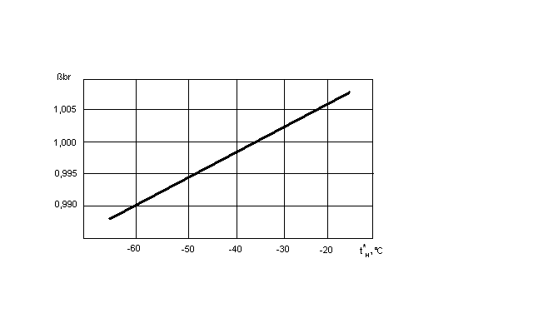
This engine has a rotor high (HPR) and of low pressure (LPR). Between rotors there is only gas - air communication. Therefore rotor (LPR) more sensitive to malfunctions of an gas - air flow duct. Consequently in operation it is necessary to analyze parameters of rotation LPR. This parameter is diagnostic. Parameter values are reduced to standard atmospheric conditions (t = + 15⁰с and Р = 760 мм.рт.ст.). For this purpose following formulas are used:
$n_{\text{нд}\text{.}\text{пр}}=\frac{n_{\text{нд}\text{.}\text{из}}\sqrt{\text{288}}}{\sqrt{T_{н}}}$ (6.4)
where n_{нд.пр} - revolutions have been reduced of low pressure rotor (%); n_{нд.из} - revolutions of low pressure rotor on instrument (%); 288 - standard temperature of the air on the earth; T_{н} - actual temperature of air on the earth.
$t_{g\text{.}\text{пр}}=\frac{(t_{g\text{.}\text{из}}+\text{273})\text{288}}{T_{н}}−\text{273}$ (6.5)
where t_{g.пр} - temperature has been reduced of gas after turbine; t_{g.из} - temperature of gas after turbine on instrument.
This parametre is diagnostic too. These parametrical values are written in the engine log book. The control of technical condition of the engine is actualized by means of comparison n_{нд.пр} (formula 6.4) and t_{g.пр} (formula 6.5), that are defined at engine test in operation, with values of these parametres from engine log book (n_{нд}._{.фор}) и (t_{g.фор} ).
Before work the students should be familiarized with elements of control system of start of the engine and control devices in an aircraft cabin. But it is necessary to devote serious consideration to questions of safety precautions and of starting engine operation preparation.
Work order
1. The «АИ-25» engine start preparation.
- remove air intakes and jet nozzles caps of the «АИ-25» and «АИ-9»;
- satisfy oneself about absence of extraneous subjects in inlet devices of engines;
- to check up free rotation of rotors HPR and LPR;.
- to check up presence of chocks under plane wheels.
To check up:
- electric current presence in onboard network;
- cleanliness of a ground under plane wheels;
- presence of fire-prevention means about the plane
- work of a control system as plane;
- work of converter ПO-1500.
The note. Engine starting «АИ-9» is carried out under the separate instruction.

2. Engine starting «АИ-25»
Before engine starting «АИ-25» it is necessary:
- to switch on automatic machines of protection network;
- to open shutoff valve of fuel system (for the chosen engine);
- to turn on in work the booster pumps of fuel system;
- a switch «Starting - engine dry starting - conservation» to put in position "Starting";
- a switch «Engine - medial - the left - the right» to put on engine that has been chosen;
- To put throttle lever in position «Small throttle»;
- To check up that the switch is stood in position "is switched off" of the engine electric stop;
- To be convinced of normal work of compressed air source ;
- To be convinced that pressure of air corresponds to requirements of airworthiness norms.
Call to attention of technicists by command "From engines!" And press the button “Start-up”. In the course of start the temperature of gases should not exceed 600^{о}С and frequency of rotor HPR rotation of should increase continuously to frequency of rotor rotation on small throttle (41-44 %). Further switch on electric generators and to increase frequency of rotor HPR rotation to 95 %.
3. To research of engine «АИ-25» technical condition.
For this:
- to define frequency of rotation LPR on instrument (n_{из} %);
- to define temperatures of gases behind the engine turbine on instrument (t_{g.из.}^{о}С);
- to write out the frequency has been reduced of rotation LPR from the engine log book (n_{ф} %);
- to write out temperature has been reduced of gases behind the turbine from of the engine log book (t_{g.ф}^{о}С);
- to define temperature of external air at date of parameters measurement (t_{н}⁰С);
- to calculate the actual frequency has been reduced of rotation LPR (n_{нд.пр.}) under the formula (6.4);
- to calculate the actual temperature has been reduced of gases behind the turbine (t_{g.пр}) under the formula (6.5);
- to calculate relative deviation of frequency has been reduced of rotation LPR (δn_{нд.пр)} from of engine log book value;
${δn}_{\text{нд}\text{.}\text{пр}}=\frac{n_{ф}−n_{\text{нд}\text{.}\text{пр}}}{n_{ф}}\text{100}$ (6.6)
- to calculate an absolute deviation of the temperature has been reduced of gases (∆ t_{g.пр}) from of engine log book value:
∆ t_{g.пр} = t_{g.пр} - t_{g.ф} (6.7)
All parameters values to write down in table 6.1, columns 1,2,3,4,5.
In a column (6) to write down decisions on each parameter.
Table 6.1
Values of parameters for accept decisions
n_{из} % | n_{ф}% | n_{нд.пр}  % | δn_{нд.пр}  % | t_{н}⁰С | Admissible  Parameters  Deviations
+1,5%;
- 2,5%
1 | 2 | 3 | 4 | 5 | 6
 |  |  |  | ╬
t_{g.из.}^{о}С | t_{g.ф} ^{о}С | t_{g.пр} ^{о}С | ∆ t_{g.пр} | ╬ | +60^{о}С

4. To investigate influences of temperature of external air
on diagnostic parameters.
For this purpose:
a) To obtain the initial data from the teacher.
b) To write down the initial information in table 6.2. (According to of the variant).
Table 6.2 (Variant )
Values of parameters for accept decisions
external air temperature
1.t_{в}⁰с =
2.t_{в}⁰с =
3.t_{в}⁰с =
4.t_{в}⁰с =
5.t_{в}⁰с =
Note:- If, according to variant, frequency has been reduced of rotor rotation (n_{нд.пр}) will be calculated, then to carry out points.c, d, e, f, g, h; - If according to variant, temperature has been reduced of gases behind the turbine (t_{g.пр}) will be calculated, then at once to carry out points k, l, m, o, p, r; c) To fix the first value of external air temperature; d) To calculate the values has been reduced (n_{нд.пр} %) for of each value (n_{из} %) and t_{в}⁰с that has been fixed. The formula (6.4). Thus
Tн = (t_{в} + 273) [K] (6.8)
e) Write down the result in table 6.2.
f) Register the second and the next values of external air temperature. Carry out points d) and e).
g) Construct the diagram of dependence n_{нд.пр} = f (t_{в}; n_{нд} _{из})
h) Make conclusions.
k) Register the first value of external air temperature .
Calculate the reduced values (t_{g.пр}) for each value (t_{g.из )} and register t_{в}⁰с. Use formula (6.8).
m) Write down in table 6.2.
o) Register the second and the next values of external air temperature. Carry out points l) and m).
p) Construct the diagram dependence t_{g.пр} = f (t_{в}; t_{g.из})
r) Make conclusions.
5. Prepare the laboratory work report which include:
- The name and the work purpose, number of variant;
- The design features of engine «АИ-25»;
- The list of the basic diagnostic parameters for estimation of engine «АИ-25» condition;
- Parameters of standard atmosphere;
- Formulas of reduction to standard atmospheric conditions of engine diagnostic parameters;
- Results of research of technical condition of engine «АИ-25» (Table 6.1);
- Results of research of influence of temperature external air on diagnostic parameters (Table 6.2).
- The diagram of dependence n_{нд.пр} = f(t_{в}; n_{нд} _{from}) or t_{g.пр} = f(t_{в}; t_{g.из}).
- Conclusions
Questions for self-examination
1. Essence of parametrical diagnostics GTE.
2. Stages of parametrical diagnostics GTE .
3. Why it is necessary to reduce parameters of the engine to flight conditions or to standard atmospheric conditions?
4. As the temperature of external air influences on diagnostic parameters.
5. To write out and explain formulas absolute and relative deviations of parameters from engine log book of values.
Literature [4]
Laboratory work № 7

Research of technical condition of the aircraft with the help
of fiberscopes
The work purpose:
- To study design and work of modern optical devices;
- To get acquainted with typical malfunctions of aircrafts and engines;
- To get practical skills of research of technical conditions aircrafts with the help of fiberscopes.

Brief theoretical information
On aircrafts there are many places access to which is impossible. Often in such places there are refusals which cause aviation incidents. There were fortuities of appearance of cracks in tanks of fuel system of the airplanes. Corrosion and cracks are dangerous on stringers of airplane tail unit. There were fortuities when hermetic is exfoliated from the upper panels of spar box. There are also other places on planes which difficultly to survey. But it is especially difficult to examine the closed parts of engines. Scratch and cracks arise on vanes of compressors and inlet guide vanes. Vanes of compressors can be contorted. This defect often arises on the big vanes of the fans. Cracks and burnouts arise in combustion chambers. Often colour is changed of fire tubes. It is a sign of combustion chambers the overheat. Gas erosion, scratches and cracks can arise on vanes of the turbines. Vanes can change its highness because of the big temperature of gases in front of the turbine.
To find out such defects it is impossible without special control devices. Therefore the optical control is important method of estimation of technical conditions of the closed places of the aircrafts and engines. In such cases various optical devices are used. These devices are shared on lenses and fibred. They have a different design and system of illumination of a subject which is looked over. Each of such devices carries out certain functions and is used for achievement of specific goals. Classification of such devices is shown on fig. 7.1.
Optical facilities
Inspection
of objects close to the observer
Inspection of object far from the observer
Inspection of object with covering
Magnifier glass
Microscopes
Binoculars
Binocular magnifiers
TV systems
Fiberscopes
Holography systems
Fig. 7.1. Classification of optical facilities of the checking

Such devices can be used and for an estimation of the sizes of defects (for example cracks and scratches) on open surfaces. For this purpose magnifiers and field-glasses are used. For more of complicated problems the cranked and lenses devices are used. But modern devices are based on glass fibber optics. These are devices are called fiberscopes. The principle of fiberscopes functioning is shown on fig. 7.2.
If the light beam (a-о) falls on a glass surface (m-m), it is reflected also the beam (o- б) arises. The angle ($α$) of beam comedown (a-о) is equal to angle ($δ$) of beam (о-б) that has been reflected. But in this case else one beam (o- в) arises. It is the refracted beam.

а n б
з
е ж к
$α$ $δ$

m o m
$β$
д
г
n в

Fig.7.2. Scheme of the rays of light passage

The angle ($β$) of aberration of this beam from a vertical axis (n - n) is more than angle ($α$). Further it is necessary to compare angles among themselves. But it is convenient to do using trigonometrical functions of these angles.
Then
$\frac{\text{sin}α}{\text{sin}β}=n$ (7.1)
where n – this is refraction factor.
At some angle ($α$₀) the angle ($β$) will be equal 90⁰ and sin$β$ = 1. In this case the equation (1) will have the following description.
$\frac{1}{\text{sin}α}=n$
$\text{sin}α_{0}=\frac{1}{n}$
The factor (n) differentiates in size for various environments (air, water, glass) in which the beam (о-в) extends. If to know environment and corresponding value of (n), then it is possible to direct the beam (а –o) under such angle ($α$₀) that the beam (о-в) will extend along of plane (m - m) and will enlight the object which is supervised. In this case intensity of luminescence of the beam (о-в) will differ a little from intensity of luminescence of the beam (а-о).
This is the way the fiberscope is functioning.

Work order
1. Study design and principle of work of optical devices.
2. Open the access hole on the AИ – 25 engine casing.
3 Look over working vanes of the third degree of low pressure compressor. For this purpose to use a fiberscope ОД- 203.
4. To examine the combustion chamber. To pay attention to a condition of fuel atomizers and of fire tubes. For this purpose to dismantle an igniter.
5. To open inspection small door on body of the engine turbine.
6. To examine working vanes of the first degree of the turbine.
7. The defects which have been found out in the course of surveys to describe in table1.
8. To estimate a technical condition of the engine.
9. To do conclusions.
10.To close all inspection small doors.
Table 7.1.
The description of the found out defects
The engine  assembly | The name of the unit | Description of defects

In protocol is necessary to present
1. Appellation and purpose of the work.

2. Brief theoretical information.
3. Work principle of fiberscopes.
4. Table 1 with results of surveys.
5. Сonclusions.

Questions for self-examination
1. What parts is difficult to review on aircrafts and engines?
2. What optical facilities are used for checking technical product ?
3. What is a fibefsckope?
4. How fiberscope works?
Literature [5]

Laboratory work № 8

Graphic-analytical method for estimating the boundary values ​​of the diagnostic parameter
Purpose of the work:
1) Attaching the theoretical knowledge of the graphic-analytical method for assessing the diagnostic value of the boundary parameter;
2) practical skills to determine the boundary values ​​of the diagnostic parameter X₀.

Brief theoretical information
Rule decision. Let performed diagnostics of technical state (TS) of a gas turbine engine (GTE) on the iron content in the oil (parameter x). Problem is to choose the parameter's value X₀ of parameter X in such way, that when X > X₀ need to decide on the removal GTE from exploitation, and if X <X₀ prevent further work.
Since the technical state of the system is characterized by a single parameter, the system has a one-dimensional space with signs. Distribution is carried out in two classes (differential diagram or dichotomy). Agree to consider: D1 - serviceable condition, D2 - defect. Then login decision rule is as follows:
If Х<Хо, X Є D₁; at Х>Хо, X Є D₂. (8.1)
The iron content in the oil bearing uniquely characterizes TS bearing (in the oil fall iron particles from the other parts: gears, slot, dowels, etc.). Depending on a number of factors of the distribution x, serviceable and defective bearings shown in fig. 8.1. Essential that field serviceable and defective states overlap and therefore fundamentally impossible to select X₀, in which the rule (8.1) shall not give to wrong decisions. Problem is that the choice was in some sense optimal, such as giving the least number of wrong decisions.

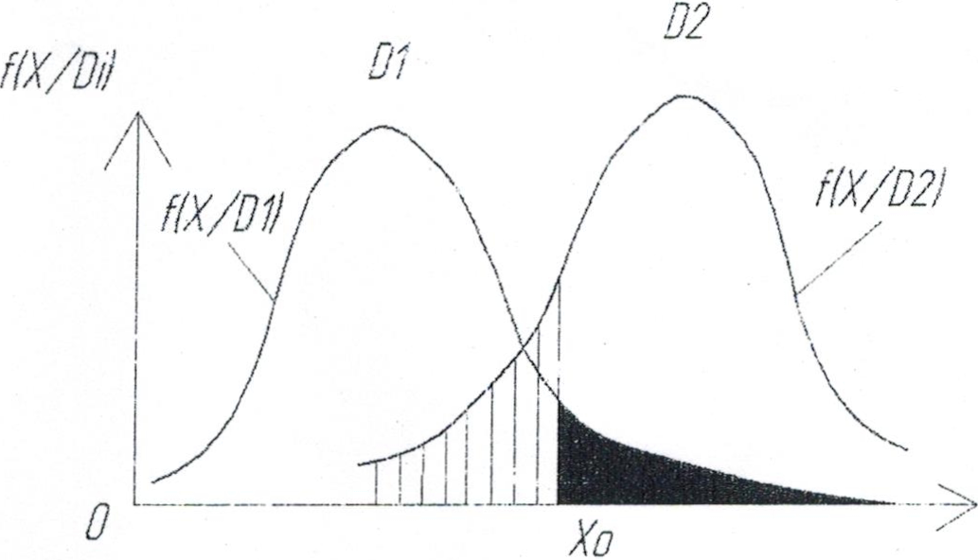
Fig. 8.1 Statistical distribution of the probability density diagnostic parameter X for the serviceable D₁ and defective D₂ conditions
Consider the possible errors in making decision.
False alarms called a case where it is decided to defect, but in reality the system is in serviceable TS, instead D₁ of take D_{2.}
Skip of the defect (aim) - the decision to defective TS, while the system has a defect, instead D₂ take D₁.
In theory, these errors are called control risk suppliers and risk of the customer. Obviously these some kind of error can have different effects and different prices.
Mark Н_{i,j} ( i,j=1,2 ) are possible solutions for the rule (1), і - corresponds to the index passed diagnosis, j - the index of the real ТS. Then Н₁₂ - pass the defect , and Н₂₁ - a false alarm, так як D₁ - serviceable ТS, D₂– defective ТS, Н₁₁ та Н₂₂ - the right decision.
Consider the probability of false alarm Р(Н₂₁) using rules (1), when Х>Хо object is serviceable, but the rule (1) is considered as defective. The area under the curve of probability density serviceable TS. Which corresponds to Х>Х₀ for serviceable products

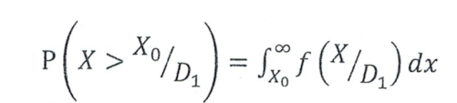 (8.2)
Probability of false alarm equal probability product of two events: the presence of the serviceable TS and value of Х>Х₀. Then

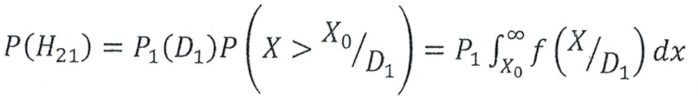 (8.3)
where Р₁=Р(D₁₎ - priori probability of diagnosis D₁ (assumed to be known based on previous statistics).
Similarly way find the probability of skipping defect.

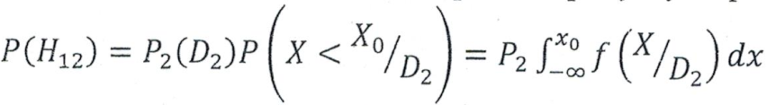 (8.4)
Medium risk. Probability acceptance of false decision is made on the probability of false alarm and skipping the defect. If the attribute "price" these errors, we obtain the expression for average risk

(8.5)
Price error has conditional value, it must take into account the effects of allowable false alarm and skipping the defect. In problems of reliability cost of admission defect usually cost significantly more false alarm (С₁₂››С₂₁). Sometimes the price is injected right decisions Н₁₁ та Н₂₂, which, for comparison with the cost of losses (errors) are taken to be negative. In general, the average risk (expected value of losses) is expressed by the equation
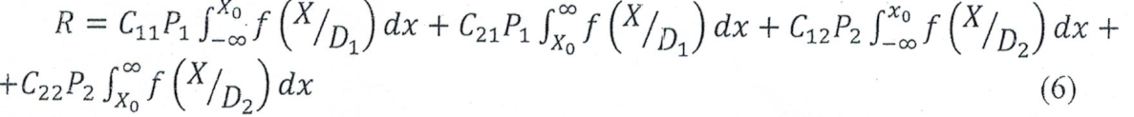(8.6)
The value of X, which seems to recognize is random and therefore equation (5) and (6) represent the mean value (expectation) of risk.
The method of minimal risk. Limit value X₀ in rule (1) in terms of the average level of risk is determined by differentiating (6) by X₀ and equating the derivative to zero. First, we obtain the extremum condition
(8.7)
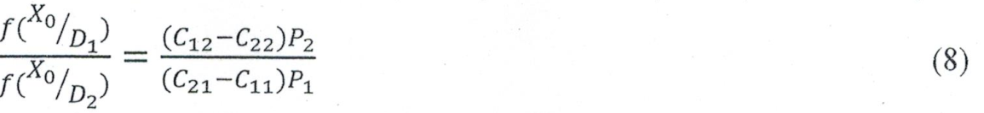 (8.8)
where C₁₂ - the price of admission defect; C₂₁ - cost of false alarms; C₁₁ <0 and C₂₂ <0 – cost of correct decisions (contingent winnings).
This condition often determines two values ​​X₀ of which one corresponds to the minimum, the second - the maximum risk (Fig. 8.2).

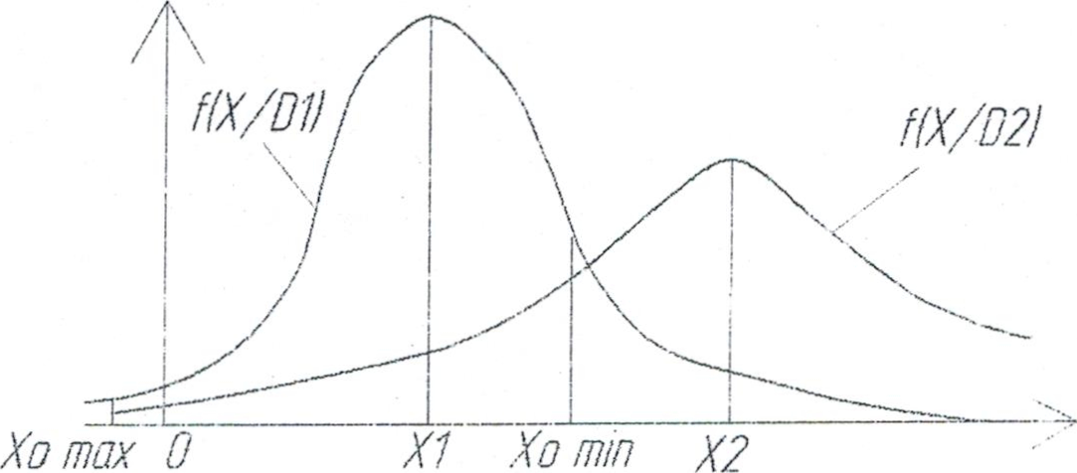

Fig.8.2 Extremum points of average risk of erroneous decisions
Relation (8) is a necessary but not sufficient condition for a minimum. For the existence of a minimum R at point X = X₀ second derivative must be positive 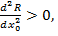which leads to the following conditions relative to the density distribution of derivative

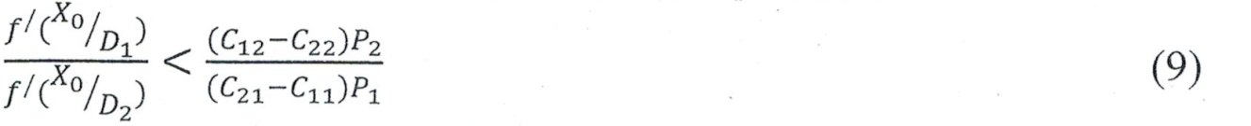
(8.9)

If the distribution f 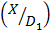 and f 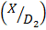 are one modal, no more then one point of maximum, then < X₀ < (10), condition (8.9) holds. Indeed, the right side of the equation is a positive value, and if Х> derivative f / < 0, whereas the Х< value f / > 0. For "two-humped" distributed (fig. 8.3) condition (8.9) should be checked at each point of extremum.

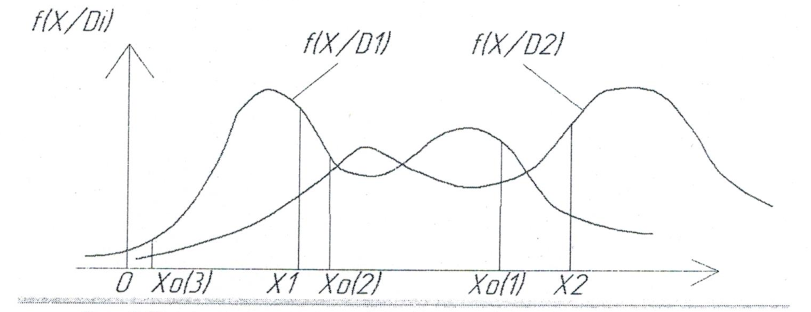

Fig.8.3. Extremum point for two-humped distributed
Further, when X₀ we mean boundary (threshold) values ​​of diagnostic parameters , which by rule (1 ) provides the minimum average risk . We assume the distribution f and f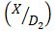one modal ("one coffin ") (see Fig. 8.1). Condition ( 8.8 ) is obtained , that the decision to refer of an object X to the state D₁ or D₂ may associate with the largest likelihood ratio . The ratio of the probability density distribution of X in two states , called the likelihood ratio .
In accordance with rule (1) by the method of minimal risk following a decision taken on the status of the object that has the given value of the parameter X:

X Є D_{1,} if
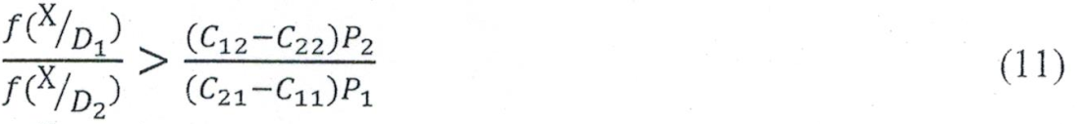
(8.10)

X Є D_{2,} if

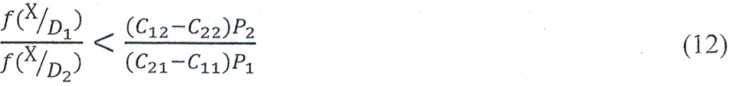
(8.11)
For the correct law:

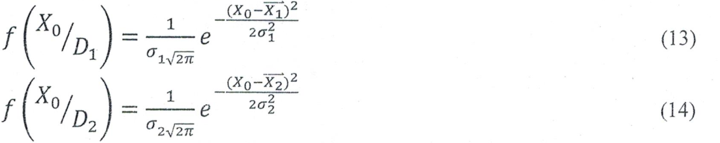
(8.12)
(8.13)

These equations can be substituted in equation (8.10). Then

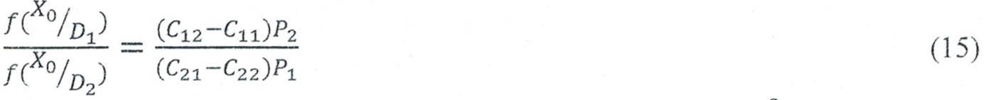
(8.14)
After conversion of (15) and the imposition of restrictions =Z, C₁ ₌0, C₂₂₌0, P₂ =1-P_{1,} Ϭ₁ =Ϭ₂ =Ϭ, we get

(8.15)

Substitute, let A= ln Z

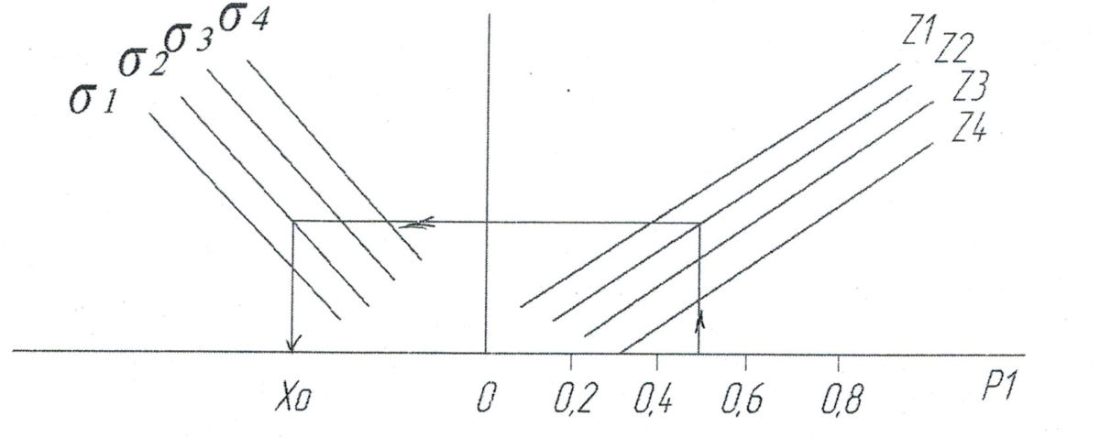

Fig. 8.4 Graph of dependence P₁ to Z and Ϭ

Questions for self-examination

1. Name, purpose and brief theoretical information.
2. Procedure performance.
3. Performance.
4. Conclusion.

Laboratory work № 9

Laboratory work is credit.

REFERENCES

1.Czchos H. Handbook of technical diagnostics / H. Czchos. - New York.: Springer, 2013. – 557p.
2.Roberts R. Learning Diagnosing Engine Problems / R. Roberts. - Powell Butte HWY : Bend, 2010. – 42p.
3. Устройство ПОЖ-М для определения содержания железа в масле ГТД. Техническое описание. - АТБ Быково, Московская обл.: - 1986.- 13 с.
4. Двигатель АИ-25. Инструкция по эксплуатации. Запорожье, ЗМКБ «Прогресс». : – 1963. - 87с.
5 . Эндоскоп ОД- 20З. Паспорт и техническое описание. Саратов,: - 1992г.- 9с.
6. Без дифракционный анализатор рентгеновский спектральный (БАРС- 3м). Техническое описание. Одесса. Завод «Красный Октябрь». – 1998. – 23с.

Навчальне видання

САПЕЛЮК Євген Антонович
БОГДАНОВИЧ Олександр Іванович
ПОПОВ Олександр Вікторович

Методичні рекомендації
(Англійською мовою)

