Task. Mach each description with the appropriate picture
- Crime: Bigamy
The suspect is described as a white female, 25-30 years old. She has long face, regular features, fair complexion, wavy hair, high and broad forehead, close-set eyes, penciled eyebrows, small ears, straight nose, thin lips, hollow cheeks pointed chin. She is tall and skinny. The main distinguishing feature is a big birthmark on her forehead.
- Crime: Armed Robbery
The suspect is described as a white male, 20-25 years old, of medium build. He has high forehead, bushy eyebrows, big ears, blue eyes, short brown hair, straight nose, full lips and pointed chin.
- Crime: Forgery
The suspect is described as a white male, 25-30 years old. He has oval face, regular features, fair complexion, short-cut hair, broad forehead, close-set eyes, bushy eyebrows, small ears, aquiline nose, thin lips, hollow cheeks and heavy beard with moustache. He is short and well-build.

- Crime: Murder
The suspect is described as a white male, 40-50 years old. He has round and plump face, large features, fair complexion, receding hair and short-cut, low forehead, close-set eyes, thick eyebrows, small ears, straight nose, thin lips, plump cheeks and massive chin. He is short and plump.
- Crime: Spying
The suspect is described as a white female, 25-30 years old. She has long face, regular features, fair complexion, curly hair, broad forehead, close-set eyes, penciled eyebrows, small ears, straight nose, thin lips, hollow cheeks pointed chin. She is tall and skinny.
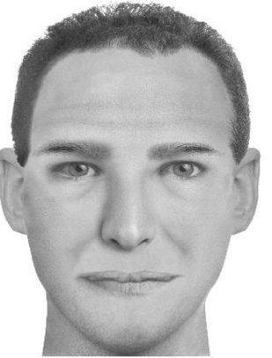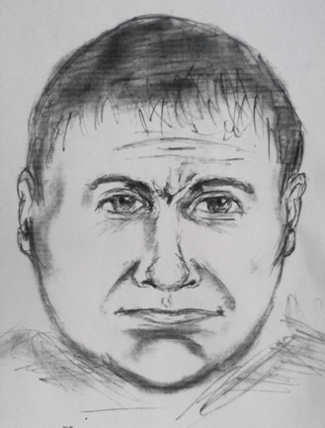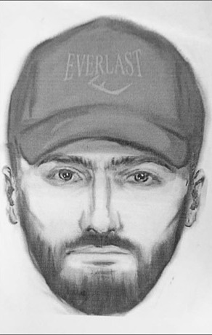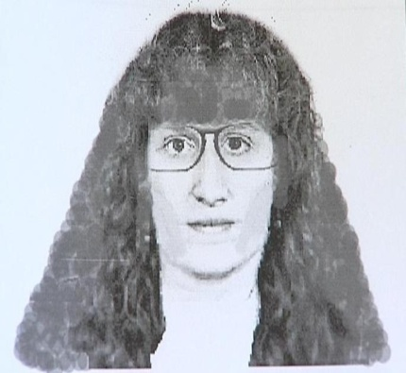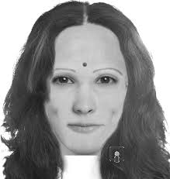
“Law Breakers”

 |  |  |  | ¹ |  |  |  |  |  | ⁷ | ⁸ |  | ¹⁰
 |  |  |  |  |  | ³
 |  |  |  |  |  | ⁴ |  |  |  |  |  |  |  |  | ¹⁵
 |  |  |  |  |  |  |  |  | ⁹
 | ² |  |  |  |  |  |  |  |  |  |  |  | ¹⁶
 |  |  |  |  |  |  |  | ¹²
 |  |  |  |  |  |  |  | ¹³
⁶ |  |  |  |  |  |  |  |  |  |  |  |  |  |  |  |  |  |  | ²¹
 |  |  |  |  |  |  |  | ¹⁷ |  |  | ¹⁸ |  | ¹⁹ |  | ²⁰
¹¹
¹⁴
 |  |  |  |  |  |  |  |  |  |  |  | ²²

Across:
2) deliberately causes damage to property  4) causes damage or disturbance in public places  6) breaks into houses or other buildings to steal  7) brings goods into a country illegally without paying tax  11)kills someone  12) makes counterfeit (false) money or signatures  13) gets secret information from another country  14) uses violence for political reasons  16) is someone who steals  17) takes control of a plane by force and  makes the pilot change course  22) sets fire to property illegally | Down:  1) is anyone who breaks the law  3) steals from shops while acting as an ordinary customer  6) marries illegally, being married already  8) attacks and robs people, often in the street  9) helps a criminal in a criminal act  10) is a member of a criminal group  15) betrays his or her country to another state  18) murders for political reasons or a reward  19) takes away people by force and demands money for their return  20) steals money, etc. by force from people or places  21) steals things from people’s pockets in crowded places

