UDC 378.141.4(043)
L.P. Korol, lecturer
(National Aviation University, Ukraine)
Types of study modes in the UK universities for specialist area Aerospace Engineering
This article deals with possible available study modes in the universities of the United Kingdom and their relevance in education system of Ukraine.
Aeronautical engineering is a fast-paced and popular area of engineering. With the global trend towards high-speed travel and the recent radical design of double-decker commercial aircraft, aeronautical engineers are of high demand throughout the world. So it is not a surprise that a big amount of universities in the world offer a degree in aerospace or aeronautical engineering. To the most prominent education providers in this sphere belong higher educational institutions of such countries as the United States of America, France, China etc. However, one should also point out the institutions of the United Kingdom, which have a very rich history of educating future aviation engineers. The first institution in the UK to teach in this field was Queen Mary, University of London, which, with the dissolution of the University of Paris (whose chair was founded at around the same time), maintains the longest continuous experience of doing so in the world.
Before reviewing the available study modes in the UK universities we should look closer at definition of this term. According to Glossary of Statistical Terms, mode of study refers to the study load of the student, whether full-time or part-time.[1] Higher Education Statistics Agency gives a more detailed view on the issue, claiming that a mode of study indicates the method by which a student is being taught their study programme. There are three main study modes:
- Full-time
- Sandwich (thick and thin respectively)
- Part-time
The Funding Councils have agreed that a common definition of full-time is that years of programme of study must involve a minimum of 24 weeks study (note that this definition does not apply to full-time final year students in institutions in Wales). Each Funding Council may also have further additional conditions. HESA will apply the 24 week rule to its definition of full-time in publications. Studying full-time allows students to focus intensively and without interruption on their academic development. Another advantage of this mode is that if a student is just having a career break, he or she will have an opportunity to complete a degree and finish studying in the shortest period of time.
Sandwich study mode is offered by some universities where some of studies take place working in industry or studying abroad. Sandwich courses normally last for four years at degree level, with work experience or foreign studies commonly taking place in a third year. Some universities arrange placements for their students, but others expect them to find one on their own. However, it is considered to be a kind of full-time study mode.
Thick sandwich students are those for which an industrial (or other) placement causes a continuous absence from full-time study of at least one academic year. A record must be returned for every student enrolled on a sandwich course irrespective of whether they are in attendance at the institution or engaged in industrial training. Students should be coded as sandwich for every year of the course and not just those in which industrial experience takes place. A thin sandwich must involve the student in an average of more than 21 hours study a week for a minimum of 24 weeks study/placement. [2]
The majority of taught degrees are available part time.Part-time students are entitled to the same supervision and tuition as full-time students, on a pro-rata basis, and to full use of university facilities and social amenities (except university accommodation). The study patterns for part-time courses vary but are normally integrated with the corresponding full-time degrees (refer to individual course entries at Postgraduate study). This means that teaching is generally carried out during the day and a minimum level of attendance is needed during term time to fulfill the requirements of the course. One can transfer from full-time to part-time study, and vice-versa, with their supervisors’ approval.
The statistical research among the first year UK students shows that full-time mode is a prevailing one both for undergraduate or postgraduate students.
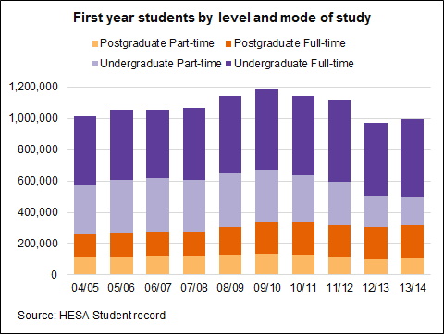

We have analyzed types of study modes available in the main universities of UK that offer various degrees connected with aviation engineering. The list of these universities is provided by Universities and Colleges Admissions Service search tool [3]. There are 45 major providers, such as University of Bath, Birmingham, Bristol, London, Cambridge etc. As we can see, all universities provide future aviation engineers of different specializations with the full-time study mode. There are also 17 propositions of sandwich study mode with on job training, namely they are available Bristol (UWE) University of the West of England, Teesside University, Staffordshire University, Queen’s University at Belfast and others. Only three providers give their students an opportunity to study full-time with study abroad. These are University of Hertfordshire, University of Leeds and University of Southampton.
Conclusions
All things considered, there are three basic study modes available in universities of the United Kingdom, which are the full-time, sandwich, part-time study modes. However, only first two modes are available for students who wish to study as aviation engineers and obtain a degree in this field. Part-time study mode is considered to be inefficient in higher education of aeronautical and aerospace engineers in the United Kingdom, so we suggest future consideration of this issue in order to find the necessity of having such study mode available for would-be specialists in this field in Ukraine.
References
- https://stats.oecd.org/glossary
- https://www.hesa.ac.uk/component/collns/?task=show_manuals&r=03011&f=070
- http://search.ucas.com/

