(F __- ___)
MINISTRY OF EDUCATION AND SCIENCE OF UKRAINE
National Aviation University
Educational and Scientific Law Institute

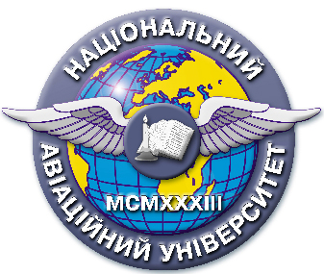
Quality management system

EDUCATIONAL AND METHODICAL COMPLEX
educational discipline
" Problems of criminal-legal protection of human rights and citizen "

for the field of knowledge 08 "Law"
specialty: 081 "Law"

QMS NAU 13.01.03-01-2018

KIEV

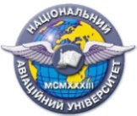 | Quality management system  EDUCATIONAL AND METHODICAL COMPLEX  educational discipline  «Problems of criminal-legal protection of human rights and citizen» | Document Code | QMS NAU CTP  09.01.06-01-2018
 |  | P. 2 of 2

Developed by
Doctor of Law, professor S. Likhova

Discussed and approved by the Department of Criminal Law and Process, Minutes № ___ of " " 2018.

Head of the Department S. Likhova

Discussed and approved by the Scientific – Methodological – Editorial Board of the Educational and Research Institute of Law, Minutes № __ of " " 2018.
Head of the SMEB ____________V. Vyshnevetskii

