Transport. –2016. – V.31. – №1. – P.22–28.

**MODELING OF SATELLITE COMMUNICATION LINKS**

**WITH ORTHOGONAL FREQUENCY-DIVISION MULTIPLEXING**

Kharchenko V.P., Wang Bo, Grekhov A.M., Leschenko A.M.

Submitted Day Month Year; accepted Day Month Year

**Abstract.**Global technologies of data transmission in real time are developing constantly. Therefore modeling of messages transmission through satellite constellations is an actual problem. In this paper the original model of a communication channel "Vehicle-to-Satellite-to-Ground Station" based on principles of the IEEE 802.11a standard is designed using MATLABSіmulіnk software. The model allows simulating data transmission with data rate from 6 to 54 Mbit/s using adaptive modulation. For uplink/downlink two types of channels were analyzed - a free space path losses with phase/frequency offset and AWGN link. On the base of this model channel integrity was investigated and dependences of a signal-noiseratio (SNR) on free space path losses, antennas diameters, number of OFDM symbols and satellite transponder noise temperature were received.

**Key words**: satellite communication channel, vehicle, satellite transponder, ground station, convolutional coding, free space loss, phase/frequency offset, Viterbi decoder, transponder noise temperature, antenna diameter.

**1. Introduction**

Remote satellite communications allow obtaining and sending info and data messages over long distances very simple and easy (Elbert 2008). Satellitessuccessfullyservetraditional-telephony andbroadcasting -markets, covering a large geographic areawithtransmissionin a single beam. Currently, there isa demand fortwo-waybroadbandaccessin the majorgeographic areasnot served bytelecommunication infrastructure. Therefore,satellitebroadband technologyis critical to thespread ofmultimedia services and applicationsthroughout the world ([Gómez](http://www.google.com.ua/search?hl=ru&tbo=p&tbm=bks&q=inauthor:%22Jorge+Matos+G%C3%B3mez%22) 2002). This technologyalreadyexistsandallows creatinga huge numberof interconnectedbroadband networksin spaceavailable fora dynamic and competitivemarket (Roddy 2006).

A newgeneration of applications has appearedthat requirehigh bandwidth, and satellitessatisfythese needsin a highthroughput.Satellite systemsare optimizedfor services suchas internet access, virtual private networks, andpersonal access. It is expectedthat the number ofsatellite broadbandsubscribersworldwidewill grow to about 6millionin 2020 (ITU 2012).

The only servicing the Asia-Pacific satellite with high bandwidth is THAICOM-4 (IPSTAR). This is the satellite with multiple spot beams and direct relay board without regenerative payload. It provides a full range of nationwide broadband satellite services in Australia, Cambodia, China, India, Indonesia, Japan, Malaysia, Myanmar, New Zealand, Philippines, Republic of Korea, Thailand and Vietnam, and has 18 gateways located in the countries it serves. Custom beams operate in the Ku, and gateway services - Ka-band. IPSTAR has 84 focused beam, a special form of the three beams and the maximum bandwidth 45 Gbit/s. Satellite provides a variety of services for state, commercial and industry sectors: controlled cell transit lines for virtual private networks, satellite news gathering, telephone service in rural areas, retail broadband, communications for the reconstruction of disaster and emergency communications and distance learning (THAICOM-4 (IPSTAR) 2014).

For wide dissemination of satellite communications is necessary to eliminate two disadvantages. The first drawback - the delay (the time required to send and receive messages). It depends on the distance between the satellite and the Earth. The second is caused by that satellite signals can be loosened under the influence of rain or atmospheric conditions. To address these shortcomings, there are technical ways related to satellite orbits and to the available radio spectrum - two elements occupying a central place in the satellite system (Osborne, Xie 1999).

In a traditional satellite communication technology a single beam is used to cover all continents and regions. Recently, several narrowly focused beams are used what allow reuse of frequencies to increase a bandwidth of 20 times or more compared to conventional satellites. Despite the higher costs associated with the technology of the focused beam, a channel estimated value is much lower than the technology based on a special shape of the beam (Manual 2007, Iridium 2008).

Remote satellites are used asa service for automationthe processes of planning.Manufacturers anddistributors of various goods, companiesin wholesale and retailtrade, including theonline shopping, scope of service (vending machines, couriers, garbage removal and maintenance), nationallogisticsandpostalcompanies will benefit from the use of remote satellites(Astrium 2013, Intelsat 2012). Using satellite communication channels it is possible instantly build the best routes for each car, distribute the load on cars taking into account their suitability, save the time and exclude errors (human factor), integrate with any CRM (Client Relationship Management) or accounting system for the transfer of orders, predict the exact arrival of car to the point of the destination, to access the system from any computer or tablet (Qualcomm 2013).

Mobile satellite telecommunication technologies evolve in the direction of the creation and development IP networks, new technologies using spectrally efficient signal-code constructions based on the use of FM modulation (M-PSK), M-QAM modulations, technologies of Orthogonal Frequency Division Multiplexing (OFDM) and Multiple-Input Multiple-Output (MІMO), which combines the spatial diversity and OFDM (Dahlman *et al.* 2011, Hanzo*et al.* 2011).

In a broadband wireless access main destructive factor for the digital channel is interference from multipath reception. This type of interference is very characteristic for radio reception in cities with buildings of different heights due to multiple signal reflections from buildings and other structures. A radical solution to this problem is the use of OFDM technology, which is specifically designed to deal with interference of multipath reception. In OFDM technology serial data stream is converted to a large number of parallel streams (sub-carriers), each of which is transferred on a separate carrier (Chang 1996).

Frequency spacing between adjacent carriers of OFDM spectrum is selected from the condition of the possibility to release individual carriers in the demodulator. OFDM is characterized by strong overlap of adjacent sub-carriers spectra, which reduces the frequency spacing and in the same time increase the density of digital information transmission. Due to the orthogonal demodulation method of subcarriers the compensation of interference from adjacent frequencies takes place, despite the fact that their sidebands are overlapping (Ohno, Giannakis 2002).

Due to the fact that a large number of parallel streams are used the symbol duration in parallel flows is substantially longer than in the serial data stream. This allows delaying an estimation of received symbols in the decoder for the time during which change the radio channel parameters due to the echoes will be stopped, and the channel will be stable.

OFDM sub-carrier symbol timeslot is divided into two parts - a guard interval, during which the evaluation of the character in the decoder is not performed and the working symbol interval, during which a decision about the received symbol value is made (Ma *et al.* 2003).

Modeling of satellite telecommunications channels without error-control coding was realized previously in our papers (Kharchenko *et al.* 2012a, 2012b, 2013a, 2013b).

The aim of this paper is to investigate conditions for effective messages transmission: 1) to design the model of communication channel "Vehicle-to-Satellite-to-Ground Station" with error-control coding using MATLAB Simulink software; 2) on the base of this model investigate a channel integrity and receive dependences of a signal-noiseratio (SNR) on a free space path loss, antennas diameters, number of OFDM symbols and satellite transponder noise temperature; 3) to analyze two types of uplink and downlink channels (with a free space path loss and phase/frequency offset and with additive white Gaussian noise (AWGN)).

**2. "Vehicle-to-Satellite-to-Ground Station"Link Design**

The model is based on principles of the IEEE 802.11a standard (IEEE 2003, Clark 2003) which is commonly used today for providing wireless connectivity in the home, office and commercial establishments. The communication range depends on the transmitter power, the receiver design, jamming and signal path. It is necessary to take into account the interaction of radio waves with ordinary objects of the building, such as the walls, metal structures, and even people in order to provide the necessary range of signal propagation. Scope of satellite systems with powerful transmitter and perfect antenna can reach the necessary range for communication with the low-orbit satellites.

Created model supports data rates 6, 9, 12, 18, 24, 36, 48, and 54 Mb/s, uses adaptive modulation and coding over a satellite communication channel with free space path losses, whereby the simulation varies the data rate dynamically.

The model (Fig. 1) for adaptive modulation in free space satellite communication channel "Vehicle-to-Satellite-to-Ground Station"consists of “Vehicle Transmitter” (Variable-Rate Data Source, Modulator

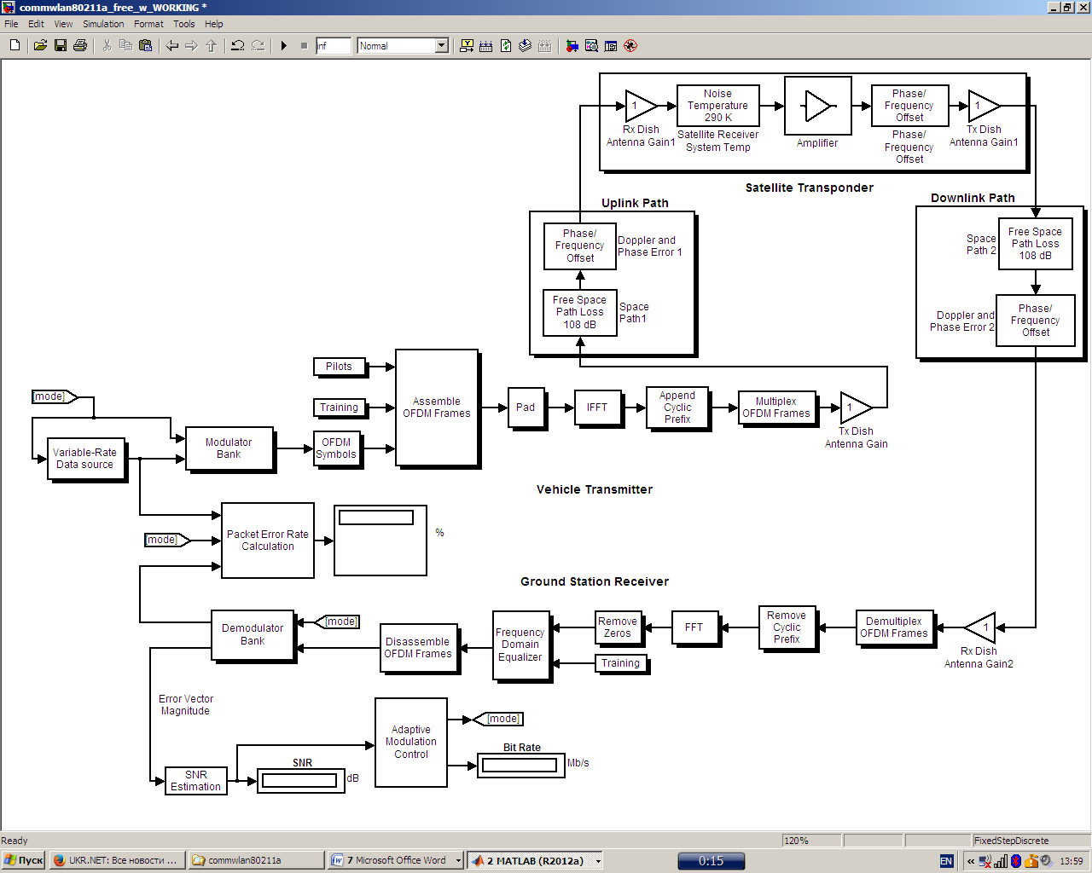

**Fig. 1.**Model of "Vehicle-to-Satellite-to-Ground Station" link

Bank, OFDM Transmitter, Transmitter Dish Antenna Gain), “Uplink Path” (Free Space Path Loss, Phase/Frequency Offset), “Satellite Transponder”(Receiver Dish Antenna Gain, Satellite Receiver System Temperature, Complex Baseband Amplifier, Phase/Frequency Offset, Transmitter Dish Antenna Gain), “Downlink Path” (Free Space Path Loss, Phase/Frequency Offset), “Ground Station Receiver” (Receiver Dish Antenna Gain, OFDM Receiver, Demodulator Bank), “Packet Error Rate Calculation block”, “SNR Estimation”, and “Adaptive Modulation Control”.

Parameter settings for the model are the following: Viterbi traceback depth is 34 (Viterbi 1971), hysteresis factor for adaptive modulation (dB) is 3, numbers of OFDM symbols per transmit block are 20 and 1000, number of OFDM symbols in training sequence is 4, Low-SNR thresholds (dB) vector [10 11 14 18 22 26 28] where 10 is for BPSK ½, 11 - for BPSK ¾, 14 - for QPSK ½, 18 - for QPSK ¾, 22 - for 16-QAM ½, 26 - for 16-QAM ¾, and 28 - for 64-QAM 2/3.

Low-SNR thresholds parameter is a seven-element vector that indicates how the simulation should choose a data rate based on the SNR estimate. The model has eight modes, each associated with a particular modulation scheme and convolutional code. The seven thresholds are the boundaries between eight adjacent regions that correspond to the eight modes. Ideally, the simulation should use the highest-throughput mode that achieves a desired (zero) packet error rate. Determining appropriate thresholds often involves running the simulation multiple times, varying the values of the Low-SNR thresholds parameter.

The communication system in this model performs such tasks as: generation of random data at a bit rate that varies during the simulation; coding, interleaving, and modulation using one of several schemes specified in the standard; OFDM transmission using 52 subcarriers, 4 pilots, 64-point FFTs (Fast Fourier Transform), and a 16-sample cyclic prefix; physical layer convergence protocol preamble modeled as four long training sequences.

In the “Vehicle Transmitter” Variable-Rate Data Source block generates random data and includes binary source. Binary data are created according to the SNR estimation at the receiver.

Modulator Bank block performs convolutional coding and puncturing using code rates of 1/2, 2/3, and 3/4; data interleaving; BPSK, QPSK, 16-QAM, and 64-QAM modulations.

Padding block changes the dimension of input matrix along its columns, rows, or both of them according to the specified values. Each row is equal to one subcarrier. Thus, rows are in the frequency domain and columns are in the time domain.

OFDM transmitter comprises Pilots, Training, OFDM Symbols, Assemble OFDM Frames, Pad, IFFT (Inverse Fast Fourier Transform), Cyclic Prefix, and Multiplex OFDM Frames block.

In order to create the OFDM symbol a serial to parallel block is used to convert N serial data symbols into N parallel data symbols. Then, each parallel data symbol is modulated with different orthogonal frequency subcarriers, and added to an OFDM symbol. All modulated subcarriers are added together to create the OFDM symbol. This is done by an Inverse Fast Fourier Transformation (IFFT). The advantage of using IFFT is that the system does not need N oscillators to transmit N subcarriers. Assemble OFDM Frames is applied in order to insert the pilot and training symbols into the OFDM symbols. Four pilots are inserted between the assemble subcarriers and then training sequence is added to the subcarriers.

In the “Uplink (Downlink) Path” Free Space Path Loss block simulates the loss of signal power due to the distance between the aircraft uplink transmitter and the satellite transponder receiver. The block reduces the amplitude of the input signal by an amount that is determined by the Loss (dB) parameter.

Phase/Frequency Offset block applies a frequency and phase offset to the input signal.

In the “Satellite Transponder” the Satellite Receiver System Temperature block simulates the effects of thermal noise on a complex, baseband signal. Modeling was provided for two values of effective satellite and ground station receiver systems noise temperatures 20 K (very low noise level) and 290 K (typical noise level). Satellite repeater or amplifier is a complex baseband model of amplifier with noise. Only linear amplifier was considered during investigation with gain equaling 1 dB.

Satellite Receiver System Temperature adds receiver thermal noise to complex baseband signal.

In the “Ground Station Downlink Receiver” the Viterbi Decoder block decodes input symbols to produce binary output symbols. Unquantized decision type parameter was used. The receiver performs the reverse operations of the transmitter, with additional training tasks.

Packet Error Rate Calculation block shows the packet error rate as a percentage and should always equal 0 during investigations.

SNR Estimation block estimates the SNR based on the error vector magnitude.

Adaptive Modulation Control takes into accounts Low-SNR thresholds, Hysteresis factor, and Bit rates. Adaptive modulation systems improve the rate of transmission. The implementationof adaptive modulation is according to the channel information that ispresent at the transmitter. The method of making adaptive modulation in thismodel is according to the estimated SNR, a bit rate will be specified and thendata source generates binary data according to the specified data rate in adaptivemodulation control.

The error rate calculation block calculates the bit error rate, by comparing thereceived data with transmitted data.

The Transmitter (Receiver) Dish Antenna Gain block multiplies the input by a constant value (gain). Dependencies of a SNR and modulation mode on transmitting and receiving antennas diameter at various free path losses were obtained using vectors [d1, d2] for each pair “transmitter-receiver”. The first element in the vector [d1, d2] represents the transmitting antenna diameter (in meters) and is used to calculate the gain in the Transmitter Dish Antenna Gain block. The second element represents the receiving antenna diameter and is used to calculate the gain in the Receiver Dish Antenna Gain block. Diameters of all antennas (transmitting antenna on a vehicle, receiving and transmitting antennas on a satellite, receiving antenna on a ground station) were changed simultaneously.

**3. Satellite Channels PerformanceSimulation**

For the communication channels of the first type with a free space path loss and phase/frequency offset dependencies of a SNR on free path losses for different modulation modes, antenna diameters, transponder amplifier linear gain and transponder noise temperatureare shown in Fig. 2.For this modeling the following parameters in the model were set up: phase/frequency offsets in uplink/downlink and satellite transponderare equal to zero; the gain of linear amplifier in satellite transponder was taken 1, 3, 12; free space path losses were taken in such a way that packet error rate always equals zero; number of OFDM symbols in training sequence is 4. The number of OFDM symbols per transmit block was taken 20 and 1000.

As follows from Fig. 2 for the communication channels of the first type changing of all antennas diameter and different transponder noise temperatures has significant influence oncharacter of dependencies. At the same time the number of OFDM symbols per transmit blockpractically does not change the dependencies.

For comparison of a free space path loss channel with AWGN channel the same model was taken but uplink/downlink was substituted by ‘AWGN’ block to simulate AWGN channel. The AWGN Channel block adds white Gaussian noise to input signal.

As follows from Fig. 3 for the communication channels of the second type changing of all antennas diameter has significant influence on character of dependencies. At the same time the number of OFDM symbols per transmit block practically does not change



**Fig. 2.**Dependence of SNR on free path losses for different modulation modes (1 - BPSK ½, 2 - BPSK ¾, 3 - QPSK ½, 4 - QPSK ¾, 5 - 16-QAM ½, 6 - 16-QAM ¾, 7 - 64-QAM 2/3, 8 - 64-QAM ¾), antenna diameters and transponder noise temperatures: dots – number of OFDM symbols per transmit block is 20, circles – number of OFDM symbols per transmit block is 1000; antennas gains:G1=1 (d1=d2=d3=d4=0.03 m), G2=3 (d1=d2=d3=d4=0.1 m), G3=12 (d1=d2=d3=d4=0.4 m).



**Fig. 3.**Dependence of SNR on SNRAWGN for different modulation modes (1 - BPSK ½, 2 - BPSK ¾, 3 - QPSK ½, 4 - QPSK ¾, 5 - 16-QAM ½, 6 - 16-QAM ¾, 7 - 64-QAM 2/3, 8 - 64-QAM ¾), antenna diameters and transponder noise temperature 290 K: dots – number of OFDM symbols per transmit block is 20, circles – number of OFDM symbols per transmit block is 1000; antennas gains: G1=1 (d1=d2=d3=d4=0.03 m), G2=3 (d1=d2=d3=d4=0.1 m), G3=12 (d1=d2=d3=d4=0.4 m).

the dependencies.

In the presence of an arbitrary phase/frequency offsets introduced by theuplink/downlink and satellite transponder the demodulator sometimes is unable to tell which constellation point is which. End signal constellations for two types of communication channels are shown in Fig. 4 and 5 for the specific case when conditions for signals propagation are almost similar. Nevertheless the type of a communication channel playsa majorrole indetermining the nature ofthe signal constellation.

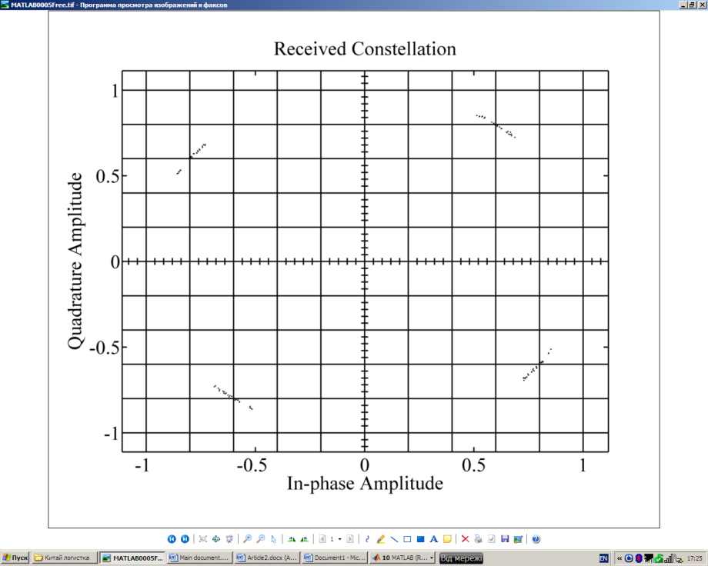

**Fig. 4.**End signal constellation for the communication channels of the first type with a free space path loss and phase/frequency offset: free path losses are 50 dB in the uplink/downlink; phase offsets are 40o, frequencies shifts are 150 Hz in the uplink/downlink and satellite transponder; number of OFDM symbols per transmit block is 20; antennas gains are G=1; SNR=16,5 dB; bit rate 12 Mb/s; satellite transponder noise temperature 290 K

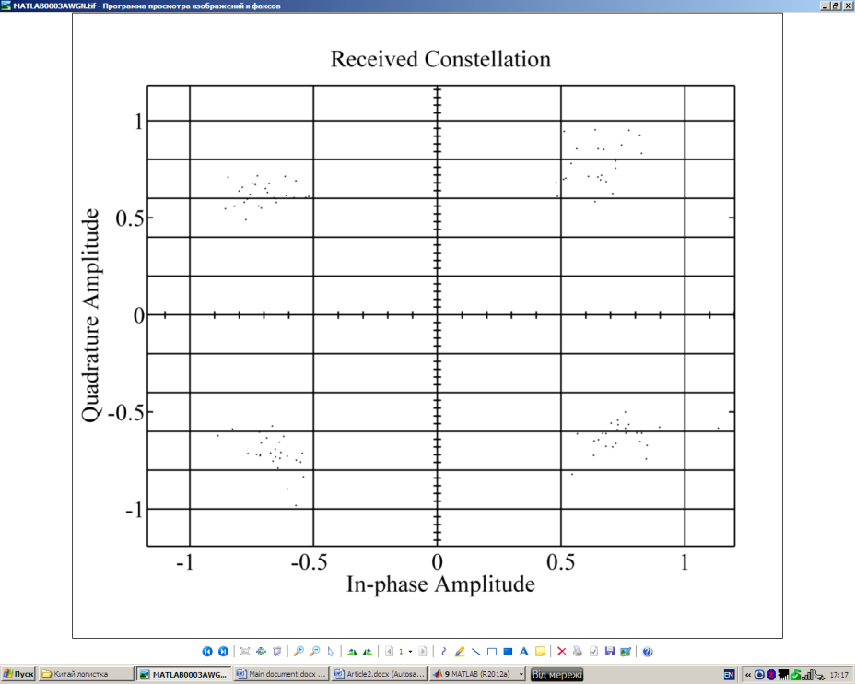

**Fig. 5.**End signal constellation for the communication channels of the second type with AWGN: SNRAWGN = 18 dB in the uplink/downlink; phase offset is 40o, frequency shift is 150 Hz in the satellite transponder; number of OFDM symbols per transmit block is 20; antennas gains are G=1; SNR=16,7 dB; bit rate 18 Mb/s; satellite transponder noise temperature 290 K

**4. Conclusions**

For modelling of messages transmissionvia low-orbit satellite constellation the original model of a communication channel "Vehicle-to-Satellite-to-Ground Station" was built using MATLABSіmulіnk software.

Two types of uplink and downlink channels with a free space path loss and phase/frequency offset and AWGN were investigated.

Dependencies of a signal-noise ratio on free space path losses, antennas diameter, number of OFDM symbols and satellite transponder noise temperature were received and analyzed.

Signal changes were analyzed by means of active windows-indicators which allowed defining constellations of the transmitted and received signals (Fig. 4, 5).

This model can be used as basic model for investigation of communication between manyvehiclesand ground stations using several satellites.

This paper covers evaluation of “Satellite-to-Aircraft” link performance which can be used for self-separation of unmanned aircraft systems (in particular for remotely piloted aircraft).

**References**

Astrium Services. 2013. Available from Internet: <http://www.marlink.com/news-astrium-services-opens-rotterdam-based-global-logistics-centre.html>

Chang, R. W. 1996. Synthesis of Band Limited Orthogonal Signals for Multichannel Data Transmission. *Bell Syst. Tech. J.*, Vol. 45: 1775-1796.

Clark, M. 2003. IEEE 802.11a WLAN model.

Available from Internet: <http://www.mathworks.com>/mat-

labcentral/ﬁleexchange/3540.

Dahlman Е.; Parkvall S.; Skold J. 2011. *4G LTE/LTE-Advanced for Mobile Broadband*. Oxford, UK: Academic Press. 2011. 431 p.

[Elbert](http://www.google.com.ua/search?hl=ru&tbo=p&tbm=bks&q=inauthor:%22Bruce+R.+Elbert%22), B. R. 2008. *Introduction to Satellite Communication*. Artech House. 447 p.

[Gómez](http://www.google.com.ua/search?hl=ru&tbo=p&tbm=bks&q=inauthor:%22Jorge+Matos+G%C3%B3mez%22), J. M. 2002. *Satellite Broadcast Systems Engineering*.Artech House. 238 p.

Hanzo, L.; Akhtman Y.; Wang L. 2011. *MIMO-OFDM for LTE, WiFi and WiMax. Coherent versus Non-coherent and Cooperative Turbo-transceivers.*  West Sussex, UK: John Wiley & Sons. 658 p.

IEEE 802.11. 2003. Wireless LAN medium access control (MAC) and physical layer (PHY) speciﬁcations.

Intelsat. 2012. Available from Internet: http://www.intelsatgeneral.com/category/tags/logistics.

ITU Broadband Reports. 2012. Available from Internet: [www.itu.int/broadband](http://www.itu.int/broadband).

Iridium Satellites. 2008. Available from Internet:<http://www.highspeedsat.com/iridium-satellite.php>.

Kharchenko, V. P.; Barabanov, Y. M.; Grekhov, A. M. 2012a. Modeling of Aviation Telecommunications,*Proceedings of the National Aviation University* (1): 5-13.

Kharchenko, V. P.; Barabanov, Y. M.; Grekhov, A. M. 2012b. Modeling of Satellite Channel for Transmission of ADS-B Messages,*Proceedings of the National Aviation University* (3): 9-14.

Kharchenko, V. P.; Barabanov, Y. M.; Grekhov, A. M. 2013a.

Modeling of ADS-B Data Transmission via Satellite. *Aviation*[17](http://www.tandfonline.com/loi/tavi20?open=17#vol_17)[(3](http://www.tandfonline.com/toc/tavi20/17/3)): 119-127.

Kharchenko, V. P.; Barabanov, Y. M.; Grekhov, A. M. 2013b.

Modelling of ‘Satellite-To-Aircraft’ Link for Self-Separation.*Transport* 28(4).

Ma, X.; Giannakis, G. B.; Ohno, S. 2003. Optimal training for block transmissions over doubly selective wireless fading channels. *IEEE Trans. Signal Processing*. 51(5): 1351-1365.

Manual for ICAO Aeronautical Mobile Satellite (Route) Service Part 2-Iridium Draft V4.0. 2007. 77 p.Available from

Internet:http: //legacy.icao.int/anb/panels/acp/wg/m/iridium_swg/.

Ohno, S.; Giannakis, G. B. 2002. Optimal training and redundant precoding for block transmissions with application to wireless OFDM. *IEEE Trans. Commun.* 50(12): 2113-2123.

Osborne, W. P.; Xie, Y. Propagation Characterization of LEO/MEO Satellite Systems at 900-2100 MHz. 1999. Emerging Technologies Symposium Wireless Communications and Systems, 21.1-21.8,*IEEEConference Proceedings*. Available from Internet:<http://opensiuc.lib.siu.edu/ece_confs/52>.

doi: 10.1109/ETWCS.1999.897339

Qualcomm. 2013. Available from Internet:<http://www.inboundlogistics.com/cms/article/qualcomm-managing-information-in-motion/>; [www.qualcomm.com](http://www.qualcomm.com).

Roddy, D. 2006.*Satellite Communications.* The McGraw Hill Companies, Inc, Fourth Edition. 656 p.

THAICOM-4 (IPSTAR) 2014. Available from Internet:

http://www.ipstar.com/pdf/IPSTARfactsheet.pdf.

Viterbi, A. 1971. Convolutional Codes and Their Performance in Communications Systems.*IEEE Trans. Commun. Technol.*COM-19(5), 751-772.