(F __- ___)
MINISTRY OF EDUCATION AND SCIENCE OF UKRAINE
National Aviation University
Educational and Scientific Law Institute

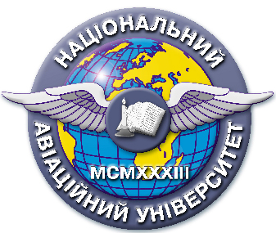
Quality management system

EDUCATIONAL AND METHODICAL COMPLEX
educational discipline
“Criminal Law”

Field of Study: 08 “Law”

Speciality: 081 “Law”
Education Professional Program: “Jurisprudence”

QMS NAU 13.01.03-01-2018

KIEV

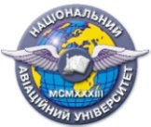 | Quality management system  EDUCATIONAL AND METHODICAL COMPLEX  educational discipline  «Criminal Law» | Document Code | QMS NAU CTP  09.01.06-01-2018
 |  | P. 2 of 2

Developed by
Associated Professor of the Department of
Criminal Law and Process I. Dioriza
Associated Professor of the Department of
Criminal Law and Process K. Katerunchuk
Senior lecturer of the Department of
Criminal Law and Process N. Semchuk

Discussed and approved by the Department of Criminal Law and Process, Minutes № ___ of " " 2018.

Head of the Department S. Likhova

Discussed and approved by the Scientific – Methodological – Editorial Board of the Educational and Research Institute of Law, Minutes № __ of " " 2018.
Head of the SMEB ____________V. Vyshnevetskii

