Тема: Globalization. Consumer trends. Ethical consumerism
План заняття:
I. Організаційний момент.
II. Початок заняття: повідомлення мети, основного завдання та цілей заняття.
III. Основна частина.
- Фонетична зарядка. Активізація вивченої лексики.
- Аудіювання. Контроль розуміння прослуханого.
- Формування навичок читання з пошуком потрібної інформації.
- Формування комунікативних навичок (обговорення-бесіда: 1) глобальних змін, які нині відбуваються у світових економічних системах; 2) зростання етичної свідомості сучасного споживача (на прикладі Японії і Великобританії).
- Удосконалення граматичних навичок (базові граматичні концепти: Present Continuous, Past Simple, Adjectives, Adverbs).
- Формування навичок письма (the letter of invitation; the letter of response)
IV. Підведення підсумків заняття. Заключний етап.

Exercise 1: Read words and find pairs of opposites in the table. Answer the questions using the words/expressions in pairs.

Reward time to spare success buyer
produce use money wisely
not worth the money
respond to the advertisement failure
punishment seller consume
not enough time advertise waste money
good value for money

Who spends money in a shop? A buyer.
- What do you have if you are early? ______
- What do you get if you commit a crime? A _____
- What do you think if something is excellent and cheap? It’s ______
- What do companies do to sell more of their products? ______
- What do eaters, drinkers and buyers do? ______
- What do you win if you do something good? A ____
- What do you have if you or your company does something well? ____
- What do you think if something is expensive and bad? It’s ____
- What do you do if you spend money on stupid things? ____
- What do you have if you are in a hurry? ____

Exercise 2: Choose the best word that fits the sentence.
- The company adverts/advertises/consumes regularly on TV and local radio.
- The reward/respond/success of the project depends on us.
- We usually sell/consume/fail about 4,000 copies of this magazine every month.
- This responses/punish/product is very popular in Japan.
- Our business succeeds/produces/rewards fifteen types of material for curtains.
- The population fails/responds/consumes nearly 100,000 tons of rice every year.
- When we introduced our new perfume, the public response/sellers/reward was fantastic.
- Our company rewards/succeeds/fails the workers’ creativity.
- The average failure/buyer/advertisement of our jeans is female and around 16 years old.

Exercise 3:
- The box contains words and phrases you have previously studied. Put them into appropriate smaller sections below.
Consumer turnover badly-paid workers ethical investment parent company deposit labour conditions investors subsidiary national figures cash flow growth in sales senior citizens ethical awareness shoppers consumer spending general market manufacturers ethical policies growth markets workforce

People | Companies | Finances | Economic  processes | Other

- Use the words and phrases from the wordchart above to complete the sentences.

1. In the 1990s there was a big increase in _____________ among shoppers in the UK.
2. Manufacturers have identified developing countries as potential ___________.
3. It seems that for __________, _______, and __________ alike, the future is definitely cleaner and greener.
4. In 1997 there was a take over by Ferrari: Maserati became its ___________.
5. The growth of ____________________ is increasingly becoming consumer-led in the UK and worldwide.
6. Increasing numbers of women in Japan are entering the __________.
7. In terms of the fair-trade movement consumers won’t accept the products that are made by badly-paid workers in poor _______________.
8. After the Co-operative Insurance Service invited all its members to vote on the most important ethical issues, and then invested accordingly; its ________ and profits increased sharply.
9. _______________________ in Japan is becoming a 24-hour business − and business is booming.

Exercise 4: Look at the cards, read the word/word combination, define its meaning in English and suggest your own sentence illustrating the term.
Globalization Consumption Disposable income Single-parent household
Life expectancy Market force Birth rate Market share
Household expenditure

Exercise 5: Translate words/word combinations and then the sentences into English.
1. тривалість життя | Між 1950-ми та 2000-ми роками в Японії відбулося різке падіння народжуваності і збільшення тривалості життя.
2. заробляти / витрачати гроші | Нині японці, а особливо 20−30-літні жінки, заробляють і витрачають більше грошей, аніж це було десять років тому.
3. наявний прибуток | Як результат, не маючи дітей на утриманні, відсутність витрат на освіту і низькі затрати на житло, люди похилого віку в Японії мають великий наявний дохід, який вони витрачають переважно на внутрішні і закордонні поїздки.
4. зростати | У 1990-х роках в Японії продажі комунікаційних технологій різко зросли.
5. умови праці | Виробники спортивного взуття, для прикладу компанія Nike, запровадили внутрішній статут, зокрема щодо питань умов праці.
6. голосувати за важливі етичні питання | Рядові інвестори, наприклад страхова компанія CIS, нещодавно попросили всіх своїх членів голосувати за найважливіші етичні питання.
7. люди похилого віку | Сьогодні люди похилого віку в Японії стають великими марнотратами.
8. етична свідомість | У 1990-ті роки у Великобританії відбувся процес зростання «етичної свідомості» серед покупців.

Exercise 8:
1) Find a proper heading to each passage. Match headings 1-6 with paragraphs a-f.
Headings: | 1. Communications technologies  2. “The silver market”  3. 24-hour shopping  4. The ethical shopper  5. Single women as a market force  6. Ethical finance

A. | Consumer spending in Japan is becoming a 24-hour business − and business is booming. For example, when one men’s clothing store started working round the clock ten years ago, sales immediately increased by 20%. Nowadays, one third of its annual sales are to customers who come in between 10 p.m. and 7 a.m. Many customers are office workers on their way home. More retail outlets are expanding their night-time opening hours because shoppers are often more relaxed at night and spend more money. The type of goods people buy is also changing. For example, fewer people are eating traditional food and the consumption of western-style meals is increasing. People are drinking a lot less sake and a lot more red wine. They are also drinking less whisky, but more beer.
B. | Increasing numbers of Japanese women are entering the workforce. In 1970, only 33% of women in their 20s and 30s worked. Now that figure is over 60%. Fewer young women are getting married. The proportion of single women is rising steadily. They are earning and spending more money than they did ten years ago. At the same time, the divorce rate more than doubled between in the late 20 years, so there was an increase in the number of single-person households.
C. | In the 1990s in Japan the sales of communications technology grew dramatically. There was a strong growth in the sale and use of mobile phones, telephone bills rose by nearly 10% from 1995 to 2000 even though overall household expenditure fell. A lot more people are using email and the Internet on a daily basis. Business people in their 50s are spending more on communications technology because they do not want to be left behind.
D. | In Japan senior citizens are becoming big spenders. Between 1950 and 2000, there was a dramatic fall in the birth rate, and an increase in life expectancy. These trends are continuing. In 1960, 5.7% of the population was aged 65 or more. From 1960 to 2000, there was an increase to 17.7%, and by 2020 this figure is expected to be 26.8%. As a result with no dependent children, no education costs, and low housing costs, they have a large disposable income and they are spending more and more money on domestic and overseas travel.
E. | In the 1990s there was a big increase in “ethical awareness” among shoppers. By 2002, shoppers in the UK spent £1.7 billion on organic food products, £1.4 billion on ‘green’ household products, a further £180 million was spent on cosmetics not tested on animals, and £107 million went on tourism.
F. | Manufacturers and shops had to learn the lesson that ethical shopping was here to stay. In fact many realized that it was an opportunity for promotion and advertising. Seven of the largest supermarket chains in the UK adopted a ‘code of conduct’ to establish ethical policies. The growth of ethical investment is increasingly becoming consumer-led. It seems that for shoppers, manufacturers, and investors alike, the future is definitely cleaner and greener.

2) What is the importance of the following numbers from the article. Complete this table with the information from the text.
1. | Proportion of sales taken in a men's clothing store between 10 p.m. and 7 a.m _____%
2. | Increase in telephone bills from 1995 to 2000 ____%
3. | Proportion of women aged 20 to 39 in work in 1970 _____%
4. | Proportion of women aged 20 to 39 in work now______%
5. | Increase in divorce rate from 1980 to 2000 ____%
6. | Proportion of population aged 65+ in 1960 ____%
7. | Proportion of population aged 65+ in 2000 _____%
8. | Proportion of population aged 65+ in 2020 (estimated) _____%

Exercise 9: Look at the following spidergram. Speak on the changes in the spending habits in the groups and changes in the areas mentioned in the text above.

Exercise 10: a. Find three examples of trends from the 1990s. Which tense is used?
b. Find three examples of present trends. Which tense is used?

Exercise 11: Look at the graph describing trends in TV viewing hours in the UK last year. Complete the extract using suitable verbs from the box A in the correct tense and appropriate adverbs from the box B the meanings of which are given in the brackets.

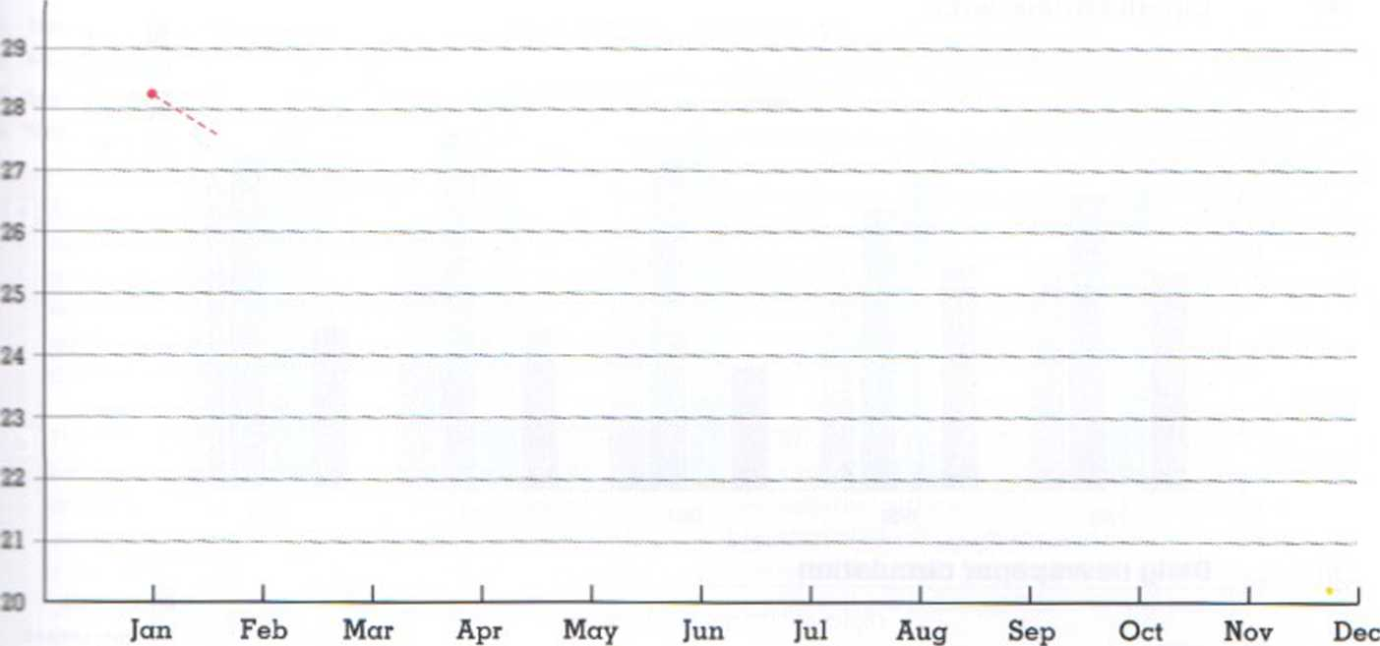

A  decrease drop fall fluctuate increase level off reach rise go down/up |  | B  steadily slightly dramatically slightly sharply

In January last year the average number of weekly viewing hours stood at 28.1. This figure 1)__________ s_______ (suddenly and often surprising) for the next two months, reaching 27.2 in February and 25.5 in March. The number of viewing hours then 2)________ a little: they 3) ________ s_______ (suddenly and rapidly) to 26.1 in April. They then 4) ______ d_______ (slowly and regularly, not suddenly) to 23.3 in May. The figure then 5) ______ very slightly to 23.5 in June and then more or less 6) _________ for the summer, which is traditionally the time people watch the least television. The figure 7) _______ s_______(suddenly and rapidly) back to 23.3 in July and 8)______ its lowest point in August at 23.2. Average viewing hours 9) _________ s_______(very small) in September to 25.3 and then 10) ______ more g______ (evenly and regularly) for the rest of the year to 26.1 in October, and 27.4 in November. The figure 11) ______ its highest point in December at 28.2 hours per week.

Exercise 12: Put the sentences in the correct order to make two letters. The first letter is an invitation. The second letter is the response.
Dear Mr Zelle, | 1
We look forward to hearing from you.
I am afraid I am unable to attend due to a business trip in Switzertand.
Dear Miles Broom,
I have enclosed a form with further information which you can also use to reserve places.
Yours sincerely,
Robert Zelle
I do hope the evening goes well.
I am writing to invite you to our annuaI dinner in the Atrium Restaurant on 19th of July.
Yours sincerely,
Miles Broom
The dinner will begin at 8.oo.
Thank you for the invitation to the annual dinner.

